News Release
For immediate release
1 December 2023

Cantiere delle Marche’s M/Y YES Sold

The 27.31 metre Cantiere delle Marche (CdM) M/Y YES has been sold. The buyer was introduced by Sanlorenzo Yachts UK’s Nick Hatfield, with Mark Seaton of Yacht and Villa and Carlo Aquilanti of Cantiere delle Marche acting for the seller.
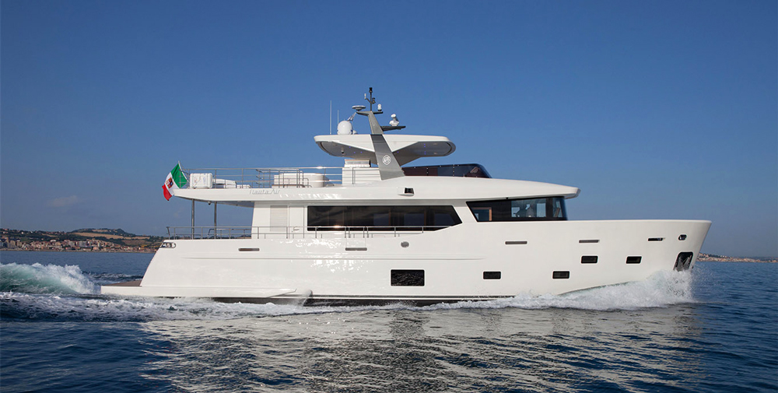
Built by the Italian shipyard CdM and designed by Nauta Yachts S.r.l, this elegant 160GT aluminium explorer yacht was launched in 2014 as part of the shipyard Nauta Air range.

With interior design by Luxury Projects, YES can accommodate up to nine guests in four well-appointed staterooms and features a dedicated stairway to the owner’s suite. There’s also separate accommodation aft for three crew, including the ship’s captain.

Designed with outdoor living in mind, there’s an impressive flybridge, sun pads, BBQ, bar, two dining areas, and spacious al fresco lounge. The connection between the interior and exterior space is maintained through the use of transparent glass in both doors and window, creating a light, bright and relaxing feel throughout.
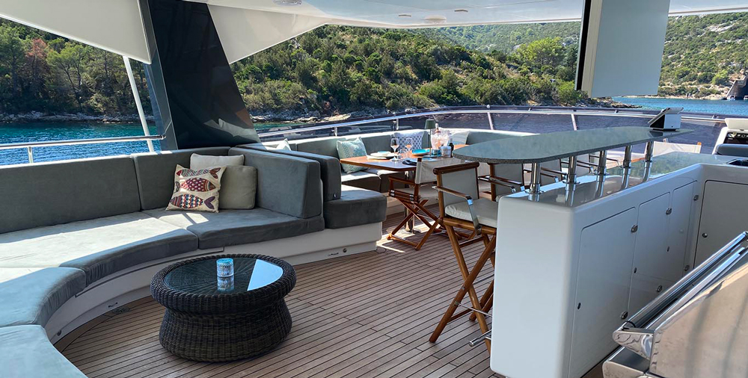
With a semi-displacement hull and twin 885hp Caterpillar engines, YES has a cruising speed on 11 knots, a max speed of 16 knots and a cruising range of 2700 nautical miles.

YES was sold for an undisclosed sum, but was asking €3,299,000.

Ends

Notes to editors

High res images are available online at https://maa.agency/media-centre

About Sanlorenzo UK
- Sanlorenzo UK is owned by the Ancasta Group.
- Sanlorenzo UK is the sole dealer in the UK and Ireland for Sanlorenzo Yachts, and Bluegame – a brand of Sanlorenzo.
- Sanlorenzo UK is based on the River Hamble at Swanwick Marina.
- For more information on Sanlorenzo UK visit https://sanlorenzoyachts.co.uk

Media enquiries via MAA: Susannah Hart – susannah@maa.agency, tel: 023 9252 2044

