Press Release

Superyacht Tenders and Toys appointed as the global superyacht partner for Taiga Motors Orca electric watercraft

17th February 2020

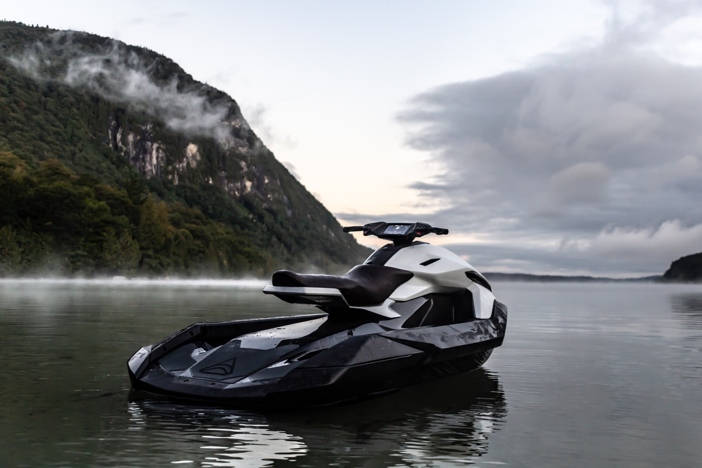

Award winning Superyacht Tenders and Toys (SYTT) is celebrating being selected as the global dealer for the superyacht market of Taiga Orca electric watercraft. These carbon, two-person, 100% electric watercraft can boast an amazing 104kph top speed, a 2-hour range and need zero maintenance making them ideal for superyachts. They are more connected and intelligent than any existing comparable watercraft offering GPS, LTS, Wi-Fi, Bluetooth, wireless updates and configurable parameters all in one data centre.

Taiga Motors was conceived to create electric vehicles enabling escape into the great outdoors without compromise and offers a range of snowmobiles and watercraft built in Canada. The Orca is the first step in Taiga’s mission to accelerate mass market adoption of electric alternatives. Partnering with SYTT is a statement of intent to work with the very best in the business.

The Orca watercraft is available for pre-order with the first units to be delivered in June/July 2020. Each watercraft comes with a five year no-maintenance powertrain warranty. The first 100 Founders Editions retail at $28,000.

Mark Peak, Head of Toy Department at SYTT comments: “This is a revolutionary watercraft which the industry is crying out for. Yachts no longer need to carry petrol and a no-maintenance craft can only be good news for all involved. The compact size of this watercraft ensures nimble handling and ease of stowage on board yachts. Each unit is customisable by SYTT so that it can match the yacht and be a unique and special craft onboard for an owner. For anyone seeking the latest and greatest this has to be at the top of the list.”

Specifications:
- 2.9m long, 1.2m wide, 1.01m tall
- Weight 263kg
- Drive 180hp (134KW) direct drive
- Range 2 hours
- Charging 80% in 20 minutes DC fast charge
- Top speed 104kph/65mph

About SYTT:
SYTT, with its headquarters in Ipswich, Suffolk designs, project manages and delivers yacht tenders and toys to superyachts globally. The company also has a yacht tender and toy rental business with a warehouse in the South of France. The company, founded in 2011 by former yacht manager Josh Richardson and his wife Claire, has grown extensively over the last nine years and is the market leader in its field. A large proportion of the company’s business comes from fitting out new build superyachts in Europe, as well as supplying to superyachts owned by Middle Eastern royalty and international billionaires.

ENDS

To learn more about Superyacht Tenders and Toys visit www.superyachttendersandtoys.com or contact info@sytt.co

High resolution media available on https://cloud.taigamotors.ca/index.php/s/1t2ezXIr9Qgk2Hp

