News release
12 September 2019

Webasto showcases Ultimate Cabin Control, bespoke electric sunroof and much more at SIBS2019

Webasto’s Ultimate Cabin Control unit air-conditioning system is taking pride of place at its stand J368 during Southampton International Boat Show.

This ultra-quiet system, optimised so such that noise is no longer perceptible in the interior of the boat when operating at its lowest speed setting, is perfect for keeping the air cool while allowing people to sleep in peace.

“We decided to demo the Ultimate Cabin Control unit at our stand,” says David Stafford, Webasto’s Commercial Manager, “to demonstrate exactly how quiet it is to our trade and consumer customers, so they can come along and listen to the silence! The technology is a market leader, it’s unparalleled. That’s why you find so many of our products on boats across the show, like Fairline, Oyster and Princess.”

The Ultimate Cabin Control unit suppresses the humming noise emissions from the air handlers used in air-conditioning systems and, at the same time, allows multiple air handlers to be connected and is capable of controlling all of the available BlueCool A-Series air handlers, either individually or multiple units simultaneously. For larger salons it is possible to connect multiple control units in series and operate all installed air handlers via a single MyTouch display.
But Webasto offers more than air-conditioning. For more than 75 years, the Webasto group has set technological standards – in both the original equipment sector and the aftermarket. As one of the 100 biggest suppliers in the automotive industry worldwide, the company develops and produces UV and flyproof roofs and sunscreens as well as heating, cooling and ventilation systems for automotives and marine craft.
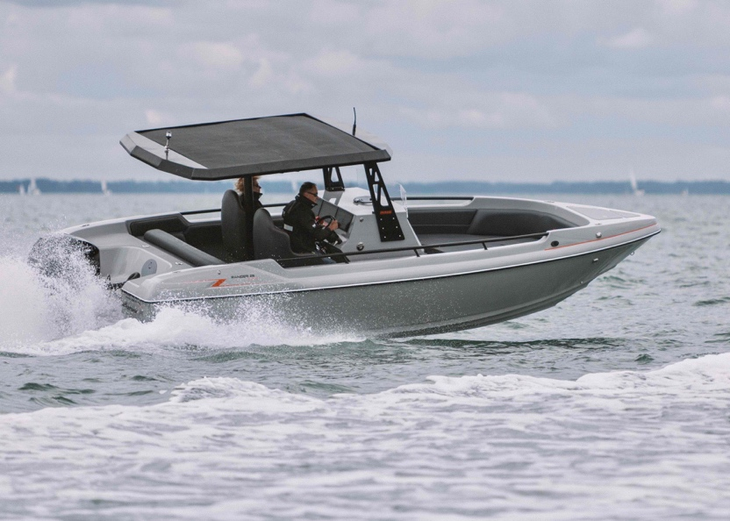
One of Webasto’s bespoke sunroofs will be on display at F005. Protecting the helm and rear seats from rain or shine, Webasto’s electric sunroof is featured on Ring Powercraft’s new ‘Ranger 25 Vengeance’ (pictured).

All of Webasto’s folding and rolling shades provide optimum protection from the sun while at sea. They are easily operated at the press of a button and are very durable – even in the environment of seawater and salty air. Fully tailored in terms of length, width, curvature, fabric and colour to the shape and appearance of the boat, they’re available in widths of up to 2,500mm.
“Visitors to the show will also be able to see our other products to make marine life as comfortable as possible, like our heaters, fridges, ice makers and our newly released C32 Chiller,” David continues. “We’ve got freezers, wine coolers and wine cellars and – at the other end of the scale – our Thermo Top heaters. Whatever your needs, come and talk to us and we can work out how to make your time on the water even more comfortable.”

For more information on Webasto visit https://www.webasto.co.uk

ENDS

Notes to Editors

A high res version of the above image is available at https://maa.agency/media-centre/
Caption: Ring Powercraft’s Ranger 25 Vengeance with WEBASTO electric sunroof

About Webasto:
- The Webasto Group is a global innovative systems partner to almost all automobile manufacturers and among the top 100 suppliers in this industry sector. In its core business areas the company develops and produces sunroofs, panorama roofs and convertible roofs as well as thermo systems for all drive types. In addition, with battery systems and charging solutions Webasto is building up a product portfolio for electromobility.
- In 2016 the Webasto Group generated sales of 3.2 billion euros and has more than 12,000 employees at more than 50 locations (with over 30 of these being manufacturing plants).
- The headquarters of the company, founded in 1901, is located in Stockdorf near Munich (Germany). For more information please visit www.webasto-group.com
- Webasto Thermo & Comfort UK Ltd is based in Doncaster.

Media enquiries
Zella Compton, MAA
Zella@maa.agency

David Stafford, Webasto
David.stafford@webasto.com

