News Release

For immediate release
12 Sept 2019

Three opportunities to view SHOCK-WBV shock mitigation units at SIBS

Underpinning SHOCK-WBV’s rapid growth and proven results, three of the UK’s most renowned powerboat manufacturers are exhibiting the brand’s shock mitigation units on boats at Southampton International Boat Show (SIBS).

SHOCK-WBV, by Sea Sure, is a seat suspension system for powerboats to decrease shock and therefore substantially increase comfort and length of time spent on the water. Currently selling to over 20 countries worldwide, the third generation, high-performance shock mitigation units are a cost-effective way for users to safely use their boats in comfort. The units are available for commercial vessels (C-series), pedestal mounted seats (P-series) and RIBs (R-series). They can be retro-fitted or installed at manufacture. All are powered by market leading FOX Float EVOL shock absorbers as standard and are straightforward to adjust for passenger weight and sea conditions.

View SHOCK-WBV’s C-series with Ring Powercraft’s Vengeance
Ring Powercraft’s Ranger 25 Vengeance makes its debut at SIBS (F005), featuring two SHOCK-WBV C-series units. Manufactured in black and orange to match the boat’s colourways, the units feature SHOCK-WBV’s new seat sliding system which allows the seat to be moved fore and aft for the optimum helming position.

“As Whole Body Vibration (WBV) technology continues to advance,” says David Jackson, Ring Powercraft CEO, “Sea Sure’s innovative and flexible approach make them the ideal partner to blend our race experience with the latest shock mitigation systems. Our new Ranger 25 Vengeance features Ring High Back Seats with C-series suspension and slider units for both comfort and usability.”

“It has been great to work so closely with Ring Powercraft on the design of the custom C-series units,” says Graham Brown, managing director Sea Sure. “We design and manufacture inhouse which means our collaborations are truly flexible. Plus, the custom colour way looks fantastic and is something that more and more customers are asking for.”

View SHOCK-WBV’s R-series with Barnet Marine Centre, and Lymington Ribs
SHOCK-WBV R-series units, designed specifically for leisure and commercial RIBs, are on display at Barnet Marine Centre (F002), and Lymington Ribs (EO71). In both cases the units have been specifically designed to fit between the standard GRP seat box and the seat, to turn a standard jockey seat into a shock mitigation seat.

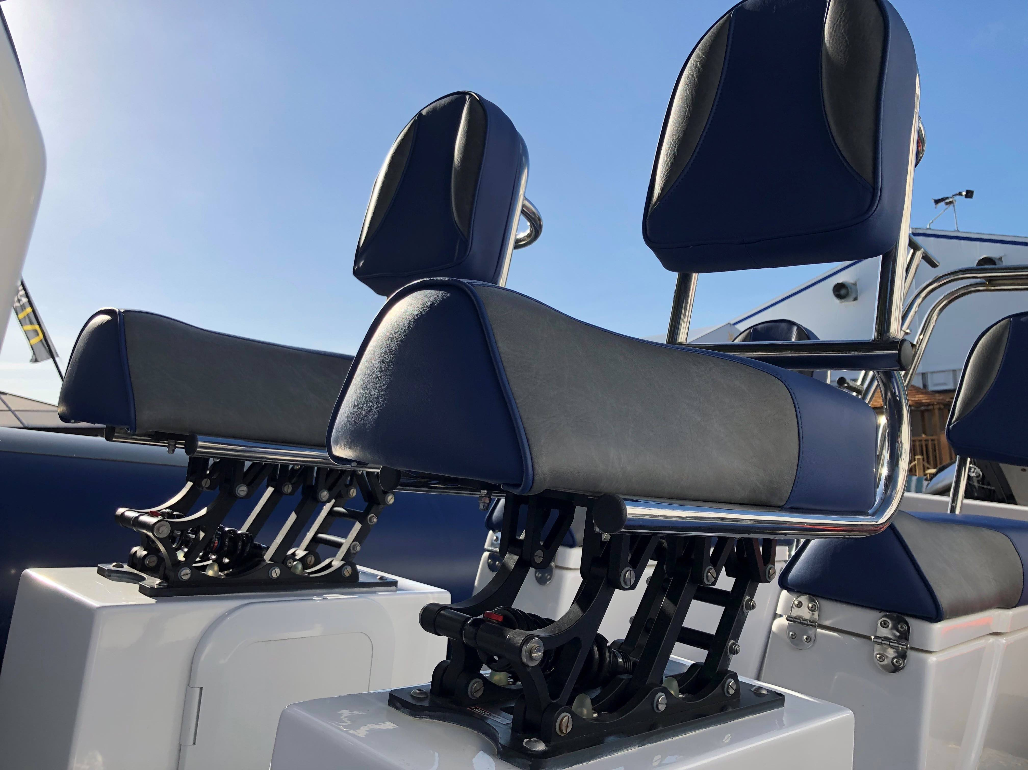

Image: Barnet Marine Centre's XS RIB featuring SHOCK-WBV R-series

SHOCK-WBV only uses the highest-grade components. Aircraft grade aluminium plate and 316 stainless steel are used in onsite production in Warsash, Hampshire. Sheet material has higher integrity and tighter tolerances than cast aluminium. It provides strength, reduces weight and increases lateral stability, all of which combine to leave the competition standing.

The SHOCK-WBV and Sea Sure team will be on hand at Barnet Marine Centre’s stand (F002) throughout the show to talk about your requirements for your powerboat. Get in touch via sales@sea-sure.co.uk or call on 01489 885 401.

For more information about SHOCK-WBV and / or Sea Sure, visit: www.sea-sure.co.uk.

ENDS

Images: a low res image is attached, for a high res version please go to www.maa.agency and visit the media centre.

Notes to editors

- SHOCK-WBV is part of the Sea Sure group.
- Sea Sure has been creating innovative engineering solutions since 1956.
- Sea Sure incorporates Blakes of Gosport, Lavac and Taylors Heater and Cookers.
- For more information about Sea Sure and / or SHOCK-WBV, visit https://www.sea-sure.co.uk

For media enquiries, more information, product tests, or hi-res images:
MAA
Zella Compton or Mike Shepherd
Email: zella@maa.agency Email: mike@maa.agency
Tel: +44 (0) 23 9252 2044 Tel: +44 (0) 23 9252 2044

