News Release

For immediate release
1 May 2019

Luxury yacht building continues at MDL’s Saxon Wharf

MDL Marinas and Oyster Yachts have signed an agreement which will see the luxury blue-water yacht maker’s presence at MDL’s Saxon Wharf, Southampton continue for the next ten years.

MDL is delighted to support the new team and company’s development plans into 2019 and beyond.
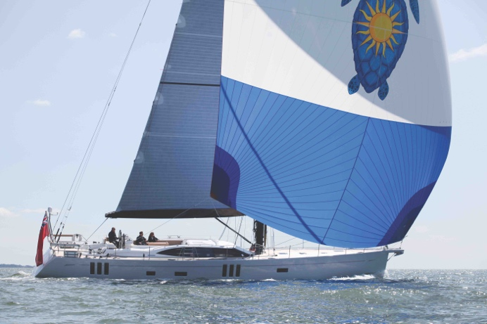
“Saxon Wharf provides the perfect South Coast base for us and complements our other sites at Wroxham, Ipswich, Palma & Newport Rhode Island,” says Clive Harrop, Chief Operating Officer at Oyster.

“Not only do we have a highly skilled and dedicated team onsite to assemble and refit our beautiful boats, we’re minutes from Solent cruising where we initially test all our projects, whether they’re bespoke, or a new build of a traditional favourite.”

Oyster (pictured) is known for designing and building the world’s finest Deck Saloon blue-water cruising yachts and is built on a foundation of over 20 million blue-water sailing miles, and 90 circumnavigations.

“We’re delighted Oyster Yachts has chosen to build its future at Saxon Wharf,” says Graham Nash, MDL’s Estates Manager. “Saxon Wharf is known as the location on the River Itchen for superyachts and other large craft needing lift-outs, repair work, or full-scale refits and so we’re really pleased that Oyster is staying with us. We consider this a testament to the service and professionalism of our staff and the quality of the marina.”

Saxon Wharf, a marine service centre, features a 200-ton boat hoist and can accommodate boats up to 80 metres. Aside from Oyster, tenants onsite include commercial ventures such as on-shore storage, training and boat repair.

MDL’s Dry Stack facility offers secure dry berthing and on-demand launching and lifting for boats up to 13 metres and its position, near the centre of Southampton, gives it straightforward access to the motorway making it the perfect location for Oyster’s sales team’s head office.

All MDL members can overnight at Saxon Wharf for free, if space is available, while non-members are welcome to enquire about availability for an annual berth.
More information on Saxon Wharf from: mdlmarinas.co.uk/mdl-saxon-wharf
More information on Oyster Yachts from: oysteryachts.com

MDL Marinas
- MDL Marinas is Europe’s largest marina group, offering members over 120 destinations to cruise to in the UK, France, Italy and Spain through Freedom Berthing. Currently MDL Marinas manage 18 UK marinas, 1 in Italy and 1 in Spain.
- MDL Marinas is proud to be landlords to over 500 marine business companies, with nearly 260 staff delivering the unique MDL experience to all members, guests and commercial partners.
- The company also advises on worldwide marina developments including Europe, China and Crimea.
- For more information visit www.mdlmarinas.co.uk

MAA
- MAA provides simple, no-nonsense solutions to marine companies’ advertising, PR, media buying and communications needs.
- From brand development and marketing materials to website, eCommerce, email campaigns and social media, MAA offers a straightforward, knowledgeable and service-orientated approach.
- MAA is able to offer unrivalled value to help clients reach their target markets.
- For more information visit www.maa.agency

Contact

Zella Compton Mike Shepherd

Zella@maa.agency Mike@maa.agency

02392 522044 02392 522044

High res images are available online from our media centre at: www.maa.agency

