ENTROPY RESINS®
New online store launched for European customers

News release, 16 May 2019

Wessex Resins and Adhesives is delighted to announce the launch of a new online store to facilitate ordering the unique range of bio-based epoxy: ENTROPY RESINS. The EU online store has been added to the current North American website WWW.ENTROPYRESINS.COM and will support the existing network of distributors and retailers.

ENTROPY RESINS are used in a variety of applications, from coating and laminating at room temperature, compression moulding, and casting and embedding to produce water clear, UV-stable finishes. Due to their sustainability credentials, ENTROPY RESINS are used extensively by action sport goods manufacturers for the construction of such items as surf and snowboards. The range is already a firm favourite among makers and creatives who love its usability and physical properties – stunning end results can be created with clear casting, like ‘river’ tables.
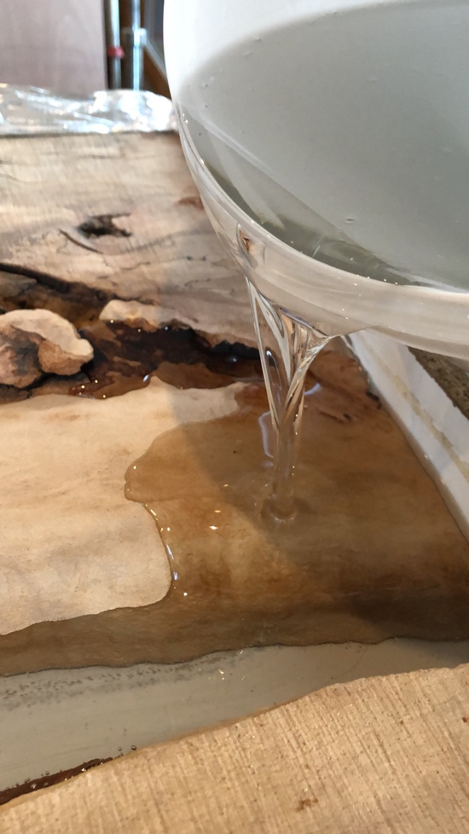
“The market take-up of ENTROPY RESINS has been phenomenal in the last four months,” says Ian Oliver, Managing Director, Wessex Resins and Adhesives. “We’ve been servicing orders from across Europe, the Middle East, Turkey, Africa and India. Manufacturers and individuals are finding all sorts of applications for ENTROPY RESINS, from high-end sports products to jewellery. We’re always delighted at the ingenious uses of the epoxy brands we manufacture (WEST SYSTEM and PRO-SET epoxy) and ENTROPY RESINS are proving no different. That’s why we’ve worked with our American partners to create this website, making it as straightforward as possible to order online.”

As well as the shop facility the website details applications, product information and data sheets and has lots of useful facts to help new, or professional users, to choose and order ENTROPY RESINS.

Wessex Resins and Adhesives manufactures and supplies ENTROPY RESINS, WEST SYSTEM and PRO-SET epoxy from its head office in Romsey, Hampshire. All three brands are manufactured under licence from Gougeon Brothers, Inc.

Find inspiring ideas and projects online at epoxycraft.com.

ENDS

Notes to Editors:

HIGH RES IMAGES ARE AVAILABLE ONLINE FROM https://maa.agency/media-centre/
ENTROPY RESINS are based upon plant-based formulations, utilising SUPER SAP® technology. They are used extensively in the production of snowboards, surfboards, paddle boards, sailboards, skateboards, kiteboards, ice hockey sticks, and other kinds of sporting equipment.
Using ENTROPY RESINS reduce the carbon footprint. By employing green chemistry techniques that require less energy and produce less harmful by-products, the greenhouse gas emissions form the production of the epoxy is reduced by 33% over conventional petroleum-based epoxies.
The raw materials going into ENTROPY RESINS epoxy and hardeners are co-products or waste products of other industrial processes. These materials do not compete with food sources or displace food-based agriculture. Using an international standard method of radiocarbon dating, the renewable content of products can be verified.
Wessex Resins and Adhesives also manufactures and provides international support for the world-renowned WEST SYSTEM® and PRO-SET® epoxy brands.
Since Michigan boatbuilding brothers Meade, Joel and Jan Gougeon first experimented with the bonding power of epoxy over 50 years ago, the WEST SYSTEM and PRO-SET product ranges have become the epoxies of choice for private boat owners, boat manufacturers, chandlers and naval engineers throughout the world.
Wessex Resins and Adhesives has been working in partnership with Gougeon Brothers, Inc. for more than 36 years, manufacturing WEST SYSTEM and PRO-SET epoxies as well as ENTROPY RESINS here in the UK.

Media enquiries:
MAA – Zella Compton, zella@maa.agency, 023 9252 2044
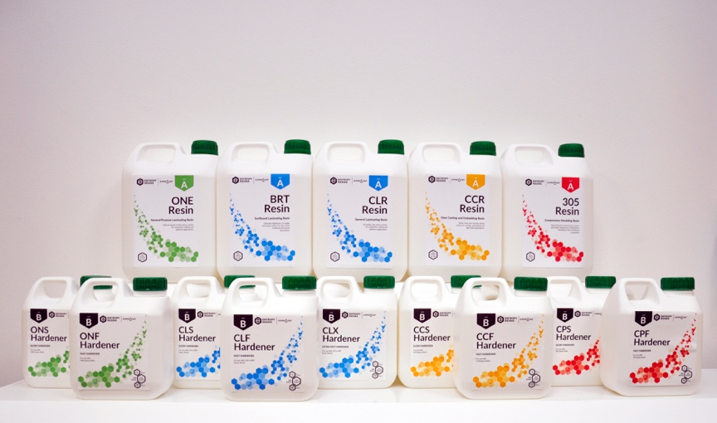
Wessex Resins and Adhesives – Sam Oliver, sam.oliver@wessex-resins.com, 01794 521 111

