News Release

For immediate release
2nd May 2019

Thames Valley and London Boat Show spectacular success at
MDL’s Penton Hook Marina

Over 2,000 people attended the inaugural Thames Valley and London Boat Show which was hosted in April at MDL Marinas’ Penton Hook Marina. The three-day event proved a spectacular success with a wide range of boats on display including those by Sealine, Jeanneau, Cranchi, Glastron, Bayliner, Alfastreet and Orkney.
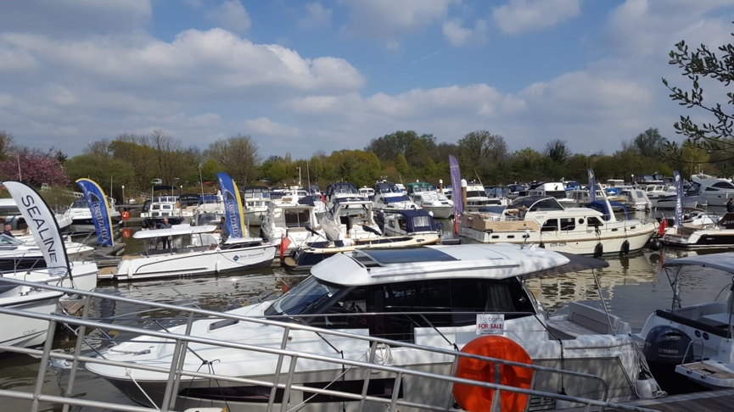

“The Thames Valley and London Boat Show was designed specifically for river lovers and was carefully curated to reflect the needs of boat buyers in the Thames Valley,” says Paul Hallas, MDL’s Thames Marina Manager.

“We had over 25 boats on display for our visitors, as well as exhibitors offering culinary delights and other marine services including electronics, decking, finance and insurance. We’re delighted with the positive feedback we’ve received, and the opportunity it gave us to create a fun and memorable experience for all. We look forward to hosting many more shows in the years to come.”

Adrien Burnand, MDL’s Head of Marketing, says: “Our marinas provide the perfect professional backdrop for showcasing wonderful boats, and with all the delicious cafes and restaurants and tenant services we have, we’re already very well set up to host these types of events. It was great to support TBS Boats with the organisation of the Thames Valley and London Boat Show. We’re also delighted to be hosting the South Coast Boat Show at MDL’s Ocean Village Marina.”

Find more information about the South Coast Boat Show (17-19 May 2019 at Ocean Village Marina, Southampton) online, and preregister at: https://southcoastboatshow.com.

ends

Images
- For other images, please visit MAA’s media centre at maa.agency.

MDL Marinas
- MDL Marinas is Europe’s largest marina group, offering members over 120 destinations to cruise to in the UK, France, Italy and Spain through Freedom Berthing. Currently MDL Marinas manage 18 UK marinas, 1 in Italy and 1 in Spain.
- MDL Marinas is proud to be landlords to over 500 marine business companies, with nearly 260 staff delivering the unique MDL experience to all members, guests and commercial partners.
- The company also advises on worldwide marina developments including Europe, China and Crimea.
- For more information visit www.mdlmarinas.co.uk

MAA
- MAA provides simple, no-nonsense solutions to marine companies’ advertising, PR, media buying and communications needs.
- From brand development and marketing materials to website, eCommerce, email campaigns and social media, MAA offers a straightforward, knowledgeable and service-orientated approach.
- MAA is able to offer unrivalled value to help clients reach their target markets.
- For more information visit www.maa.agency

For further information contact:

Zella Compton or Mike Shepherd
Zella@maa.agency Mike@maa.agency
023 9252 2044 023 9252 2044

