News Release
For immediate release
1 April 2019

Book your free water activity taster today for
Gosport Marine Festival

There are over 600 FREE opportunities to get afloat in the brilliant Gosport Marine Festival on Saturday 11th May. The ever-popular festival is back to take parents, children, families and friends onto, and into, the water. Book a fun, free, trial session for Standup Paddleboarding, rowing, sailing, kayaking and much more via https://gosportmarinescene.com/events/gosport-marine-festival/.

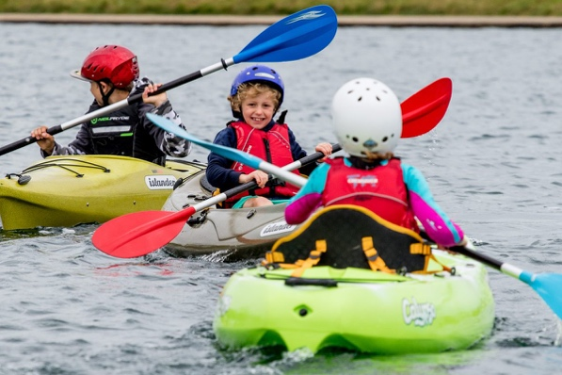
Gosport Marine Festival provides the opportunity to find out what it’s like to sail a dinghy, row a boat, or glide along on a kayak. People need to book online as the activities are extremely popular and then turn up on the day, preferably wearing something that they don’t mind getting wet. All the safety equipment needed will be provided free of charge.
“Our water-based activities are very popular,” says Mitch Youngman from the organising committee, “so we advise booking online as soon as possible. We give priority to Gosport residents, but it’s first come, first served. Even though the activities run all day, places are limited, so whatever it is that you fancy, get online and book your slot now.”
The festival is mainly based in Dean and Reddyhoff’s Haslar Marina, plus there will be a fantastic array of other activities at the Cockle Pond and Trinity Church’s green.
“We’ve got 24 miles of coastline in Gosport,” Mitch continues, “and the idea of the festival is showing people how they can make the most of it. We’ve also got big Sail Training Yachts, historic ships to visit in Haslar Marina and accessible catamarans for wheelchair users. There’s certainly something to tempt even the staunchest land-lubber onto the water.”

The festival is a joint initiative between Gosport Marine Scene (a group of marine based organisations dedicated to increasing awareness of opportunities in the marine sector) and Gosport Borough Council. Now in its fourth iteration, numbers taking part have risen consistently especially among the younger age brackets. And while people are on the water, their families can enjoy food stands, day-long entertainment and exhibitions ashore.
The bustling TimeSpace amphitheatre (near Trinity Church) will feature an electric programme of entertainment curated by Haslar Radio, including dance, song, brass, instrumental and choral music. On Trinity Green there will be displays by many maritime organisations, while inside the church Little Shipmates will provide seafaring activities upstairs for children too young to go afloat.

“This truly is a lovely day,” says Mitch. “It’s made possible by the contributions of the Sea Cadets, our local sailing clubs, the activity providers and our sponsors which makes it a true community event.”

Find out more from: https://gosportmarinescene.com/events/gosport-marine-festival/

ENDS
HIGH RESOLUTION IMAGES ARE AVAILABLE ONLINE FROM https://maa.agency/gallery/gosport-marine-festival-2017/

Media enquiries:
For further information and requests for interviews, please contact:
Zella Compton
Tel.: 023 9252 2044
Email: zella@maa.agency

GMF MD contact details:
Mitch Youngman
Email: chairman@gosportmarinefestival.org.uk

