For immediate release
26 February 2019

Wessex Resins and Adhesives to run
repair demonstrations at RYA Dinghy Show

If your dinghy suffered last season, Wessex Resins and Adhesives is offering free repair demonstrations on its stand C42 at the RYA Dinghy Show, Alexandra Palace, 2nd and 3rd March. The demonstrations offer expert advice about fixing all-too-common problems using the WEST SYSTEM® brand.
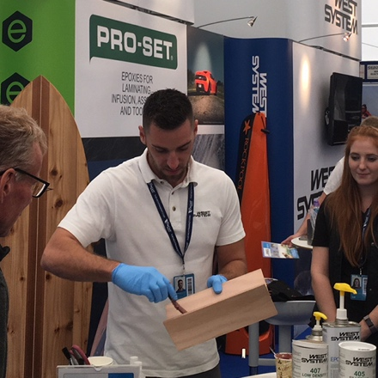
Glass Fibre Repair Demonstration
(Sat 2, Sun 3 March, 14:30, C42)
It’s straightforward, time effective and economical to make small repairs to glass fibre hulls using WEST SYSTEM epoxy and G/flex. These demonstrations include techniques for hull / deck repairs.

WEST SYSTEM Mini Pack Demonstration
(Sat 2, Sun 3 March 12:30 daily, C42)
The Mini Pack is a one-stop-pack for small repair jobs, and includes resin, hardeners, two fillers, gloves and more. This demonstration explores how the contents can be used to effect repairs and explores techniques for fileting, bonding and the use of glass reinforcement.

Wessex Resins and Adhesives (WRA) is the UK home for WEST SYSTEM, PRO-SET and ENTROPY brands, all expertly engineered epoxy resins which give unparalleled longevity, stability and durability for marine (and other) projects. Whether your dinghy is traditional wood, or made with composites, WRA’s experts will be able to offer advice and practical guidance on anything from sheathing to small repairs, as well as bigger projects such as Osmosis treatment.

“We really enjoy meeting our customers,” says David Johnson, WRA’s Sales Director. “It’s the passion and pride for the projects they’re undertaking. It doesn’t matter if it’s a new build or repair, the fact that we can help people, that we have solutions for their biggest challenges, really motivates the team. Even though our products are straightforward to use, for GRP and wood, the range is wide. Having an initial chat will point you in the right direction from the outset, so come along to our repair demonstrations, or stop by C42 and have a chat.”
continues . . .

WEST SYSTEM epoxy (a general purpose system designed for coating, bonding and gap filling) is also used by professional boat builders such as Princess, Sunseeker and Spirit Yachts. “We use WEST SYSTEM epoxy for all our timber bonding,” says Nigel Stuart, Spirit Yachts’ Managing Director. “By using WEST SYSTEM epoxy, we can build extremely light boats that offer the excellent racing and cruising performance our customers expect.”

Companies such as Maguire Boats use PRO-SET products (Advance Infusion, Laminating and Adhesive systems) for their ability to produce lightweight and incredibly strong composite structures. “Our Exocet Moths dominated the Moth Worlds in Bermuda (2018),” says Simon Maguire, founder of Maguire Boats. “It’s a combination of factors, obviously, but PRO-SET is a core component in our design. It’s versatile, and hard-working. We’ve never looked back, and neither have those who race our boats!”

ENTROPY products (bio-based adhesives and coatings) help decrease carbon footprint and are used extensively for sporting goods such as surfboards, paddle boards, windsurfers, skateboards, kiteboards and ice hockey sticks.

Find Wessex Resins and Adhesives on stand C42 at the RYA Dinghy Show. Or check out https://westsysteminternational.com for further information.

ENDS
Notes to Editors:
- Wessex Resins and Adhesives manufactures WEST SYSTEM, PRO-SET and ENTROPY epoxy products in the UK under license from Gougeon Brothers Inc., and distributes these leading brands across the whole of Europe, Africa and the Middle East via a well- respected distribution network.
- Wessex Resins and Adhesives provides international support for the world-renowned WEST SYSTEM, PRO-SET and ENTROPY epoxy brands.
- Since Michigan boatbuilding brothers Meade, Joel and Jan Gougeon first experimented with the bonding power of epoxy over 50 years ago, the WEST SYSTEM® and PRO-SET® product ranges have become the epoxies of choice for private boat owners, boat manufacturers, chandlers and naval engineers throughout the world.
- West System International (WSI) has been working in partnership with Gougeon Brothers, Inc. for more than 36 years, manufacturing WEST SYSTEM, PRO-SET and ENTROPY epoxies here in the UK.
- Whether an epoxy is needed for laminating, bonding, coating, tooling or infusion, the combined breadth of WEST SYSTEM, PRO-SET and ENTROPY products will provide the solution. West System and PRO-SET have passed extensive quality testing. They are certified by Lloyds Register and DNVL.

Media enquiries:
MAA – Zella Compton. zella@maa.agency 023 9252 2044

