News Release

For immediate release
7 February 2019

MDL Marinas announces latest accreditation for top-level manager

MDL Marinas is delighted to announce that Kerry Marriott, MDL’s Head of Operations (Central and Chichester), has achieved her Certified Marina Professional accreditation under the umbrella of British Marine and Global Marina Institute.

After completing her Advanced Marina Manager’s course in Athens, Greece in 2018, Kerry was presented with her professional certification in January at a British Marine and Global Marina Institute meeting.

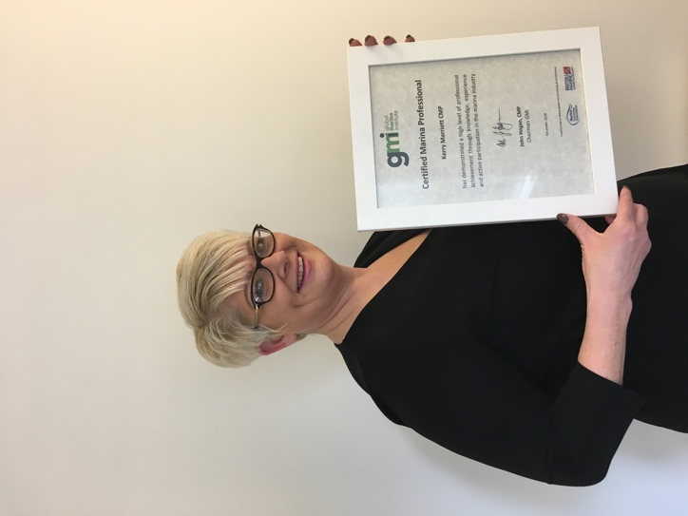
Pictured: Kerry Marriott with her accreditation certificate.

In order to achieve professional accreditation, Kerry required extensive industry experience (a minimum of five years in a marina management position or ten years relevant management experience which she gained at MDL) and to attend both the Intermediate and Advanced Marina Management British Marine training courses.

Kerry joined MDL in 2000 and has forged her career from an administrator to Head of Operations. Over the past 12 months she has been managing MDL’s Hamble, Southampton and Chichester Harbour Marinas, as well as finding the time to study.

“The course was very interesting,” says Kerry. “We studied with other marina professionals from a wide variety of nationalities and backgrounds. We have similar challenges all over the world with weather, and depth, and had a wonderful time sharing experiences and learning from one another. I’d like to thank both MDL and British Marine for their help and support in achieving this long-held goal.

“I love being around the water and MDL,” she continues. “It’s very much a people business, and it’s lovely to be able to make changes which make our marinas even better for

customers. Plus I get to work with our outstanding teams, who are always keen to put new ideas into practice.”

Full details of British Marine’s courses can be found online at britishmarine.co.uk. For further information about MDL, visit mdlmarinas.co.uk

ENDS

Images
- For a high res images, please visit MAA’s media centre at maa.agency.

MDL Marinas
- MDL Marinas is Europe’s largest marina group, offering members over 120 destinations to cruise to in the UK, France, Italy and Spain through Freedom Berthing. Currently MDL Marinas manage 18 UK marinas, 1 in Italy and 1 in Spain.
- MDL Marinas is proud to be landlords to over 500 marine business companies, with nearly 260 staff delivering the unique MDL experience to all members, guests and commercial partners.
- The company also advises on worldwide marina developments including Europe, China and Crimea.
- For more information visit www.mdlmarinas.co.uk

MAA
- MAA provides simple, no-nonsense solutions to marine companies’ advertising, PR, media buying and communications needs.
- From brand development and marketing materials to website, eCommerce, email campaigns and social media, MAA offers a straightforward, knowledgeable and service-orientated approach.
- MAA is able to offer unrivalled value to help clients reach their target markets.
- For more information visit www.maa.agency

For further information contact:

Zella Compton or Mike Shepherd
Zella@maa.agency Mike@maa.agency
023 9252 2044 023 9252 2044

