News Release
For Immediate Release
28th February 2019

Excellent customer service at the heart of MDL’s Torquay Marina
Coastal Marina of the Year Runner Up Award

MDL is delighted to announce that Torquay Marina has received the Yacht Harbour Association Coastal Marina of the Year Runner Up award for a marina over 250 berths.

Voted for by members of the public and marina berth holders, the prestigious Marina of the Year awards focus on the quality of the marina facilities and the customer service received from the marina staff.

“We are delighted to receive this award and it is testament to the hard work of the team here at Torquay Marina. Knowing that this accolade is voted for by our customers on the strength of the customer service they receive makes it all the more valuable to us,” comments Mike Smith, Torquay Marina Manager.

“The whole process has allowed us to find out more about our customers, visitors and annual berth holders, and what is important to them. We can now take what we have learnt and further put this at the heart of what we do, therefore, continuing to improve so that we offer the best marina experience possible.”

The award will be officially presented to representatives from Torquay Marina on the 24th April at the bi-annual Marina Conference in Bournemouth.
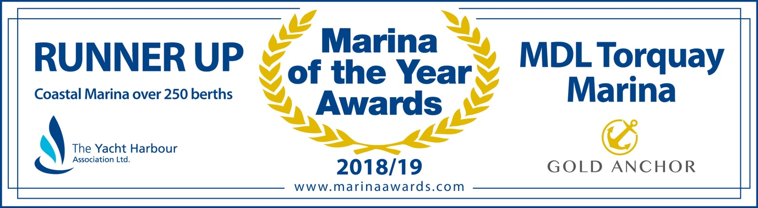
ENDS

Notes for editors:
Torquay Marina
- The marina is situated in the north-east corner of Torbay and is sheltered from the prevailing south-westerly winds, providing a safe haven for boats in all weathers. The marina is also conveniently located for crossing the Channel to Brittany, Normandy and the Channel Islands, ideal for a weekend away. With modern facilities and superb bluewater cruising, it's popular with yachtsmen from home and overseas.
- Torbay itself offers many lovely anchorages, with plenty of coves and beaches to explore, including Babbacombe Bay, Fishcombe Cove and Goodrington Beach. Heading south is the picturesque fishing village of Brixham, where MDL also has a marina, and where there are many fine restaurants.
Additionally, Torquay Marina’s various marine tenants on site provide chandlery, boat brokerage and new boat sales. Basic provisions are available from the dock office and there is a restaurant and café.

- MDL Marinas
- MDL Marinas is Europe’s largest marina group, offering members over 120 destinations to cruise to in the UK, France, Italy and Spain through Freedom Berthing. Currently MDL Marinas manage 18 UK marinas, 1 in Italy and 1 in Spain.
- MDL Marinas is proud to be landlords to over 500 marine business companies, with nearly 260 staff delivering the unique MDL experience to all members, guests and commercial partners.
- The company also advises on worldwide marina developments including Europe, China and Crimea.
- For more information visit www.mdlmarinas.co.uk

MAA
- MAA provides simple, no-nonsense solutions to marine companies’ advertising, PR, media buying and communications needs.
- From brand development and marketing materials to website, eCommerce, email campaigns and social media, MAA offers a straightforward, knowledgeable and service-orientated approach.
- MAA is able to offer unrivalled value to help clients reach their target markets.
- For more information visit www.marineadagency.com

For media enquiries, more information, product tests, or hi-res images:

MAA

Zella Compton or Mike Shepherd
Email: zella@maa.agency Email: mike@maa.agency
Tel: +44 (0) 23 9252 2044 Tel: +44 (0) 23 9252 2044

