News Release

For immediate release
18 February 2019

Hythe Marina Village Boat Jumble announced
Sat 13th April, 2019

MDL’s Hythe Marina is delighted to announce its next boat jumble will take place on the morning of Saturday 13th April 2019. The boat jumble is an annual event which draws sellers and buyers from across the South Coast in search of a bargain and is run by MDL and Hythe Marina Association.
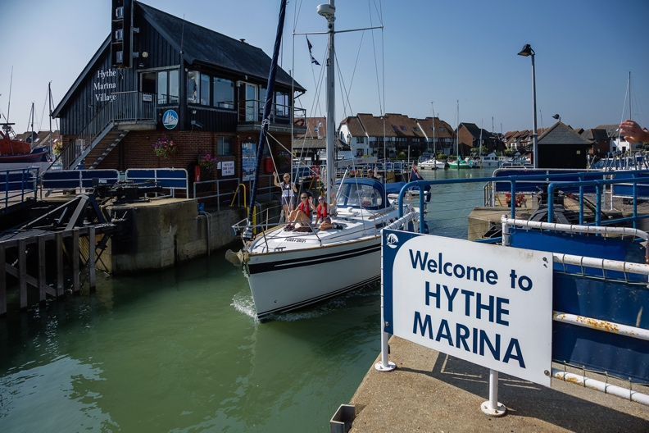
Entry is free for visitors, who are welcomed from 9.30am.

Always popular, those who wish to set up their stall (be it out of their boot, or on a table) are advised to be at
Hythe Marina Village, Shamrock Way,
Hythe, Southampton SO45 6DZ
by 8am in the morning.

Fees for selling are: car £10, 4x4s / vans £15, and car + trailer £20.

All profits from this great event will go to local good causes.

Phil Bridges, Hythe Marina’s Night Lock Keeper, says: “The boat jumble is one of the events of the year. We normally get around 40 people selling goods, from inflatable ribs to oars and outboards. There is always a bargain to be found. And, once you’ve finished shopping, visitors are more than welcome to stay for lunch at our great restaurants, the Boathouse and Marine Seventeen.”

Pitches can be booked by emailing p.bridges@mdlmarinas.co.uk, or calling the Lock Office on 023 8020 7073. Limited short stay visitor berthing is available for this event, but please phone ahead to confirm a berth as they’re subject to availability (£9.25 up to 15m – or at no cost to MDL Freedom Berthing customers).

ends

MDL Marinas
- MDL Marinas is Europe’s largest marina group, offering members over 120 destinations to cruise to in the UK, France, Italy and Spain through Freedom Berthing. Currently MDL Marinas manage 18 UK marinas, 1 in Italy and 1 in Spain.
- MDL Marinas is proud to be landlords to over 500 marine business companies, with nearly 260 staff delivering the unique MDL experience to all members, guests and commercial partners.
- The company also advises on worldwide marina developments including Europe, China and Crimea.
- For more information visit www.mdlmarinas.co.uk

MAA
- MAA provides simple, no-nonsense solutions to marine companies’ advertising, PR, media buying and communications needs.
- From brand development and marketing materials to website, eCommerce, email campaigns and social media, MAA offers a straightforward, knowledgeable and service-orientated approach.
- MAA is able to offer unrivalled value to help clients reach their target markets.
- For more information visit www.maa.agency

Contact

Zella Compton Mike Shepherd

Zella@maa.agency Mike@maa.agency

02392 522044 02392 522044

High res images are available online from our media centre at: www.maa.agency

