News Release
For immediate release
2 January 2019

Ancasta enables First Class Sailing to build its fleet with two Beneteau Oceanis 38.1

Ancasta is delighted to announce that First Class Sailing has purchased two new Beneteau Oceanis 38.1.
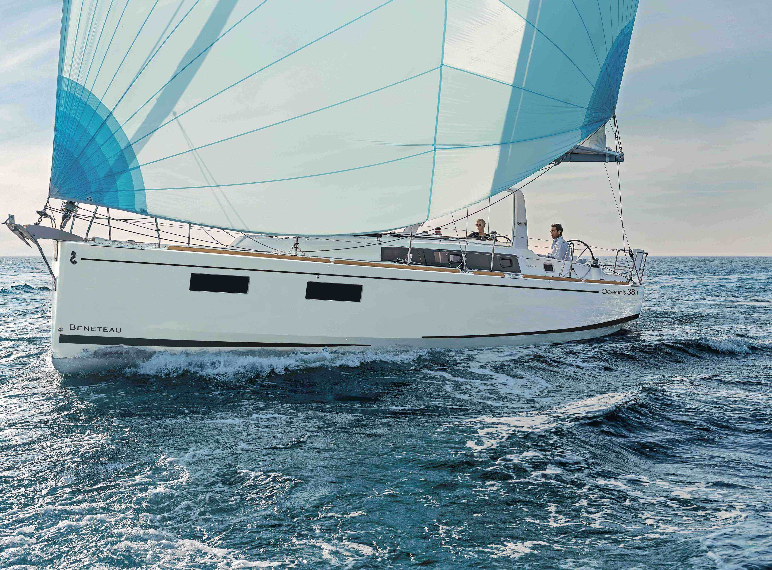
The Beneteaus will be used as part of the sail training which First Class Sailing offers, including RYA courses from Competent Crew to Yachtmaster Ocean, boat handling and mile building sailing weekends plus more.

Ancasta is the largest Beneteau Power and Sail dealer in the UK and the largest boat sales network in Europe.

Will Blair, Ancasta’s Group Marketing Director, says: “This is a great endorsement for Ancasta as First Class Sailing is drawing on two decades of professional experience. Choosing to use our comprehensive services underpins the credibility of both the service we deliver, and the products we work with and bears testament to the fact that these beautiful boats made by Beneteau are unmatched in terms of design, quality and performance.”

Charlie Tulloch from First Class Sailing says: “Our fleet works very hard. We add new boats every five years to make sure our customers are getting the best experience and training on the latest yachts available. We are delighted we chose Ancasta to broker the deal because of the excellent service they provide. Ancasta makes the process as straightforward as possible and has worked with us from the outset to make sure we’re getting the best boats for our very specific needs – great to cruise, straightforward to sail, comfortable to stay on while being robust enough to endure years of training crews and still look great.”

The Beneteau Oceanis 38.1 model has been chosen for its cruising comfort. It features two helm stations, a mainsail arch, and a spacious cockpit. Plus, as it’s good and taut to aft and low on the water, the rigidity under sail takes it further and faster with exceptional stability. With three cabins, berths for eight and a toilet/shower room, it offers stylish comfort in its well optimised interior space.

Ancasta will be showcasing Beneteau Oceanis 38.1, as well as a fantastic array of power and sail boats, at Boot Dusseldorf Boat Show 2019 (19-27th Jan). Book your appointment today at Ancasta.com.

First Class Sailing runs RYA practical courses out of MDL’s Shamrock Quay, Southampton, as well as offering RYA shore-based learning (including courses in clients’ offices) in London. Find out more at www.firstclasssailing.com.

ENDS

Notes to editors

About Ancasta International Boat Sales
- Ancasta International Boat Sales has 17 offices across Europe.
- Ancasta is the largest Beneteau Power and Sail dealer in the UK.
- Ancasta is the largest UK dealer for Prestige Luxury Motor Yachts dealer and Prestige Yachts in the Balearics.
- Ancasta is exclusive UK dealer for Lagoon Catamarans.
- In addition Ancasta is a new boat dealer for CNB Yacht Builders and McConaghy Yachts.
- The Ancasta Group incorporates Hamble Yacht Services Refit & Repair and Advanced Rigging and Hydraulics, both operating from Port Hamble.
- For more information on Ancasta visit www.ancasta.com

About First Class Sailing

- Established in London, First Class Sailing is owned by Principal Charlie Tulloch.

- First Class Sailing runs practical RYA Sailing courses from Shamrock Quay in Southampton and office-based RYA courses in various Central London locations. It also arranges other sailing adventures across the Channel, the Atlantic Ocean and to Norway as well as competing in races such as the ARC, Rolex Fastnet and Round the Island Race.

- Enquiries Charlie Tulloch
Shamrock Quay
William Street
Southampton
SO14 5QL
0203 006 3717
info@firstclasssailing.com
www.firstclasssailing.com

Media enquiries via MAA
Zella Compton - zella@maa.agency, tel: 023 9252 2044

For high res images visit maa.agency (media centre)

