News Release
For immediate release
3 January 2019

Ancasta offers VIP service for visitors to boot Düsseldorf International Boat Show 2019

See flagship boats from Beneteau, Lagoon, Prestige and CNB 66 in Düsseldorf with Ancasta.
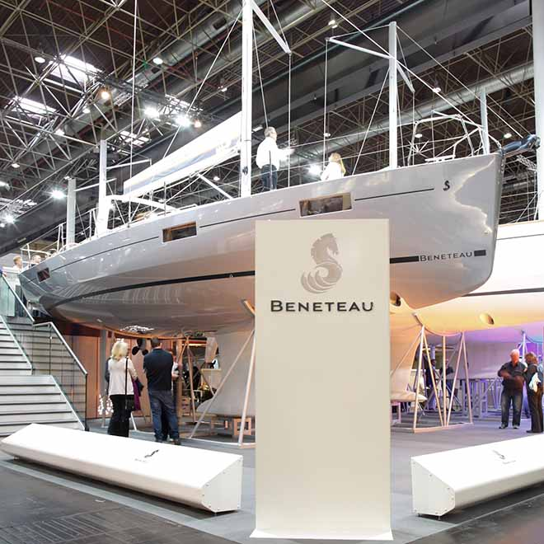
Beneteau is exhibiting a comprehensive selection of boats from its sail and power ranges at boot Düsseldorf Boat Show 2019 (19th – 27th Jan 2019). On show will be the whole of Beneteau’s new First range, the only time the series has been shown together in one location.

Visitors will also enjoy the world launch of the Lagoon 46 and see why it was recently nominated for Multihull of the Year by Multihull World.

UK buyers should contact Ancasta International Boat Sales (02380 450 000, www.ancasta.com) to arrange appointments to view.

Ancasta is offering support to those wishing to attend the show where, in addition to the Prestige 590 and CNB66, Ancasta will be presenting Beneteau’s Swift Trawler range including the 47 (nominated for European Boat of the Year), Gran Turismo, First and Oceanis ranges.

“We’re offering a VIP service for 2019,” says Will Blair, Ancasta’s Group Marketing Director, “to make your trip as simple as possible and to take the hassle out of a show visit, we are laying on cars, local chaperoning, luggage storage and tickets for those wishing to visit. For many, boot Düsseldorf will be easier to reach than previous visits to ExCel London, and our extensive range of impressive beautiful yachts and powerboats will certainly make the trip worthwhile.”
continues . . .

Ancasta can ensure that UK buyers have appointments to see the new Beneteau, CNB, Prestige and Lagoon boats on show, and can also help with travel arrangements. Those planning to visit are encouraged to contact Ancasta as soon as possible for help organising their trip to see the impressive list of models on show which currently include:

Prestige Luxury Motoryachts:
- Prestige 460S TBC
- Prestige 520
- Prestige 590
- Prestige 630S
- Prestige 680S

Beneteau Powerboats:
- Beneteau Gran Turismo 40
- Beneteau Gran Turismo 46
- Beneteau Gran Turismo 50
- Beneteau Swift Trawler 30
- Beneteau Swift Trawler 35
- Beneteau Swift Trawler 47

Beneteau Sailing boats:
- Beneteau First 14
- Beneteau First 18
- Beneteau First 24
- Beneteau First 27
- Beneteau Oceanis 31
- Beneteau Oceanis 35.1
- Beneteau Oceanis 38.1
- Beneteau Oceanis 41.1
- Beneteau Oceanis 46.1
- Beneteau Oceanis 51.1
- Beneteau Oceanis Yacht 62

Lagoon Catamarans:
- Lagoon 40
continues . . .
- Lagoon 46

CNB Custom Yacht Builders:
- CNB 66

UK buyers should contact Ancasta International Boat Sales (02380 450 000, www.ancasta.com) to arrange appointments to view.

Ends

Notes to editors

About Ancasta International Boat Sales
- Ancasta International Boat Sales has 17 offices across Europe.
- Ancasta is the largest Beneteau Power and Sail dealer in the UK.
- Ancasta is the largest UK dealer for Prestige Luxury Motor Yachts dealer and Prestige Yachts in the Balearics.
- Ancasta is exclusive UK dealer for Lagoon Catamarans.
- In addition Ancasta is a new boat dealer for CNB Yacht Builders and McConaghy Yachts.
- The Ancasta Group incorporates Hamble Yacht Services Refit & Repair and Advanced Rigging and Hydraulics, both operating from Port Hamble.
- For more information on Ancasta visit www.ancasta.com

Media enquiries via MAA: Zella Compton - zella@maa.agency, tel: 023 9252 2044

