NEWS RELEASE

15 Jan 2019

MAA’s Digital Marketing Team Expands

Leading marine marketing agency MAA strengthens its digital marketing team by welcoming Susannah Hart to the company as Digital Marketing Account Manager.

Susannah will be responsible for the expansion of the digital marketing services offered by MAA as well as the implementation of client’s social media and online marketing campaigns.

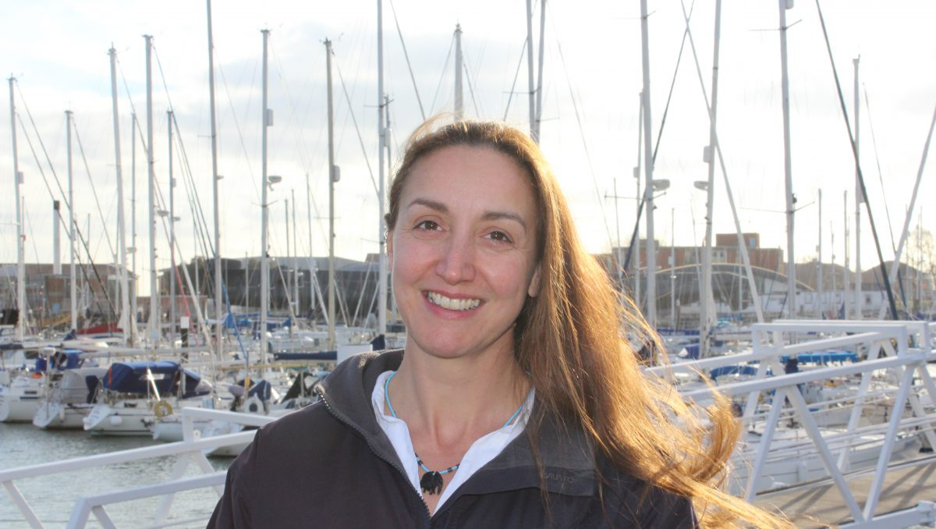
Susannah joins MAA with a wealth of industry experience from across multiple sectors including, manufacturing, marina management, charter and membership sailing. She is also a keen sailor and scuba diver, having previously owned and operated her own PADI dive centre.

“I am really looking forward to getting to know our clients, understanding their needs and bringing to life their online promotional activities across the different digital platforms,” she said.

Mike Shepherd, MAA director added: “We are delighted that Susannah has joined MAA. She comes with a genuine passion for all things marine and experience in both B2B and B2C marketing which will be invaluable for developing the services we offer and further establishing us as the go to agency for the marine industry.”

MAA assists companies with the full spectrum of marketing services. The agency was set up by Mike Shepherd in 2009. Since then it has experienced consistently strong growth and this expansion of the skilled team at MAA supports further growth in 2019 and beyond.

ENDS
The Marine Advertising Agency Ltd provides simple, no-nonsense solutions to
marine companies’ advertising, PR, media buying and communications needs. From brand development and marketing materials to website, eCommerce, email campaigns and social media, MAA offers a straightforward, knowledgeable and service-orientated approach. MAA is able to offer unrivalled value to help clients reach their target markets. For more information visit www.maa.agency
Media enquiries:
Emma Stanbury, emma@maa.agency Zella Compton, zella@maa.agency T: 023 9252 2044

