News Release
For immediate release
16th January 2019

Gosport Marine Scene announces date for
Nab Tower Pursuit: 15 June 2019

The Nab Tower Pursuit, Gosport Marine Scene’s annual charity pursuit event for sailing yachts of all different shapes and sizes, will take place on Saturday 15 June, 2019. It’s open to all; full details of the event and conditions of entry are available online at https://gosportmarinescene.com/events/nab-tower-pursuit-2019

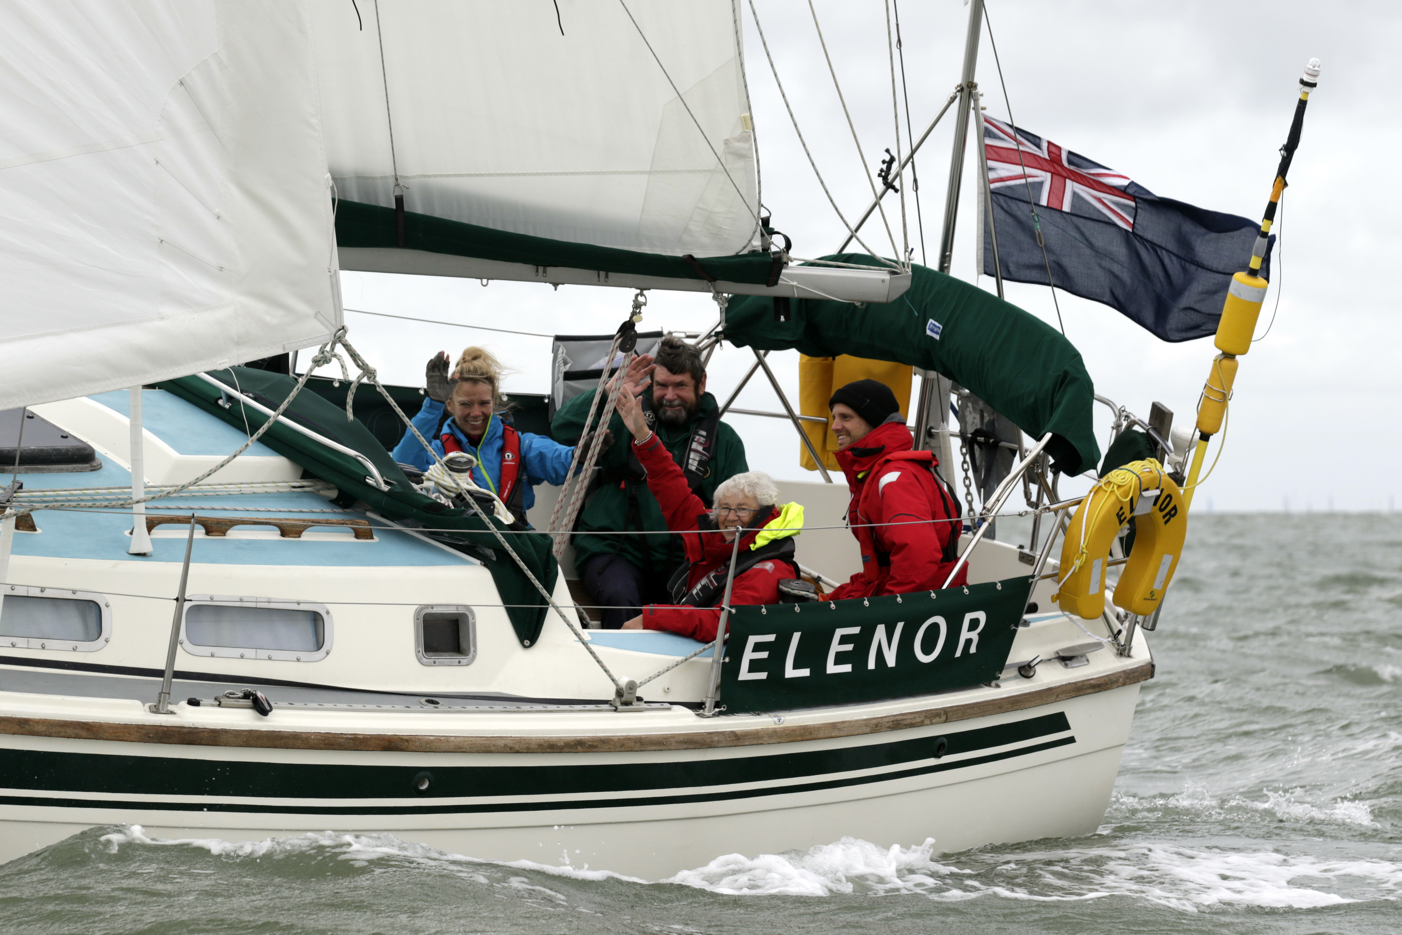
The Nab Tower Pursuit is always a memorable day out on the water. The course takes the fleet out to round the Nab Tower and back to finish around Fort Gilkicker, at the eastern end of Stokes Bay. The event is rounded off with a prize giving and celebratory barbecue hosted at the Hornet Services Sailing Club, Haslar Creek.

Peter Newell, the Pursuit Director comments: “This is the fourth year we have run this event and it gets better each and every year. It provides an opportunity to sail in company with other yachts around the famous Nab Tower whilst raising money for charity. The prize giving and party in the evening rounds off the day in a fabulous location among fellow sailors. It’s a date not to be missed.”

This charitable event has raised over £18,000 in the past three years. 100% of the entry fee goes directly to funding Marine Futures which aims to fund 10 young Gosport people each year to experience the fun and challenges of sailing 60-foot sail training yacht, SY Discovery. While skippers can choose which charity to raise money for, Gosport Marine Scene encourages support of Marine Futures as it also provides young people a chance to experience the local Gosport marine industry. To date, 18 young Gosport people have benefited from this experience, of which four have now taken up employment in local marine businesses.

More information about the Nab Tower Pursuit is online at www.gosportmarinescene.com (Pursuit), including an entry form.

ENDS

Media enquiries:

For further information and requests for interviews, please contact:
Mike Shepherd
Tel.: 023 9252 2044; or mobile 07786 265 455
Email: mike@maa.agency

GMF MD contact details:
Mark Bowden
Tel: 07802 650623
Email: mark@gosportmarinescene.com
Notes for Editors

About Gosport Marine Scene and Gosport:
Organiser of Gosport's:
Marine Business Network, Gosport Marine Festival
Talent & Career Programme
Gosport Peninsula is a centre of excellence in ocean racing, sail training, marine tourism and trade.
Gosport is the home of: Alex Thomson Racing & Hugo Boss, Clipper Round the World Race, Global Ocean Race, Sail Training International, ASTO, Ocean Youth Trust South, Lee-on-Solent RYA Onboard, Toe in the Water . . . just for starters

