For immediate release: 12th December 2018
Les Sauveteurs en Mer reveals its bespoke Crewsaver lifejacket at Paris Boat Show 2018
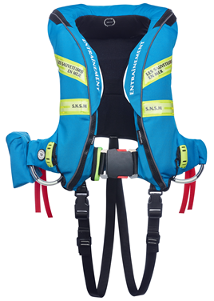
Leading safety solutions provider, Survitec, with its pioneering lifejacket brand, Crewsaver, has reconfirmed its position in the search and rescue (SAR) market by securing a contractual agreement to supply Les Sauveteurs en Mer (SNSM) – the French SAR organisation – with 2,000 bespoke Crewsaver lifejackets.
Crewsaver designers worked closely with SNSM in the design and trial phases to develop the SOLAS approved custom-made ErgoFit 3D Twin Chamber lifejacket. Supplied in two colourways – one for operation and one for training purposes.
The partnership was announced in September and the lifejackets have been officially unveiled by the SNSM at the Paris Boat Show this December (hall 1 stand K15). All visitors to the SNSM stand can try on the lifejackets and have a photo printed in the SNSM photo booth.
In detail, these lifejackets are equipped with a high specification twin-chamber bladder design and ergonomic cover which moulds to the shape of the wearer providing comfort and increased freedom of movement. The lifejacket bladder provides exceptional in-water turning speeds, increased mouth freeboard and an integrated, inflatable chin support.
A newly designed halo hood system has been tailored to the shape of the inflated bladder to significantly reduce the amount of water that can reach the wearer’s airway in an in-water situation. This improved bladder and spray hood compatibility is combined with a new double-halo hood construction. The result is a fully self-supporting hood, which once deployed, forms a spacious chamber above the face. The hood also includes an internal barrier to provide further protection against any water ingress, whilst doubling up as an anti-glare panel to shield the wearer’s eyes from the flashing lifejacket light.
In addition, the SNSM lifejacket incorporates a new buckle system. With its slimline design, the quick lock buckle makes the lifejacket easy to don and accommodates the use of a single loop harness attachment point for ease of tethering.
Further features include AIS and PLB attachment points, safety knife pocket, built-in Crewsaver surface lifejacket light and buddy line - providing the necessary tools to assist the SNSM rescue efforts in even the most demanding of environments.
Survitec’s in-country partner, Navicom, introduced Survitec to SNSM and was instrumental in securing the partnership which will see the lifejackets distributed to more than 175 SNSM stations in France and French overseas regions.
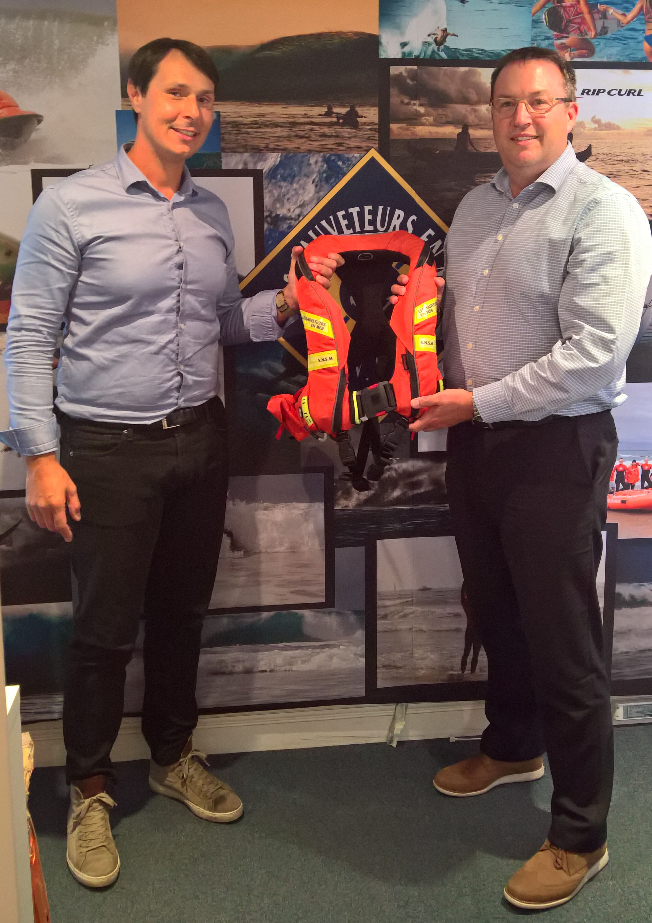
Benjamin Serfati, Purchasing Director at Les Sauveteurs en Mer (SNSM), said: “We had only one concern throughout this project, the SAFETY and COMFORT of our rescuers, this project was made possible thanks to our sponsor TOTAL without whom we would not have been able to carry out this project and Crewsaver who knew how to meet our expectations.”
David Duffin, Survitec Sales Director, said: “We’re excited to be working in partnership with SNSM. It is a highly respected search and rescue organisation and the contract represents a real stamp of approval for our business. It is a great endorsement of our equipment that an international body such as the SNSM, which requires the very best for their rescue volunteers would seek us out. Our existing relationships with a number of different nation’s search and rescue institutions was an undoubted part of our appeal ahead of this partnership and bears testament to the strength and depth of the Survitec service network. We have been working closely with SNSM to ensure the final product is fit for its needs.”
Having successfully supplied the UK’s Royal National Lifeboat Institute (RNLI) with equipment for more than two decades, and a similar long-standing relationship with the Dutch KNRM (The Royal Netherlands Sea Rescue Institution), Survitec’s proven success in this sector has helped it land a significant contract with the French organisation. For search and rescue teams, having the right personal protection significantly enhances chances of their survival – and the people they rescue.
From search and rescue organisations to you
Inspired by product developments with SNSM, Crewsaver has launched its new leisure lifejacket, the ErgoFit+. Featuring the halo hood system and quick lock buckle, this lifejacket will be available for purchase from April 2019. For more information about the ErgoFit+, visit www.Crewsaver.com.

//ENDS//

For media information, hi-res images or product tests please contact:

Crewsaver
Hazel Proudlock, Marketing Dept
T +44 (0) 1329 820406
E hazel.proudlock@survitecgroup.com

Zella Compton – MAA (www.maa.agency)
T +44 (0) 23 9252 2044
E zella@maa.agency

Notes to Editors
Crewsaver is a world-leading manufacturer of marine safety equipment and clothing for the commercial and leisure marine industries. Based in Gosport, Hampshire, the company designs and manufactures bespoke safety equipment for several countries’ Special Forces, and the aviation and oil industries. Crewsaver is the only company to hold an exclusive contract to supply lifejackets to the UK government’s Environment Agency and the Royal National Lifeboat Institution (RNLI). They are part of the Survitec Group. www.crewsaver.com

Survitec Group Survitec is a global leader in survival and safety solutions to the marine, defence, aviation and offshore markets. Survitec has over 3,000 employees worldwide covering 8 manufacturing facilities, 15 offshore support centres and over 70 owned service stations. It is further supported by a network of over 500 3rd party service stations and distributors. Across its 160-year history, Survitec Group has remained at the forefront of innovation, design and application engineering and is the trusted name when it comes to critical safety and survival solutions. www.survitecgroup.com

