News Release

For immediate release
17 December 2018

MDL Marinas raises £3,000 for charity

MDL Marinas has raised £3,000 to be divided between two great charities, Blue Marine Foundation, and Ocean Youth Trust South.

The money was raised at TheYachtMarket.com Southampton Boat Show 2018, where MDL members and guests bought tickets for a daily raffle and donated money for refreshments during a daily charity hour at the company’s waterfront stand.

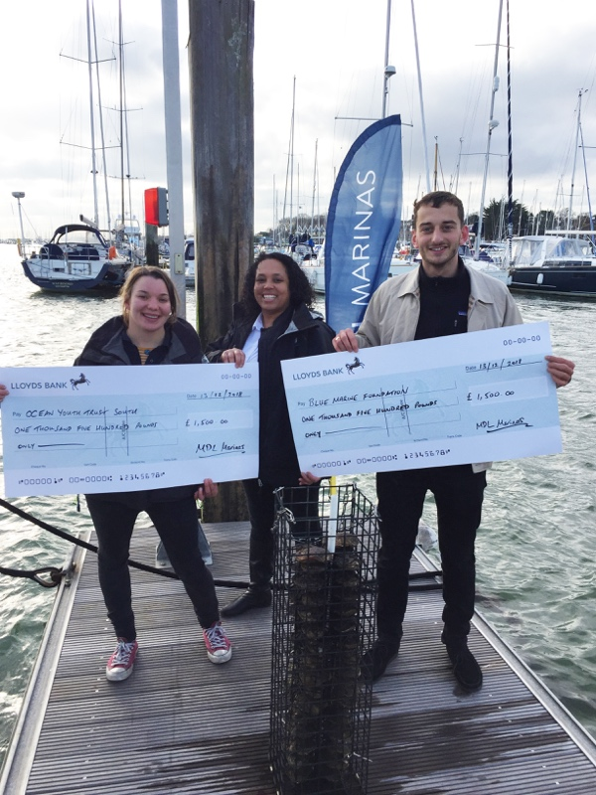
MDL’s raffle featured prizes such as a Crewfit 180N Pro lifejacket from Crewsaver and a spa package courtesy of Towergate Insurance, as well as many other terrific prizes from other sponsors such as Mistral Hayling Ltd., Clean to Gleam, Salcombe Gin, West System International, Hamble Point Yacht Charters, and Musto.

Additionally, the following companies made a donation to be featured on the charity supporters wall: Hamble Point Yacht Charters, Inland & Coastal Marina Systems Ltd., Marine Advertising Agency, Mistral Hayling Ltd, Musto, OneSails GBR (South), Plymouth Sea Chest Ltd., and Ski Weekends.

Pictured is Maxine Lane, Senior Marketing Manager at MDL Marinas, presenting cheques to Jacob Kean Hammerson from Blue Marine Foundation and Peta Koczy (Staff Skipper)
from Ocean Youth Trust (South) at Port Hamble Marina.

The Blue Marine Foundation (BLUE) works to provide innovative solutions to overfishing and enabling the creation of marine reserves. MDL has supported BLUE for three years, during which time BLUE has initiated a conservation project to replenish the Solent’s oyster population. Currently there are 105 Oyster cages in MDL Marinas.

Tim Glover, BLUE’s UK Projects Director says: “MDL Marinas has made a huge contribution to BLUE’s Solent Oyster Restoration Project by funding its original research study and then going on to design, build and install innovative cage systems beneath its pontoons in seven Solent marinas. Thanks to MDL’s enthusiastic support, the project has been able to house more than 20,000 breeding oysters in these cages which are capable of producing billions of oyster larvae a year to significantly help the re-population process. This kind of commitment from a Solent marine enterprise is invaluable to the project’s success.”

Mark Todd, Chief Executive of Ocean Youth Trust South says: “MDL is one of Ocean Youth Trust South’s most valued supporters and we are so grateful for all that they do for us. Not only do they provide a home for our vessel Prolific, but they do a tremendous amount to give disadvantaged and vulnerable young people the chance to experience sailing and to benefit from the skills learned on a voyage, from confidence and communication to resilience and teamworking. The money that MDL has raised will ensure that more places can be offered to young people who would never otherwise have the chance to take part in anything like this. Earlier this year, we were contacted by a 14-year old whose first voyage with us was supported by MDL, to say: ‘The knowledge and skills that I gain each time I sail will stay with me for life. My confidence grows with each voyage and so does my leadership and teaching skills. There is nothing quite like sailing on the Prolific.” MDL’s support for Ocean Youth Trust South really does change young lives for good, and on behalf of all the young people who benefit, we can’t thank them enough.”

“We are delighted with the amount of money we have raised for our chosen charities,” says Adrien Burnand, MDL’s Head of Marketing. “We’ve been supporting both for a long time and continue to be impressed with their dedication and the difference that they are making in their respective areas. Our members and partners have been brilliant, getting behind all the activities at this year’s boat show, and we will continue to raise money for these two fantastic charities throughout the year.”

For more information on MDL’s association with both charities, visit https://www.mdlmarinas.co.uk

ENDS

Notes for editors:

MDL Marinas
• MDL Marinas is Europe’s largest marina group, offering members over 120 destinations to cruise to in the UK, France, Italy and Spain through Freedom Berthing. Currently MDL Marinas manage 18 UK marinas, 1 in Italy and 1 in Spain.
• MDL Marinas is proud to be landlords to over 500 marine business companies, with nearly 260 staff delivering the unique MDL experience to all members, guests and commercial partners.
• The company also advises on worldwide marina developments including Europe, China and Crimea.
• For more information visit www.mdlmarinas.co.uk

The Marine Advertising Agency Ltd
• MAA provides simple, no-nonsense solutions to marine companies’ advertising, PR, media buying and communications needs.
• From brand development and marketing materials to website, eCommerce, email campaigns and social media, MAA offers a straightforward, knowledgeable and service-orientated approach.
• MAA is able to offer unrivalled value to help clients reach their target markets.
• For more information visit www.maa.agency

For media enquiries, more information, product tests:

Marine Advertising Agency
Zella Compton or Mike Shepherd
Email: zella@maa.agency Email: mike@maa.agency
Tel: +44 (0) 23 9252 2044 Tel: Tel: +44 (0) 23 9252 2044

