News Release

For immediate release
4th December 2018

Major international award for Ocean Youth Trust South skipper: Peta Koczy

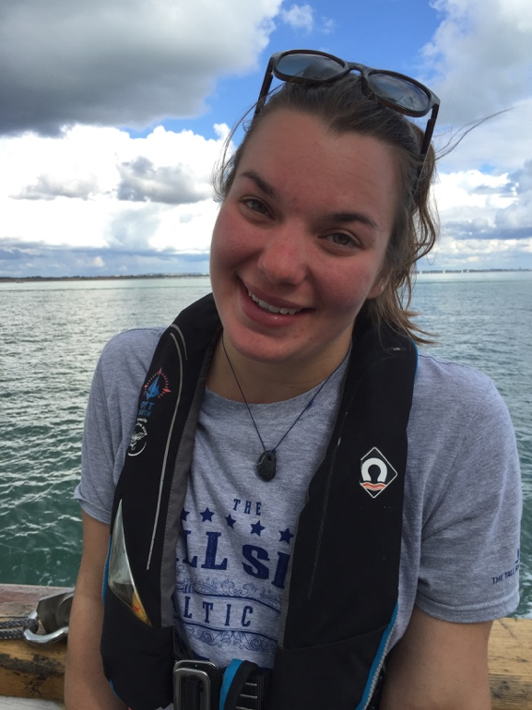
Ocean Youth Trust South’s Staff Skipper, Peta Koczy, has been awarded the title of Young Sail Trainer of the Year 2018 by Sail Training International.

This is a worldwide award for a young professional sail trainer under the age of 25, to encourage and recognise high-performing individuals who deliver sail training to young people at sea.

Peta was appointed Staff Skipper of Ocean Youth Trust South’s 32-metre vessel Prolific a year ago, at the age of just 23.

The award was announced in early December at the Sail Training International conference in Seville.

Peta Koczy said: “I feel incredibly honoured to have won this award. Prolific is a fantastic boat and it is such a privilege to be able to skipper her and to work with an incredible team of staff and volunteers at Ocean Youth Trust South. But the most important thing is always the young people who come on our voyages.

“Only a few years ago I was a 15-year old heading off for my first voyage, just like the thousands of young people who try sail training every year. Not all of them want to go into sailing as a career but what I always hope is that the experience will give them the confidence and skills to go forward in life. Sail training has given me some amazing opportunities and the best thing about being a skipper is being able to offer the same chance for other young people to change their lives.”
Continues . . .

Mark Todd, Chief Executive of Ocean Youth Trust South, said: “We appointed Peta because we knew she was one of the outstanding sail trainers of her generation, and she has proved that by skippering Prolific through the 2018 sailing season with immense skill. Our staff, volunteers, clients, young people and other supporters cannot speak highly enough of her ability to combine a common-sense, practical approach with a warmth of personality which makes everyone feel welcome and valued on board. We couldn’t be prouder of the fact that she has now been recognised as the best under-25 sail trainer in the world.”

Peta is currently working hard to refit Prolific over the winter ready for a busy sailing season in 2019. There are still places available on-board next year for young people aged 11-25 – see www.oytsouth.org/charity.asp for more details.

ENDS

More on Ocean Youth Trust South:
www.oytsouth.org/charity.asp

For more information, contact Caroline White:
caroline.white@oytsouth.org
07986 354697

