October 1, 2018
Gemma Davies
EMEA Marketing Manager
gemma.davies@navico.com

Simrad Active Imaging Elevates GO Series With Superior Scanning Sonar quality

Egersund, Norway – Announcing Simrad Active Imaging™ Sonar — advanced new scanning-sonar technology that provides incredibly detailed, high-resolution imaging without sacrificing range. Replacing Simrad TotalScan™ transducers currently available with GO series displays, Active Imaging redefines what an angler can expect from sonar.

Active Imaging Sonar provides incredibly clear views of fish-holding structure and cover with all-new levels of refined detail at a range unmatched by any other structure imaging technology. Available in two models — 3-in-1 and standalone — Simrad Active Imaging 3-in-1 combines scanning sonar with a traditional medium/high CHIRP sonar element for easy single-transducer installation, while the standalone transducer is designed for install alongside a separate CHIRP sonar transducer.

“Other high-frequency sonar imaging solutions provide an enhanced view of structure below and to the sides of the boat, but the scanning range is significantly limited,” said Leif Ottosson, CEO, Navico Group. “Our Active Imaging provides the industry’s highest-quality images while still delivering views of up to 300 feet to the left and right of a boat — offering unparalleled information with one powerful scan. We also designed it as a seamless transition for our GO Series of displays, making it simple for our current customers to take advantage of. We’re excited about the elevated experience that Active Imaging will bring to anglers on the water — helping them find more fish.”

There is no compromise on high-resolution detail whether anglers are operating at 800kHz or 455kHz frequencies. Active Imaging provides clear and precise views of structure, fish and bottom composition at distances up to 300 feet from either side of a boat. Incredibly easy to use, there is no need to change frequencies while fishing — anglers can see where they should be fishing instead of just the immediate area around the boat at a set frequency.

The Simrad Active Imaging 3-in-1 transducer will be bundled with our best selling Simrad GO series displays, beginning October 2018. Both Active Imaging standalone and Active Imaging 3-in-1 transducers can be purchased separately for £310 and £359.99, respectively. To learn more about Simrad Active Imaging or the entire line of high performance Simrad marine electronics, please visit www.simrad-yachting.com.

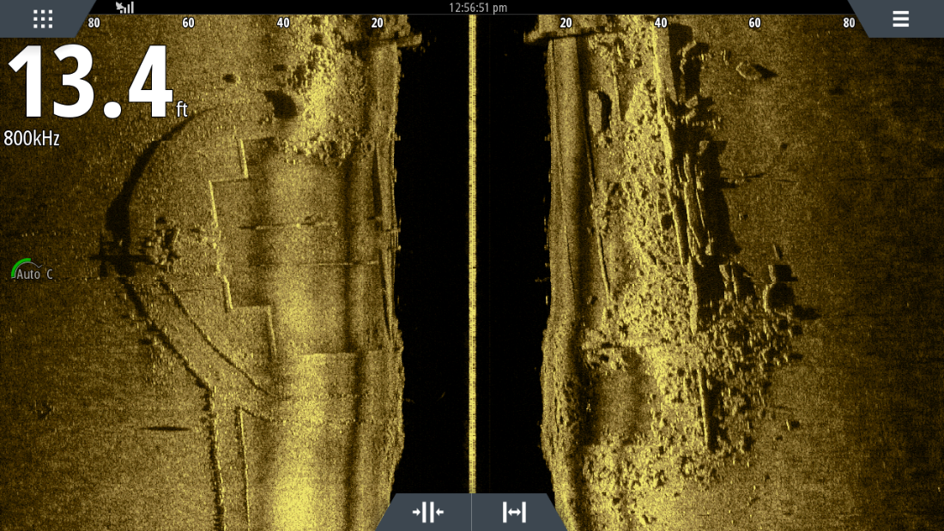
Simrad Active Imaging Sonar

For imagery and other editorial requests, please contact: Gemma Davies
gemma.davies@navico.com

About Navico: A privately held, international corporation, Navico is currently the world’s largest marine electronics company, and is the parent company to leading marine electronics brands: Lowrance, Simrad Yachting and B&G. Navico has approximately 1,500 employees globally and distribution in more than 100 countries worldwide. www.navico.com

