For immediate release: 13.11.2018
NEW ErgoFit+. Discover how the best just got better. Crewsaver takes man overboard protection to the next level at METSTRADE 2018
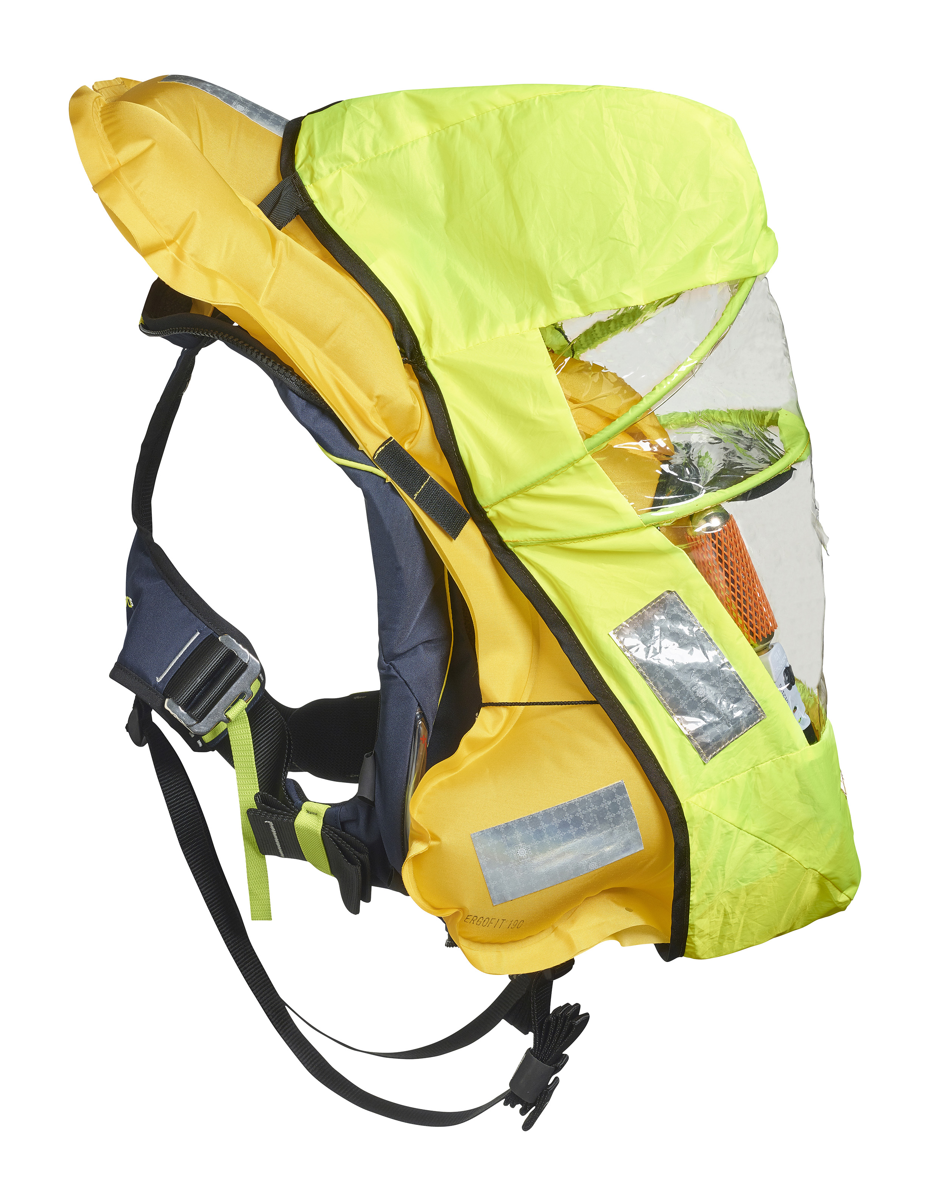
Crewsaver continues to prove its commitment to your safety and survival with the launch of its new ErgoFit+ lifejacket. The ErgoFit+ lifejacket will arrive in March 2019 and is the result of over 60 years of pioneering lifejacket development. Featuring industry-first developments, this lifejacket offers the next level in man overboard protection – equipping you with the very best to ensure your safety is taken care of.
It has long been known that the addition of a spray hood inside a lifejacket can significantly enhance the wearer’s safety. It increases visibility, helps retain heat and protects the airway to reduce the risk of water inhalation.
Enter the ErgoFit+ and its halo hood system. This revolutionary hood system is inspired by product developments for the aviation market as well as the renowned search and rescue (SAR) organisation, Les Sauveteurs en Mer.

The halo hood system has been tailored to the shape of the inflated bladder to significantly reduce the amount of water that can reach your airway. This improved bladder and spray hood compatibility is combined with a new double-halo hood construction. The result is a fully self-supporting hood, which once deployed, forms a spacious chamber above the wearer’s face. The hood also includes an internal barrier protecting you further against any water ingress, whilst doubling up as an anti-glare panel to shield your eyes from the flashing lifejacket light.
“We work closely with organisations across a variety of sectors to constantly drive forward the safety technology used in our products. When we develop a new feature, we are quick to look at where else this feature can be utilised to advance our other product ranges. The journey of the halo hood system from its aviation origin, to adapting for SNSM’s bespoke lifejacket and now our new ErgoFit+ is a perfect example of this.” – Crewsaver’s head of design, Nigel Parkes
The renowned ErgoFit bladder is, as always, a step above the rest. With its sculpted shape, the bladder distributes buoyancy uniquely around the wearer to maximise in-water support and airway protection. Even when wearing heavy clothing, the ErgoFit is designed to rotate the wearer quickly whilst increasing the distance between the waterline and airway (mouth freeboard). The sculpted shaping around the shoulders provides improved in-water mobility and with it the ability for the wearer to self-help recovery back to safety.
In addition, the ErgoFit+ incorporates a new buckle system. With its slimline design, the quick lock buckle makes the lifejacket easy to don and accommodates the use of a single loop harness attachment point for ease of tethering.
A technological collaboration between Crewsaver innovations and that of its new partner, Exposure, is evident in the ErgoFit+. The Exposure OLAS Tag, a portable crew tracking and overboard location alert system that can be easily integrated into this lifejacket.

//ENDS//

For media information, hi-res images or product tests please contact:

Crewsaver
Hazel Proudlock, Marketing Dept
T +44 (0) 1329 820406
E hazel.proudlock@survitecgroup.com

Zella Compton – Marine Advertising Agency Ltd
T +44 (0) 23 9252 2044
E zella@maa.agency

Notes to Editors
Crewsaver is a world-leading manufacturer of marine safety equipment and clothing for the commercial and leisure marine industries. Based in Gosport, Hampshire, the company designs and manufactures bespoke safety equipment for several countries’ Special Forces, and the aviation and oil industries. Crewsaver is the only company to hold an exclusive contract to supply lifejackets to the UK government’s Environment Agency and the Royal National Lifeboat Institution (RNLI). They are part of the Survitec Group. www.crewsaver.com

Survitec Group Survitec is a global leader in survival and safety solutions to the marine, defence, aviation and offshore markets. Survitec has over 3,000 employees worldwide covering 8 manufacturing facilities, 15 offshore support centres and over 70 owned service stations. It is further supported by a network of over 500 3rd party service stations and distributors. Across its 160-year history, Survitec Group has remained at the forefront of innovation, design and application engineering and is the trusted name when it comes to critical safety and survival solutions. www.survitecgroup.com

