For immediate release: 13.11.2018
Crewsaver secures partnership with Exposure Lights and Exposure OLAS
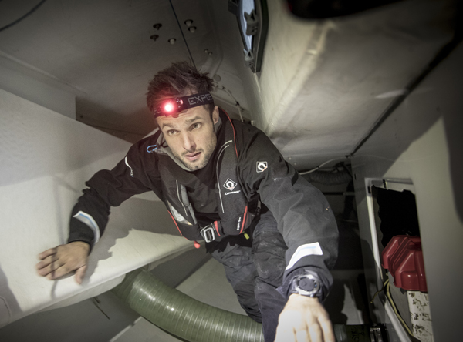
Crewsaver, a world-leading designer and manufacturer of marine safety equipment, secures partnership with Exposure Lights and Exposure OLAS. The agreement sees Crewsaver become the sole marine distributor for the UK and Ireland for the marine and dive light ranges and Overboard Location Alert Systems (OLAS).

Designed for high performance, Exposure Lights combine the latest advantages of LED technology with powerful Lithium-ion rechargeable batteries, creating very lightweight, highly compact torches with unrivalled power, functionality and versatility for their size. This includes the ability to combine high power search light options (visible up to 3 nautical miles), with red beam, and a variety of safety features in very small, lightweight and buoyant casing.

Exposure Lights are much more than just torches, they combine high powered LED search capabilities with its patented MOB technology and precision engineering to create floating, water activated strobes. This allows you to not only use the light to search but also as a position indicating light when in the water.

In addition, a technological collaboration between Crewsaver innovations and that of Exposure, is evident in Crewsaver’s new ErgoFit+ lifejacket, arriving March 2019. The Exposure OLAS Tag, a portable crew tracking and overboard location alert system, can be easily integrated into this lifejacket - taking man overboard protection to the next level.

Tom Harrop, brand manager for Exposure Lights comments, “We are delighted to be teaming up with Crewsaver, with their reputation for top quality safety products. Both our companies constantly strive to improve safety and survival afloat. Working together, both in terms of servicing the retailers and product innovation, ensures this benefits the sailing and paddling consumer.”

Crewsaver’s commercial director, Matt Bridge adds, “Exposure Lights technologies have rapidly made significant changes in both marine safety lighting and on-water tracking. The power of their tiny, cordless, rechargeable lights, as well as the OLAS system, makes a great additional range for us to promote to retailers and integrate into our Crewsaver product lines.”

With the addition of the Exposure products to its existing offering of unique lifejackets, liferafts and safety equipment, Crewsaver has created the most comprehensive safety range available. So, you can rest assured - when it comes to the worst, that you have the best.

//ENDS//

For media information, hi-res images or product tests please contact:

Crewsaver
Hazel Proudlock, Marketing Dept
T +44 (0) 1329 820406
E hazel.proudlock@survitecgroup.com

Zella Compton – Marine Advertising Agency Ltd
T +44 (0) 23 9252 2044
E zella@maa.agency

Notes to Editors
Crewsaver is a world-leading manufacturer of marine safety equipment and clothing for the commercial and leisure marine industries. Based in Gosport, Hampshire, the company designs and manufactures bespoke safety equipment for several countries’ Special Forces, and the aviation and oil industries. Crewsaver is the only company to hold an exclusive contract to supply lifejackets to the UK government’s Environment Agency and the Royal National Lifeboat Institution (RNLI). They are part of the Survitec Group. www.crewsaver.com

Survitec Group Survitec is a global leader in survival and safety solutions to the marine, defence, aviation and offshore markets. Survitec has over 3,000 employees worldwide covering 8 manufacturing facilities, 15 offshore support centres and over 70 owned service stations. It is further supported by a network of over 500 3rd party service stations and distributors. Across its 160-year history, Survitec Group has remained at the forefront of innovation, design and application engineering and is the trusted name when it comes to critical safety and survival solutions. www.survitecgroup.com

