NEWS RELEASE

13 Nov 2018

MAA PRESS DINNER CRUISES TO SUCCESS

The second annual MAA METSTRADE press dinner took place onboard Wapen van Amsterdam. The lively, by invitation only, event was attended by 35 European and American journalists and key business leaders from the marine trade world.
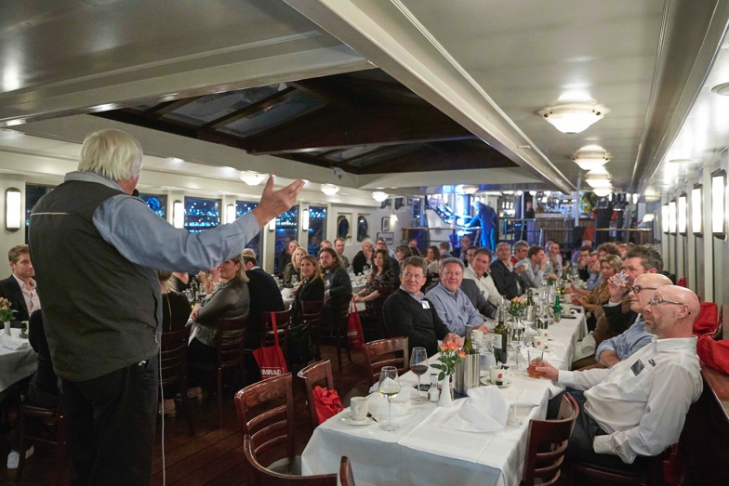
Not only are the annual MAA press events well-known as an unparalleled networking opportunity, the curated discussion of industry developments and challenges always proves a dynamic starting point for debate.

This year’s host, Tom Cunliffe (author, sailor and raconteur), regaled the audience with a few choice stories (what happens at sea stays at sea) before opening up the evening’s question and answer sessions.

Highlights included a lively Q&A session with Leif Ottosson, the chief executive officer of Navico, in which he discussed the future developments of marine electronics and spoke eloquently of Navico’s information display system which simplifies monitoring and control of onboard systems.

“We are moving ever closer to complete connectivity on board, everything will link to one display; navigation, engine, power management and even the bilge pump can be monitored from one screen. Like your car you’ll be able to jump in and go whenever and wherever you please, with ease,” Leif predicts.

Matthew Laster (Lowrance) also took to the podium and intrigued guests with his expert knowledge of HDS LIVE which delivers powerful, real time sonar for fish finding and chart plotters.

On top of the water, the Q&A continued with Matt Bridge, commercial director of Crewsaver, who’s new Ergofit+ lifejacket is sure to prove popular and is officially launched at METS.

Similarly with safety in mind, Ben Metcalfe from Landau (UK Chief executive) talked guests through the thinking and practicalities behind Lifecord and why it was nominated for a DAME award.

“The press dinner proved an enormous success,” says Mike Shepherd, MAA director. “In particular I’d like to thank our title sponsor NAVICO, as well as Landau and Crewsaver who make events like the METSTRADE press dinner possible. I hope that everyone enjoys the exhibition and makes the most of their time at this amazing event.”

MAA was set up by Mike Shepherd in 2009, since then the company has experienced consistently strong growth. MAA was awarded Best Marine Company to Work For at the 2016 British Marine awards and is now firmly established as one of the foremost agencies in the marine industry.

MAA helps companies with everything from media planning and buying, PR and social media to brand development, eCommerce and website design and development.
For more information visit www.marineadagency.com

For further information please contact Mike@maa.agency.

ENDS

The Marine Advertising Agency Ltd provides simple, no-nonsense solutions to
marine companies’ advertising, PR, media buying and communications needs. From brand development and marketing materials to website, eCommerce, email campaigns and social media, MAA offers a straightforward, knowledgeable and service-orientated approach. MAA is able to offer unrivalled value to help clients reach their target markets.
For more information visit www.maa.agency
Media enquiries:
Emma Stanbury, emma@maa.agency Zella Compton, zella@maa.agency T: 023 9252 2044

