News Release

For immediate release
5 November 2018

A –‘HEAD’ of the game
Blakes’ classic toilets now come in any colour
(Find Blakes at METS Trade Stand 01.475)

Renowned worldwide for their reliable systems, quality build and comfort, Blakes’ toilets made by Sea Sure now come in any colour. They can also have words – or even logos – engraved in the porcelain bowl. Additionally, Sea Sure (Blakes’ parent company since 2007) has added an optional electric push-button flush to the range.

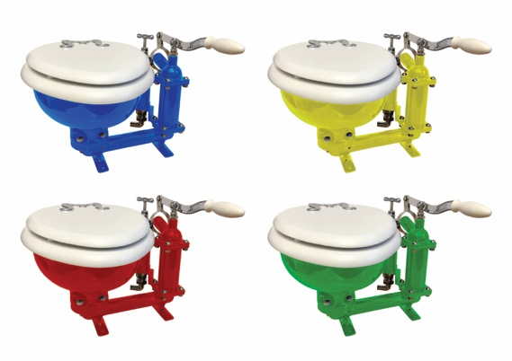
The toilets, which were first designed in the late Victorian era for classic racing yachts, have featured various colours in their long and well-respected past although most were made in white. But now Blakes’ bowls can be made in any single colour imaginable.

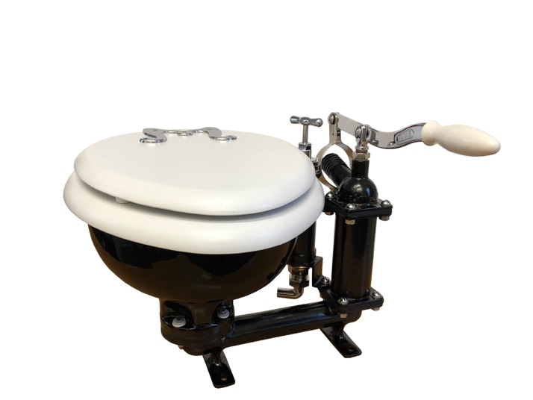
“Traditionally porcelain was not white,” says Graham Brown, managing director. “Pastels were the fashion for a long time during the 1960/70s and then white became the high-end look. That’s changing again. Colour is coming back into designer bathrooms onshore, and we’re bringing it back to Blakes. We’re delighted with the results.”

Not only does Sea Sure make the Baby Blake Classic Marine and Blakes’ Victory Classic Marine Toilet, the company also renovates the Blakes’ toilets at its long-established factory in Warsash, Hampshire. Renovation takes as little as two weeks and includes dissembling the toilet, stripping and re-polishing all of the original castings, as well as re-powder coating and re-chroming all of the parts. Plus, all perishable seals and gaskets are replaced ready for another 80 years of service.

Sea Sure is exhibiting Blakes at METS Trade at Stand 01.475, and welcomes all visitors to the Belship Boulevard.
continues. . . .

Blakes Classic Marine Toilets
Well-known and respected by yachtsmen and women the world over, Blakes are hand-built using the finest, marine grade materials to withstand the rigors of the marine environment.

Both the Baby Blake and Victory Classic feature pumps on the right with a rigid handle on the discharge pump and 1.5 inch hose connection on discharge outlet. Castings are manufactured in bronze for maximum corrosion resistance, and both feature separate pumping systems to ensure that clean and waste water are never mixed, and are suitable for use with a holding tank. They can be safely fitted above or below the waterline and come with options to upgrade the seat material to mahogany and/or configure toilet to a left-handed pump. And, they come in a spectrum of colours to suit every yacht’s needs.

Perishable spares kits are available.

More information on Blakes is available via sea-sure.co.uk. Or visit Stand 01.475 at METS Trade to discuss your requirements.

ENDS

Notes for editors

- BLAKES is part of the Sea Sure group.
- Sea Sure has been creating innovative engineering solutions since 1956.
- Sea Sure is the exclusive UK dealer for SKYDEX.
- Sea Sure incorporates SHOCK-WBV, Lavac and Taylors Heater and Cookers.
- For more information about Sea Sure and / or BLAKES, visit https://www.sea-sure.co.uk

For media enquiries, more information, or hi-res images:

Marine Advertising Agency

Zella Compton or Mike Shepherd
Email: zella@maa.agency Email: mike@maa.agency
Tel: +44 (0) 23 9252 2044 Tel: +44 (0) 23 9252 2044

