News Release
For immediate release
5th November 2018

Ancasta opens Portland and Poole office to service central south west

Ancasta, the leading international boat sales company, has opened a new office in Portland and Poole. Providing a 24/7 brokerage service, the office run by Kevin MacDonald, offers the high service, quality of care and wide choice as traditionally delivered by Ancasta whether that’s buying a new, or previously loved sail or power boat. Kevin can be contacted on: Mob: +44 (0) 07587 038437 or via email: kevinmacdonald@ancasta.com.

Ancasta’s new office is virtual which means that Kevin works across the twelve marinas in the area from Christchurch to Bridport with The Royal Motor Yacht Club, Poole Town Quay Marin, and Portland Marina in between.

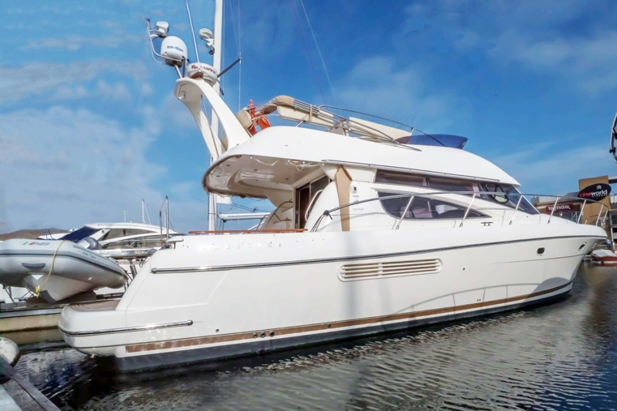
For sellers, all boats are listed via Ancasta’s extensive network of marketing including websites, magazines and other offices, like the Prestige 46 pictured (Ancasta ref: 33352).

And for buyers? Kevin offers door to door travel arrangements to view potential boats. Plus, like all Ancasta brokers, he can offer advice and research help if you’re at the start of the buying or selling process and when further along can arrange the full complement of services from finding storage and berths, to guiding you through taxing paperwork. Kevin’s extensive travels also means that he can recommend professional help when needed, such as marine mechanics or electricians.

“Ancasta wanted to consolidate its presence,” explains Kevin who moved from Plymouth to Poole in summer 2018 to take up the role, “and offer buyers and sellers from Hampshire, Dorset and Somerset the expert hands-on service which they receive from other Ancasta offices, but based in this beautiful part of the world.
continues . . .
“Plus, we’re actively involved in putting shared-ownership deals together for racers, yachts and cruisers. So whatever your needs, or whatever you’re thinking about, we can help you make the best decisions whether it’s for buying a new boat, or upgrading your old one.”

Well experienced, Kevin’s been with Ancasta for five years and a broker for eleven with a keen interest in power, especially Beneteau. His current listings include a Beneteau Swift Trawler 44 Ancasta ref number (33353), and a Prestige 46 Ancasta ref number (33352).

To view Ancasta’s full listings, visit Ancasta.com, or to contact Kevin call Mob: +44 (0) 07587 038437 or email: kevinmacdonald@ancasta.com

Ends

Notes to editors

About Ancasta International Boat Sales
- Ancasta International Boat Sales has 17 offices across Europe.
- Ancasta is the largest Beneteau Power and Sail dealer in the UK.
- Ancasta is the largest UK dealer for Prestige Luxury Motor Yachts dealer and Prestige Yachts in the Balearics.
- Ancasta is exclusive UK dealer for Lagoon Catamarans.
- In addition Ancasta is a new boat dealer for CNB Yacht Builders and McConaghy Yachts.
- The Ancasta Group incorporates Hamble Yacht Services Refit & Repair and Advanced Rigging and Hydraulics, both operating from Port Hamble.
- For more information on Ancasta visit www.ancasta.com

Media enquiries via Marine Advertising Agency:
Zella Compton - zella@maa.agency, tel: 023 9252 2044

For high res images visit Marine Advertising Agency’s media centre.

