Wessex Resins and Adhesives Ltd now producing high-performance, bio-based ENTROPY RESINS®

News release, 12 November 2018

Wessex Resins is delighted to announce it is now manufacturing ENTROPY RESINS, under license from Gougeon Brothers, Inc., for the European, Middle Eastern, African, Turkish, and Indian markets. ENTROPY RESINS is a range of high-performance, bio-based epoxy formulations. These products can help reduce the carbon footprint of companies manufacturing finished composite parts.
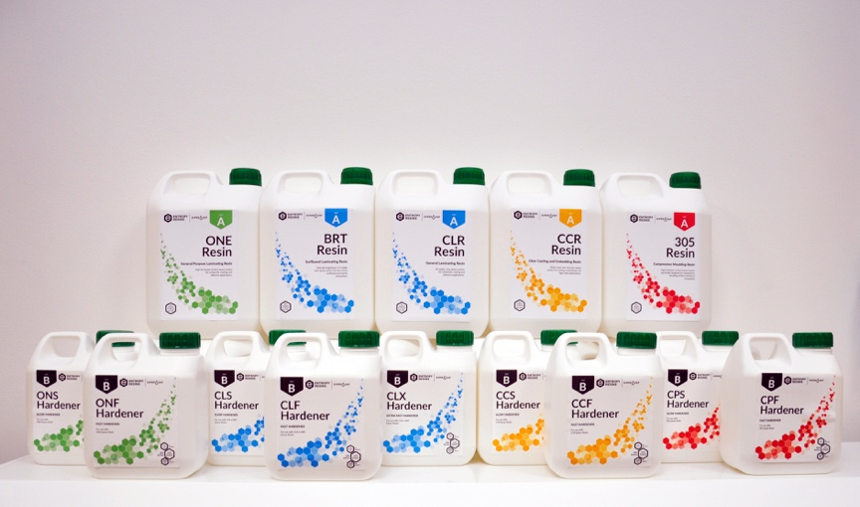
ENTROPY RESINS are largely plant-based formulations, utilising SUPER SAP® technology. They are used extensively in the production of snowboards, surfboards, paddle boards, sailboards, skateboards, kiteboards, ice hockey sticks, and other kinds of sporting equipment.
Long-term sustainability is at the forefront of ENTROPY RESINS developments.
Wessex will produce ENTROPY RESINS at their factory in Romsey, Hampshire and market, distribute, and support the products through an extensive network of established distributors.
As a best-in-class bio-based epoxy product, there are six standard products in the ENTROPY RESINS range:
ONE System is the industry leading high-bio ambient cure laminating epoxy. It features faster cure speeds, low viscosity and includes quick air-releasing properties ideal for fibre-reinforced composite laminations and coatings. The ONE System was formulated for an excellent balance of high performance and bio-based renewable content.
CLR System is the flagship, high-performance clear coating epoxy system. This water clear, UV stabilized epoxy is great for highly coloured products that call for a clear, colourless epoxy with minimal yellowing. The CLR System features a quick air-release and world-class UV resistance.
BRT System is a clear laminating epoxy designed specifically for ultra-white cosmetic applications such as surfboard laminations over EPS (polystyrene) or PU (polyurethane) foam. An optically brightened version of the CLR System, BRT System can be paired with all CLR Clear hardeners. It’s available in extra fast, fast, and slow cure speeds.
continues . . .
CPM System is a versatile epoxy for the compression moulding processes. It delivers high bio-content, excellent fibre wetting qualities. CPM System’s thixotropic characteristics limit sag in high-temperature cure applications. A high modulus combined with excellent elongation properties enable durable yet lightweight composite parts.
CCR System is a clear, UV stabilised epoxy designed for casting, potting, and embedding applications. Low colour and low viscosity allow for bubble free, crystal clear castings. It’s ideal for art and hobby applications. CCR System offers two hardener speeds: slow (CCS) for high-build casting and fast (CCF) for quick, small project, fast-casting applications such as resin jewellery.
305 System is an industrial epoxy system formulated for compression moulding processes. It delivers on the same a high bio-content, excellent fibre wetting qualities, and thixotropic characteristics of CPM System, but with increased temperature resistance for even faster cycle times. A high modulus and excellent elongation properties enable durable, lightweight composites parts.
“This is a fascinating concept and wonderful opportunity for Wessex to be in a market that is only going to get bigger,” says Ian Oliver, Managing Director Wessex Resins. “Everybody wants to do more for the environment. ENTROPY RESINS are bio-based epoxy systems with a meaningful percentage of raw materials from sustainable feedstock sources. Manufacturers and individuals who are serious about the environment can reduce their carbon footprint. It’s an innovative and high-quality, high-performance product. ENTROPY RESINS expands our epoxy offerings along with our established brands, WEST SYSTEM and PRO-SET.
“Wessex Resins and Gougeon Brothers, Inc. take an approach of continual research and development. We’ll be working with our international colleagues to increase the performance and plant-based content of the products over time.”
ENDS

Notes to Editors:
West System International (a division of Wessex Resins and Adhesives) manufactures and provides international support for the world-renowned WEST SYSTEM and PRO-SET marine epoxy brands.
Since Michigan boatbuilding brothers Meade, Joel and Jan Gougeon first experimented with the bonding power of epoxy over 50 years ago, the WEST SYSTEM® and PRO-SET® product ranges have become the epoxies of choice for private boat owners, boat manufacturers, chandlers and naval engineers throughout the world.
West System International (WSI) has been working in partnership with Gougeon Brothers, Inc. for more than 36 years, manufacturing WEST SYSTEM and PRO-SET epoxies here in the UK. WEST SYSTEM and PRO-SET epoxy systems have a long-distinguished history that has earned a unique place at the heart of the worldwide epoxy user community. Whether you need an epoxy for laminating, bonding, coating, tooling or infusion, the combined breadth of WEST SYSTEM and PRO-SET products will provide the solution. Both ranges have passed extensive quality testing and are certified by Lloyd’s Register.
continues . . .

Media enquiries:
Marine Advertising Agency – Zella Compton, zella@maa.agency, 023 9252 2044
West System International – Hamish Cook, Hamish.cook@wessex-resins.com 01794 521 111

