October 1st 2018
Gemma Davies
EMEA Marketing & PR Manager
gemma.davies@navico.com

Lowrance® Goes ‘LIVE’ With New Flagship Fishfinders
Marine Electronics Leader Brings Live Sonar, Live Charting and Live Smartphone Connectivity to Anglers
Tulsa, Okla. – Lowrance®, a world-leader in fishing electronics since 1957 — announced today the release of its new high-performance line of fishfinder/chartplotters, HDS LIVE™. A significant leap forward in fishfinding technology, HDS LIVE delivers powerful real-time sonar, charting and connectivity features including Active Imaging™, LiveSight™, Genesis Live and LiveCast™ smartphone integration.

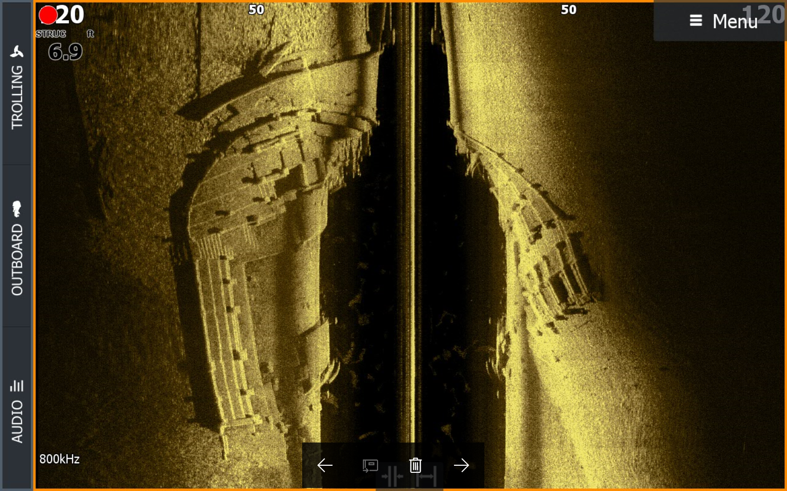
- Active Imaging Sonar
See structure and cover with a new level of refined detail and at a range unmatched by any other structure imaging technology with Active Imaging. Offering industry-leading clarity without sacrificing range, it delivers unmatched image quality of structure, fish and bottom composition. Active Imaging 3-in-1 sonar combines Lowrance CHIRP, with SideScan and DownScan Imaging™ allowing anglers to quickly search fish-holding structure, and enhances FishReveal™ with higher-level clarity and target separation. Active Imaging 2-in-1 sonar includes Side and DownScan Imaging™ and is perfect for use with a separate traditional sonar transducer. Simple to use without the need to change frequencies while fishing in most conditions, Active Imaging 800 kHz provides crystal-clear detail with uncompromised range. For anglers needing to see further than 120 feet, Active Imaging can also operate at 455 kHz. Active Imaging enhancements — including greater resolution, a cleaner 3D view and a new Custom Depth Shading feature — are coming to existing StructureScan® 3D modules in the Fall of 2018 through a free software update.

LiveSight Sonar
Sonar interpretation made simple, Livesight™ sonar delivers the most detailed views of fish, down to every turn and flip of the tail, as they swim in and around cover. You’ll be fishing in real-time as you watch fish react to your lure, see how they are relating to structure and gain insight on what will work, what won’t and what to do next.
Perfect for drop-shotting, vertical-jigging or lure-tracking in front of your boat, LiveSight helps you pinpoint fish locations, so you’ll know whether they are actively feeding. Mount the transducer in a front-facing position to cast toward the fish, or mount it in a down-facing position to do some vertical-jigging below your boat.
When using LiveSight forward in conjunction with the Lowrance Point-1 GPS antenna, an innovative on-chart indicator shows the direction the transducer is pointed, allowing anglers to line up on a waypoint or pinpoint the structure they are trying to fish.

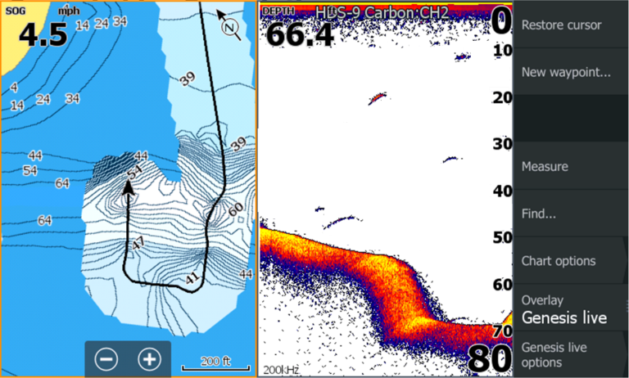
- Genesis Live Charting
Delivering real-time, custom-mapping capabilities, HDS LIVE harnesses the power of Genesis Live charting, which uses digital depth to create depth-contour overlays on charts. Incredibly easy to use, users can control contour transparency, density of contours drawn on the screen up to unprecedented ½-foot intervals, depth and safety shading color palettes, and more. Charts can quickly and easily be saved to an SD card for continuous use.

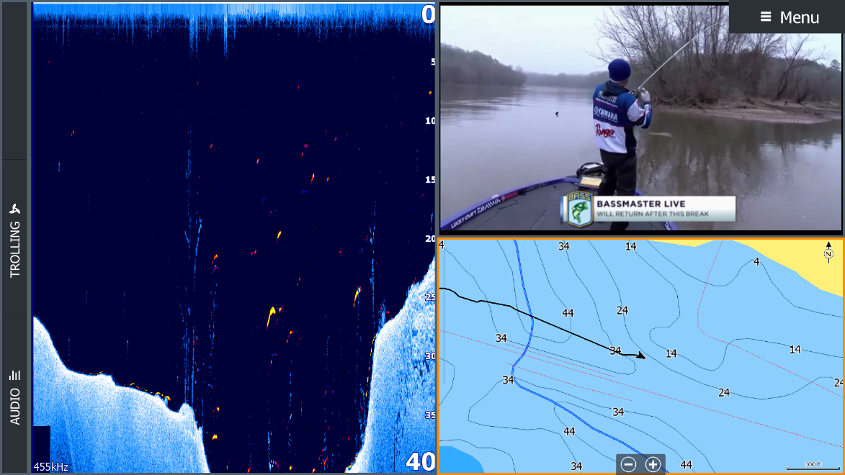
- LiveCast Smartphone Integration
HDS LIVE allows anglers to display important fishing information and entertainment from their smartphones on their 12- and 16-inch sunlight viewable displays. Users can view their smartphone in full-screen or split-screen windows via HDMI connection allowing them to stream video, view Google Maps and fishing data on the HDS LIVE touchscreen — all while their phone is safely stowed.

“After 60 years, Lowrance continues to be the No.1 choice for finding fish,” said Leif Ottosson, CEO and president, Navico. “Today, HDS LIVE takes fishfinding to a whole new level — delivering new sonar, charting and connectivity features that will make the most of your time on the water. Once you experience it, you won’t want to fish without HDS LIVE.”

HDS LIVE features a stunning new low-profile design with edge-to-edge glass; a SolarMAX™ HD screen; bracket, flush and rear mounting options; user-programmable keys; and an optional fully-programmable Bluetooth® remote. Available in 7-, 9-, 12- and 16-inch display sizes, HDS LIVE ranges in price from £1,219.99 to £5,200. Active Imaging can be purchased as a bundle with HDS LIVE or as a separate accessory for £310; the LiveSight transducer is priced at £2249.99.

For more information about the all-new, high-performance Lowrance HDS LIVE, the complete line of Lowrance marine electronics, or to locate an authorized Lowrance dealer, please visit www.lowrance.com.

-30-

For imagery and other editorial requests, please contact:
Gemma Davies – gemma.davies@navico.com

About Lowrance: The Lowrance® brand is wholly owned by Navico, Inc. A privately held, international corporation, Navico is currently the world’s largest marine electronics company, and is the parent company to leading marine electronics brands: Lowrance, Simrad Yachting, B&G and C-MAP. Navico has approximately 1,500 employees globally and distribution in more than 100 countries worldwide. www.navico.com

