Gemma Davies
EMEA Marketing & PR Manager
gemma.davies@navico.com

October 1st 2018

Lowrance® Unveils New Elite Ti² Series
Marine Electronics Leader Introduces Next Generation Displays with Advanced Sonar and Wireless Networking
Tulsa, Okla. – Lowrance®, a world-leader in fishing electronics since 1957 — announced today the next-generation release of its powerful, yet affordable fishfinder/chartplotter family, Elite Ti². Delivering enhanced high-resolution sonar functionality, wireless networking and Bluetooth® call/text message display, the Elite Ti² gives anglers access to features previously reserved for Lowrance’s premium HDS family of displays. Here’s what’s new with Elite Ti²…
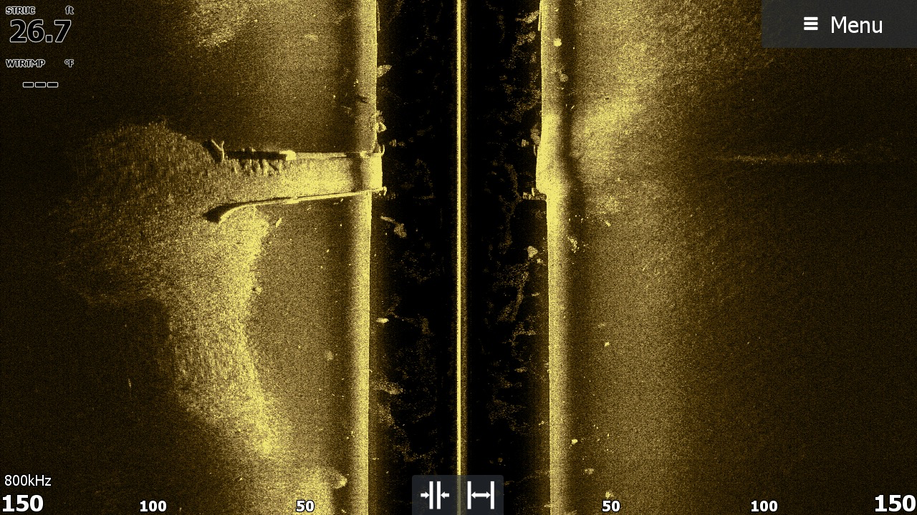
- Active Imaging™ Sonar
Active Imaging Sonar rethinks what anglers should expect from a fishfinder. Offering industry-leading clarity without sacrificing range, it delivers unmatched image quality of structure, fish and bottom composition. A 3-in-1 sonar solution, Active Imaging combines Lowrance CHIRP sonar, with Side and DownScan Imaging™ allowing anglers to quickly search fish-holding structure, and enhances FishReveal™ with higher-level clarity and target separation. Simple to use, without the need to change frequencies while fishing in most conditions, the Active Imaging 800 kHz setting provides crystal-clear detail with uncompromised range. For anglers needing to see farther than 120 feet, Active Imaging can also operate at the 455 kHz frequency.

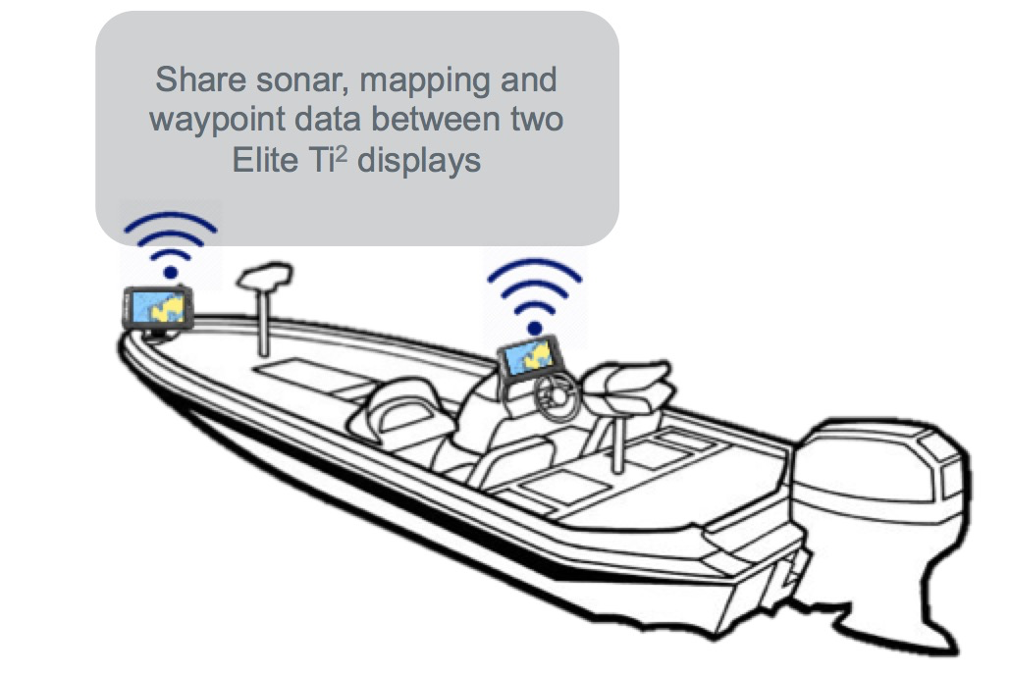
- Wireless Networking
Now featuring full connectivity without the hassle of cable installation, Elite Ti² offers anglers the ability to wirelessly share sonar and charting between two displays, as well as sync waypoint data, and the display’s network configurator allows for quick and easy set up.
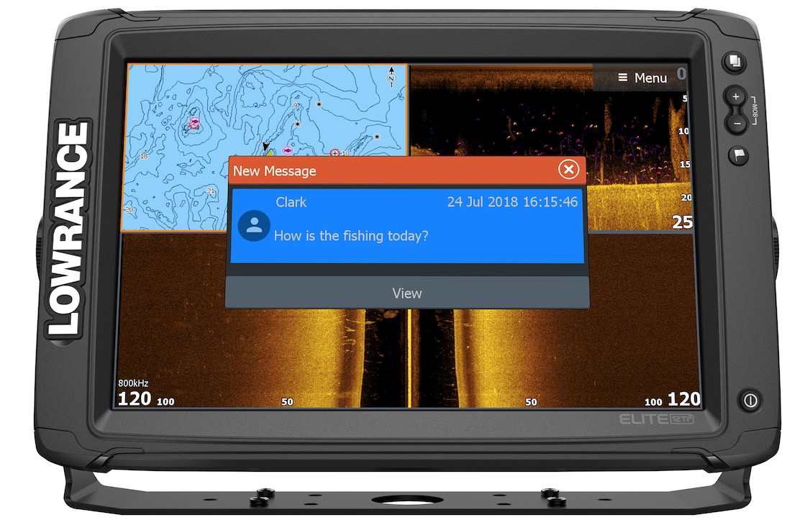
- Bluetooth® Calling and Text Notifications
Offering greater convenience on the water, Bluetooth notifications on Elite Ti² allow anglers to keep their phones stored in a safe location while still receiving incoming call and text notifications. Android features include incoming text message display and reply, new message and message template creation, and access to message history and call logs. iOS features include display of incoming text messages and call log.

“Our Elite Ti Series has been a favorite among anglers, offering cutting-edge fish finding technology in a perfectly priced standalone unit, and with the introduction of Elite Ti² we’re giving them even more to be excited about,” said Leif Ottosson, CEO and president, Navico. “Active Imaging sonar, wireless networking of sonar and chart data and mobile messaging convenience, bring high-value performance from our top of the line HDS range to anglers at an amazing price.”

Lowrance Elite Ti² is available in 7-, 9-, and 12-inch display sizes, and various charting and transducer bundles, ranging in price from £829.99 to £2,539.99. For more information about the all-new, Lowrance Elite Ti², the complete line of Lowrance marine electronics, or to locate an authorized Lowrance dealer, please visit www.lowrance.com.

-30-

For imagery and other editorial requests, please contact:
Gemma Davies
EMEA Marketing & PR Manager
gemma.davies@navico.com

About Lowrance: The Lowrance® brand is wholly owned by Navico, Inc. A privately held, international corporation, Navico is currently the world’s largest marine electronics company, and is the parent company to leading marine electronics brands: Lowrance, Simrad Yachting, B&G and C-MAP. Navico has approximately 1,500 employees globally and distribution in more than 100 countries worldwide. www.navico.com

