For Immediate Release:
October 24th 2018
Gemma Davies
EMEA Marketing & PR Manager
gemma.davies@navico.com

Lowrance® Introduces Link-9 Fixed Mount
VHF Radio

Tulsa, Okla. – Lowrance®, a world-leader in fishing electronics since 1957 — announced today the release of Link-9, its latest VHF radio. Designed as a replacement for the current Link-8, the Lowrance Link-9 VHF radio features a sleek, industrial design with a large, intuitive interface, removable fist microphone, built-in AIS receiver and a front mountable mechanical design for easy installation.

With its integrated GPS receiver, Lowrance Link-9 now has four ways to ensure GPS reliability in the event of an emergency. A GPS antenna in the face of the radio is perfect for open-air installations and the SMA connector can be coupled with a GPS-500 antenna. NMEA 0183 and NMEA 2000 connections allow the user to get GPS data from a chartplotter or from another antenna that’s already in the system.

Lowrance Link-9 also answers the call for increased situational awareness on the water. The built-in dual channel AIS receiver monitors the position of nearby AIS-equipped vessels to assist in collision avoidance in crowded waterways. The information is clearly viewable on the Link-9 built-in screen or can be overlaid on top of a chart or radar through a compatible multifunction display. Share recreational cruises and sportfishing trips with up to five friends using Track Buddy, which requests the location of another VHF radio using a digital selective calling (DSC) position request.

A number of other features have been added including Navigation mode, which displays speed and course, and Man Overboard (MOB) function, which drops a waypoint in the current location and provides distance and steering instructions to retrieve a person in the water. The waypoint is also transmitted over NMEA 2000 to the rest of the network.

Lowrance Link-9 is simple to install with a low profile front mount design that matches perfectly with Lowrance MFD’s. A start-up wizard, easy channel scan and a favorites’ option enhance the user-friendly functionality of the large, clear white dot matrix LCD screen. The remote mountable fist mic can be connected to the front or rear of the radio and optional extension cable allows the radio and mic to be mounted separately. This offers a simple, cost-effective solution without cable clutter.

The Lowrance Link-9 VHF Radio is available November 2018 and priced at £469.99. For more information on the Link-9, the brand’s entire line of marine electronics, or to locate an authorized Lowrance dealer, please visit www.lowrance.com.

-30-

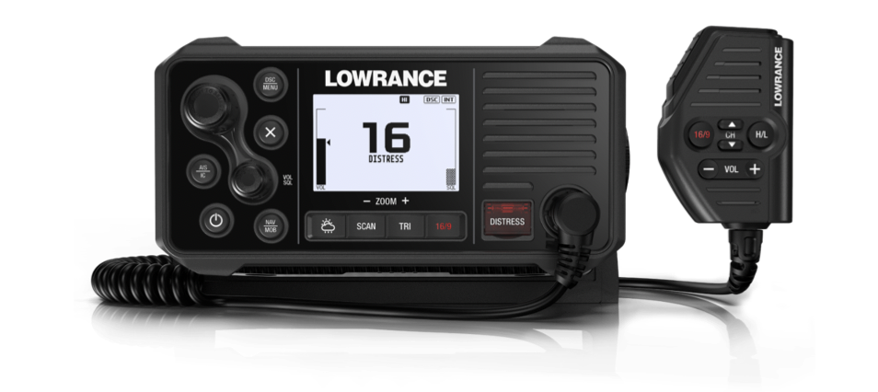

About Lowrance: The Lowrance® brand is wholly owned by Navico, Inc. A privately held, international corporation, Navico is currently the world’s largest marine electronics company, and is the parent company to leading marine electronics brands: Lowrance, Simrad Yachting and B&G. Navico has approximately 1,500 employees globally and distribution in more than 100 countries worldwide. www.navico.com

