October 1, 2018
Gemma Davies
EMEA Marketing & PR Manager
gemma.davies@navico.com

Lowrance® Offers Innovation in Dome Radars with New HALO24
Tulsa, Okla. – Lowrance®, a world-leader in fishing electronics since 1957 — announced today the release of a new, innovative pulse compression radar, HALO24, which combines the performance and reliability of Lowrance’s award-winning radars with the advantages of a new profile and lightweight design.

Boasting 60 rpm high-speed rotation at distances up to 2 nautical miles – an industry first – the Lowrance HALO24 dome radar allows for increased safety and improved performance. The extremely fast refresh rate is excellent for high-speed and short-range tracking. Offering high-quality short-, mid-, and long-range detection capability, up to 48 nautical miles, HALO24 is designed to process multiple ranges simultaneously for advanced, instantaneous Dual Range performance. In addition, the radar features integrated VelocityTrack™ Doppler technology that provides instant visual feedback on the motion of radar targets in relation to the boat — color-coding approaching vessels for high visibility, while de-emphasizing diverging targets. HALO24 also includes MARPA functionality, increasing situational awareness and decreasing the risk of collision.

“The HALO24 dome radar was designed with the latest innovations in radar technology,” said Leif Ottosson, CEO, Navico Group. “With our products, it’s vital that we offer something that no one else has — with the HALO24, anglers will get unmatched radar speeds, an easy user experience with multiple viewing modes, and an advanced feeling of safety with all potential hazards visible on screen.”

The lightest 24-inch pulse compression radar dome on the market, the low-profile HALO dome offers different power-level options ensuring high-speed radar coverage when and where it’s needed. In a matter of seconds, the radar will boot from low-power standby to full functionality in any mode — harbor, weather, and bird. Incredibly easy to use, the radar will optimize up to 18 different parameters for each pre-defined mode ensuring the ultimate view.

The new Lowrance HALO24 pulse compression dome radar is priced at £2,770 and is scheduled to be available from October 31st from authorized dealers across EMEA. An Ethernet-connected Lowrance multifunction display or radar control unit is required for operation, and a heading sensor and GPS receiver are required for MARPA target tracking. For more information about HALO24 and other Lowrance marine electronics, or to locate an authorized Lowrance dealer, please visit www.lowrance.com.

-30-
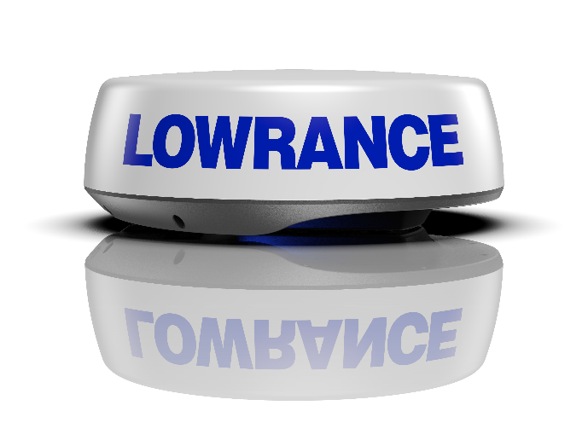
For imagery and other editorial requests, please contact:
Gemma Davies
gemma.davies@navico.com
About Navico: A privately held, international corporation, Navico is currently the world’s largest marine electronics company, and is the parent company to leading marine electronics brands: Lowrance, Simrad Yachting and B&G. Navico has approximately 1,500 employees globally and distribution in more than 100 countries worldwide. www.navico.com

