LIFECORD NOMINATED FOR THE FINAL ROUND OF THE DAME AWARDS
As the official distributor, Landau UK Commercial is delighted to announce that the smart kill cord ‘Lifecord’ has been nominated as one of the final round products for the Dame Awards 2018 in the Lifesaving and Safety Equipment category.
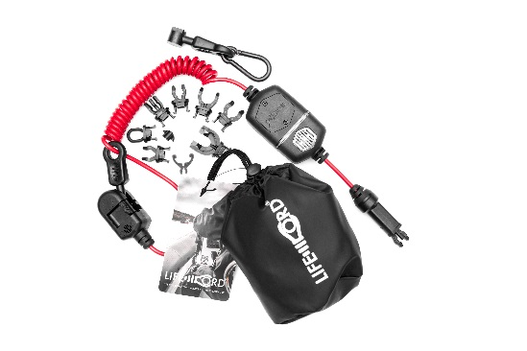
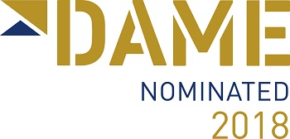

The Dame Awards is the most significant marine equipment competition of its kind, anywhere in the world. For 28 years, it has focused attention on the art and science of design in all aspects, from styling, functionality and innovation, through to ease of implementation, practicality of use – and even packaging. It is judged by a panel of top naval architects, boat, interior and industrial designers, plus user experts. To be nominated and then to win a DAME Category and attain the ultimate prize of DAME Award Overall Winner marks a product as being at the pinnacle of design practice in the industry.
The category winners and overall Dame Award winner will be announced on the morning of the first day of the METSTRADE Show which is being held from the 13-15 November 2018 at RAI in Amsterdam.
ENDS

Notes to Editors:

Landau UK
Landau UK are specialists in vessel general maintenance, upgrades and annual contract maintenance projects for commercial marine, leisure, trade, workboats and commercial passenger ships of all sizes across the UK and Europe.

Having launched into the leisure marine market back in 1993, Landau UK’s Commercial marine division was established during 2014 and has gone from strength to strength ever since. Strong working relationships have been developed with the likes of Babcock, the Ministry of Defence, Defra and the Marine Management Organisation.

Landau UK is one of the only marine services companies to have gained accreditation for ISO 9001 certification to the upgraded International Quality Standard ISO 9001:2015. This clearly demonstrates our commitment to being at the forefront of developments in this discipline. In addition, Landau UK’s Commercial division have invested in a dedicated commercial team and tender support function to further enhance and support all commercial projects.
To find out more like us on Facebook, follow us on Twitter, connect with us on Linkedin, or visit www.landauukuk.com
For further information, images and interviews
Please contact: Sara Boyes, Marketing & Tender Manager, sarab@landauuk.com, +44 (0) 1489 577 588, Landau UK, Unit C, Building 9, Swanwick Marina, Swanwick, Southampton, SO31 1ZL

