LANDAU UK EXHIBITING AT METSTRADE 2018 (Stand 03.212)
Landau UK are delighted to be once again exhibiting, at METSTRADE 2018 and would like to invite you to join us in the British Pavilion, Hall 3 on Stand 03.212. The Marine Equipment Trade Show will be held from 13-15 November 2018 at the RAI Exhibition Centre, providing a key industry event over three days.
Landau UK are specialists in vessel general maintenance, upgrades and annual contract maintenance projects for commercial marine, leisure, trade, workboats and commercial passenger ships of all sizes across the UK and Europe.
As a fully-fledged member of the British Marine Electronic and Electrics Association (BMEEA) Landau UK’s service levels are considered to be amongst the highest available; hence why Landau UK was awarded 2016 BMEEA Dealer of the Year and Motor Boat Outstanding Service Award 2017.
Landau UK’s team of engineers regularly travel to all corners of the world, providing innovative solutions to any idea or requirement you may have, using the latest products and techniques. With a pledge to continually go beyond, Landau UK’s engineers ensure that installations are not only in and working, but that they also soundly interface with other equipment.
During METSTRADE Landau UK will be displaying the following:
Lifecord
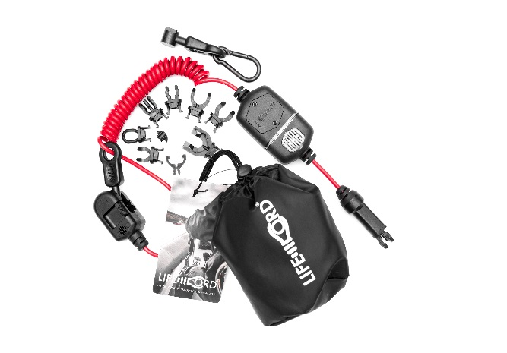
Lifecord is a newly designed kill cord providing the certainty and reliability of a tethered connection between a boat’s engine ignition kill switch and pilot, ensuring the vessel’s engine stops should the pilot be inadvertently thrown from the helm. However, unlike the typical passive kill cords commonly seen, Lifecord is a ‘smart’ kill cord incorporating detection technology designed to trigger an audible and visual warning alarm should Lifecord be connected to the boat’s kill switch but not the pilot, similar to the seatbelt warning in your car.

Plus…..
The team from Landau UK will also be on hand during the show to discuss their full range of services and solutions available to all leisure and commercial vessels. Pop along to Stand 03.212 in the British Pavilion at METSTRADE in Amsterdam from the 13th – 15th November 2018 to fully appreciate the diverse range of services and solutions which are available through Landau UK.
ENDS

Notes to Editors:

Landau UK
Landau UK are specialists in vessel general maintenance, upgrades and annual contract maintenance projects for commercial marine, leisure, trade, workboats and commercial passenger ships of all sizes across the UK and Europe.

Having launched into the leisure marine market back in 1993, Landau UK’s Commercial marine division was established during 2014 and has gone from strength to strength ever since. Strong working relationships have been developed with the likes of Babcock, the Ministry of Defence, Defra and the Marine Management Organisation.

Landau UK is one of the only marine services companies to have gained accreditation for ISO 9001 certification to the upgraded International Quality Standard ISO 9001:2015. This clearly demonstrates our commitment to being at the forefront of developments in this discipline. In addition, Landau UK’s Commercial division have invested in a dedicated commercial team and tender support function to further enhance and support all commercial projects.
To find out more like us on Facebook, follow us on Twitter, connect with us on Linkedin, or visit www.landauuk.com
For further information, images and interviews
Please contact: Sara Boyes, Marketing & Tender Manager, sarab@landauuk.com, +44 (0) 1489 577 588, Landau UK, Unit C, Building 9, Swanwick Marina, Swanwick, Southampton, SO31 1ZL

