LANDAU UK CELEBRATE 25 YEARS SERVICING THE MARINE INDUSTRY AND LOOK FORWARD TO THE FUTURE WITH DYNAMIC EXPANSION PLANS.

Landau UK are delighted to announce rapid expansion plans for 2019, including adding a raft of new service offerings to their portfolio, with an aim of tripling the size of the business and turnover within just three years.
The new initiatives announced by Landau UK CEO, Ben Metcalfe include:
- Expanding existing services to include fabrication, hydraulics and more complex blasting
- Moving to larger premises with in-house lifting facilities
- Applying for more public sector and MOD contracts
- The growth of specialist resource supply to include marine carpenters and electricians
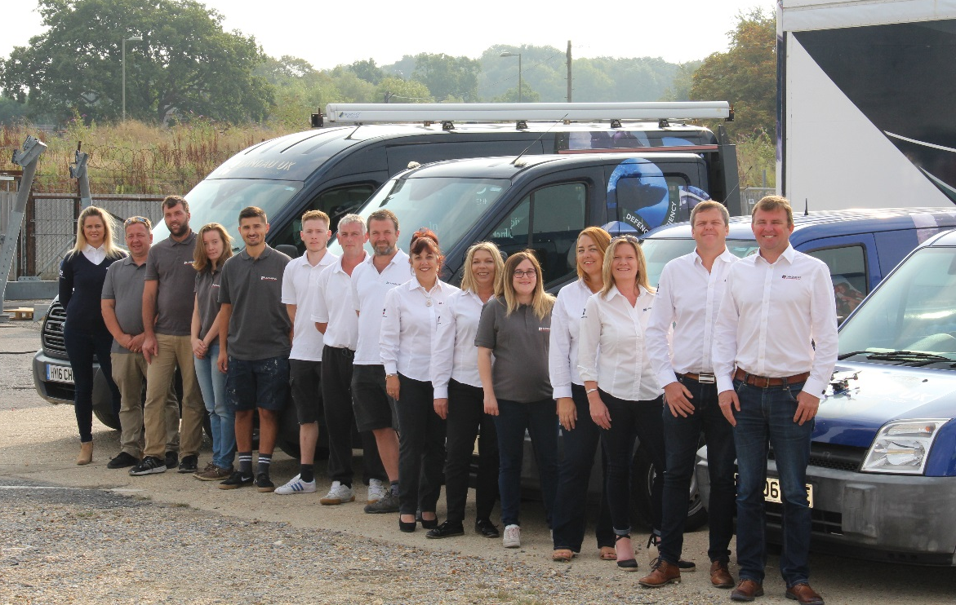
The timely announcement comes as Landau UK celebrate a quarter of a century in business on the South Coast. CEO Ben Metcalfe said, “It’s been a phenomenal 25 years for Landau UK, from setting up the company in a bedroom in Whiteley, to our state-of-the-art facilities in the prestigious Swanwick Marina. From our initial contract with Princess, to launching the commercial arm of the business in 2014 and our contract with the MOD / Babcock, we’ve seen enormous growth. However, as we expand and grow the business, we are committed to keep the ‘family feel’ our customers expect from us. We will continue to focus on providing quick reactions, attention to detail, emergency repairs and second-to-none customer service”.

ENDS

Notes to Editors:

Landau UK
Landau UK are specialists in vessel general maintenance, upgrades and annual contract maintenance projects for commercial marine, leisure, trade, workboats and commercial passenger ships of all sizes across the UK and Europe.

Having launched into the leisure marine market back in 1993, Landau UK’s Commercial marine division was established during 2014 and has gone from strength to strength ever since. Strong working relationships have been developed with the likes of Babcock, the Ministry of Defence, Defra and the Marine Management Organisation.

Landau UK is one of the only marine services companies to have gained accreditation for ISO 9001 certification to the upgraded International Quality Standard ISO 9001:2015. This clearly demonstrates our commitment to being at the forefront of developments in this discipline. In addition, Landau UK’s Commercial division have invested in a dedicated commercial team and tender support function to further enhance and support all commercial projects.
To find out more like us on Facebook, follow us on Twitter, connect with us on Linkedin, or visit www.landauukcommercial.com
For further information, images and interviews
Please contact: Sara Boyes, Marketing & Tender Manager, sarab@landauuk.com, +44 (0) 1489 577 588, Landau UK, Unit C, Building 9, Swanwick Marina, Swanwick, Southampton, SO31 1ZL

