October 12, 2018
Gemma Davies
PR & Marketing Manager, EMEA
gemma.davies@navico.com
+44 1794 518448

B&G® Launch Revolutionary Wireless Wind Sensor

B&G are proud to announce the launch of the new WS300 series of high precision wind sensors, offering improved accuracy and performance

Southampton, UK - B&G®, the world’s leading sailing navigation and instrument specialist, today announced the launch of the new WS300 wind series, a new range of wireless and wired wind sensors designed for cruising and club racing sailors.

The WS320 is a revolutionary new wireless wind sensor aimed at yachts with masts up to around 25m. The new sensor is easy to install, very low weight and does not compromise performance vs. a wired unit. The new WS320 offers high performance, improved aerodynamics and accuracy. The smart rechargeable solar power management system ensures that data is always available to your instruments and autopilots, no matter what the weather. The new WS310 is the wired option; it comes with the same improvements in accuracy and aerodynamics, but allows for the more traditional wired installations.

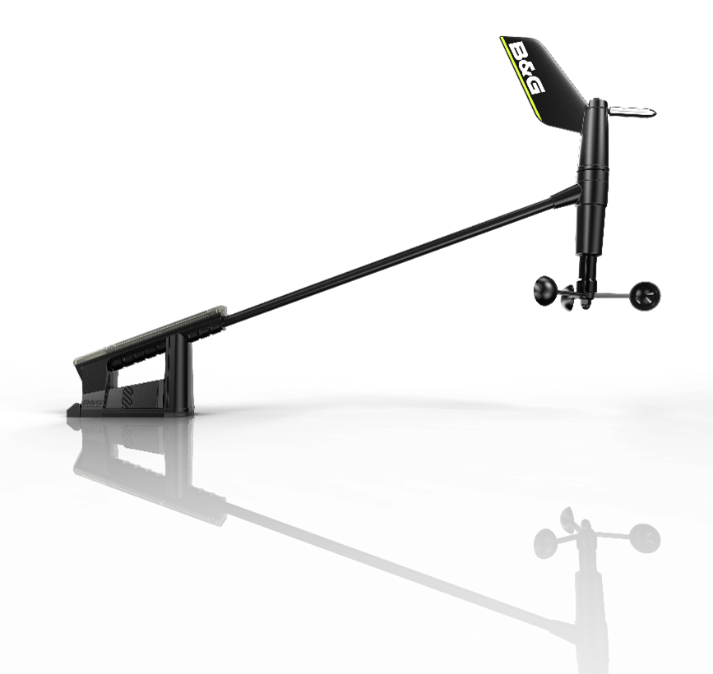
“We are delighted to launch our new wind sensors, both the wireless and wired units offer exceptional performance in terms of accuracy of wind angle and speed, and are also extremely reliable”, said Alan Davis, B&G’s Product Line Director. “As the most exposed sensor on a yacht, the wind sensor is critical for instruments and autopilot steering. Reliability of these sensors is key and to address this the WS310 and WS320 have undergone rigorous validation. We have conducted benchmarking tests against multiple different sensors in over 500 individual wind tunnel tests and conducted over 200,000 hours of field tests without failure.”
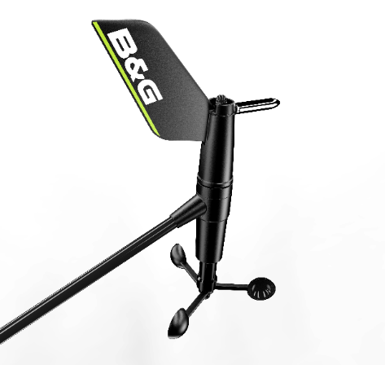

One of the main challenges with wind sensors is installation. The new WS320 wireless sensor is lightweight and eliminates the need to run wires through the mast of smaller boats, therefore making installation much easier. Importantly opting for a wireless sensor does not mean you have to sacrifice accuracy, it is the same as the wired version, outputting wind at a super smooth five times per second.
Part Number | Description | RRP (inc VAT)
000-14391-001 | WS310 Wired Wind Sensor | € 502.80
000-14390-001 | WS320 Wireless Wind Sensor | € 598.80
000-14382-001 | WS310 Wind Pack, 20M cbl, Interface | € 603.60
000-14383-001 | WS320 Wireless Wind Pack, with Interface | € 730.80

To find out more about the WS300 series and the full B&G range of sailing electronics and navigational products, visit www.bandg.com.
For imagery and other editorial requests, please contact:
Gemma Davies
EMEA PR & Marketing Manager – Navico
gemma.davies@navico.com

About B&G: The B&G brand is all about passion for sailing - totally dedicated to the needs of sailors, whether cruisers, racers or Professionals, it is wholly owned by Navico, AS. Navico is currently the world’s largest marine electronics company and produces products under leading marine electronics brands: Lowrance, Simrad and B&G. Navico has approximately 1,500 employees globally and distribution in more than 100 countries worldwide. www.navico.com

