For Immediate Release
October 23, 2018
Gemma Davies
EMEA Marketing & PR Manager
gemma.davies@navico.com

B&G® V60 VHF RADIO IS PERFECT ADDITION TO MID-LEVEL SAILBOATS

Southampton, UK - B&G®, the world’s leading sailing navigation and instrument specialist, announced today the release of its V60 mid-level VHF radio. Designed as a replacement for the V50, the B&G V60 includes a large, intuitive interface, built-in AIS receiver, a front mountable mechanical design for easy installation and optional wireless handsets with inductive charging.

With its integrated GPS receiver, the V60 now has four ways to ensure GPS reliability in the event of an emergency. A GPS antenna in the face of the radio is perfect for open-air installations and the SMA connector can be coupled with a GPS-500 antenna. NMEA 0183 and NMEA 2000 connections allow the user to get GPS data from a chartplotter or from another antenna that’s already in the system.

The B&G V60 also answers the call for increased situational awareness on the water. The built-in dual channel AIS receiver monitors the position of nearby AIS-equipped vessels to assist in collision avoidance in crowded waterways. The information is clearly viewable on the V60’s built-in screen or can be overlaid on top of a chart or radar through a compatible multifunction display. Share location details and keep track of up to five friends using Track Buddy, which requests the location of another VHF radio when the MMSI is entered into the VHF contact list.

Provided with the B&G V60 is the option to pair up to two wireless handsets so the radio can be taken anywhere onboard. The H60 handset was designed as an intuitive portable companion to the V60 and each handset duplicates the radio’s display and controls, enabling remote access to all key functions. The V60 doubles as a handy on-board intercom as a result of having multiple stations.

A number of other features have been added including Navigation mode, which displays speed and course, and Man Overboard (MOB) function, which drops a waypoint in the current location and provides distance and steering instructions to retrieve a person in the water. The waypoint is also transmitted over NMEA 2000 to the rest of the network.

The B&G V60 is simple to install with a low profile front mount design that matches perfectly with B&G MFD’s. A start-up wizard, easy channel scan and favorites option enhance the user-friendly functionality of the large, clear white dot matrix LCD screen. The remote mountable fist mic can be connected to the front or rear of the radio and optional extension cable allows the radio and mic to be mounted separately. This offers a simple, cost-effective solution without cable clutter.

The B&G V60 Radio is available November 2018 and priced at £550. For more information or the full B&G range of sailing electronics and navigational products, visit www.bandg.com.
-30-
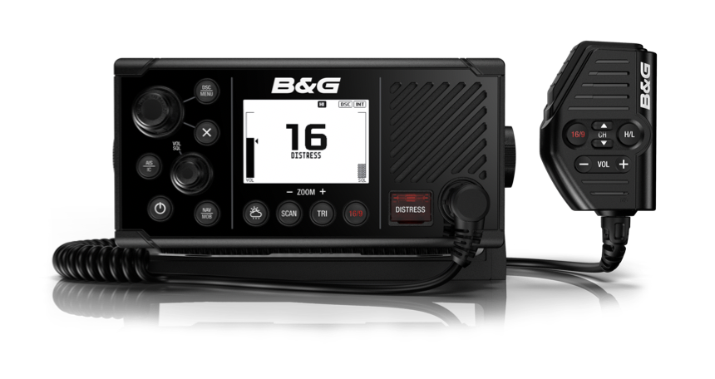
About Navico: A privately held, international corporation, Navico is currently the world’s largest marine electronics company, and is the parent company to leading marine electronics brands: Lowrance, Simrad Yachting and B&G. Navico has approximately 1,500 employees globally and distribution in more than 100 countries worldwide. www.navico.com

