October 1, 2018
Gemma Davies
EMEA Marketing Manager
gemma.davies@navico.com

B&G® HALO24 NEWEST EVOLUTION IN DOME RADAR TECHNOLOGY

Southampton, UK - B&G®, the world’s leading sailing navigation and instrument specialist, announced today the launch of the new HALO24, an innovation in pulse compression radar. HALO24 combines the performance and reliability of B&G’s award-winning radars with the advantages of a new profile and lightweight design, as well as cutting-edge technology – including nearly real-time updates and VelocityTrack™ target tracking.

Boasting 60rpm high-speed rotation at distances up to 2 nautical miles, an industry first, the B&G HALO24 dome radar allows for increased safety and improved performance. The lightest 24-inch Pulse Compression radar dome in its class, HALO24 reduces weight up the rig which delivers increased stability for cruisers and increased speed for racers. Offering high-quality short, mid, and long-range detection capability, up to 48 nautical miles, HALO24 is designed to process multiple ranges simultaneously for advanced, instantaneous Dual Range performance. In addition, the radar features B&G VelocityTrack™ Doppler technology that provides instant visual feedback on the motion of radar targets in relation to the boat — color-coding approaching vessels for high visibility while de-emphasizing diverging targets, as well as MARPA functionality, increasing situational awareness and decreasing the risk of collision.

“The HALO24 dome radar was designed with the latest innovations in radar technology,” said Leif Ottosson, CEO, Navico Group. “With our products, it’s vital that we offer something that no one else has — with the HALO24, sailors will get unparalleled radar speeds, an easy user experience with multiple viewing modes, and an advanced feeling of safety with all potential hazards visible on screen.”

The low profile Halo dome offers different power-level options ensuring high-speed radar coverage when and where it’s needed. In a matter of seconds, the radar will boot from low-power standby to full functionality in any mode — harbor, offshore and weather. Incredibly easy to use, the radar will optimize up to 18 different parameters for each pre-defined mode ensuring the ultimate view.

The new B&G HALO24 pulse compression dome radar is priced at £2,770 and is currently available from authorized dealers across EMEA. An Ethernet-connected B&G multifunction display or radar control unit is required for operation, and a heading sensor and GPS receiver are required for MARPA target tracking. For more information on the HALO24, radar bundles and accessories, or the full B&G range of sailing electronics and navigational products, visit www.bandg.com.

-30-
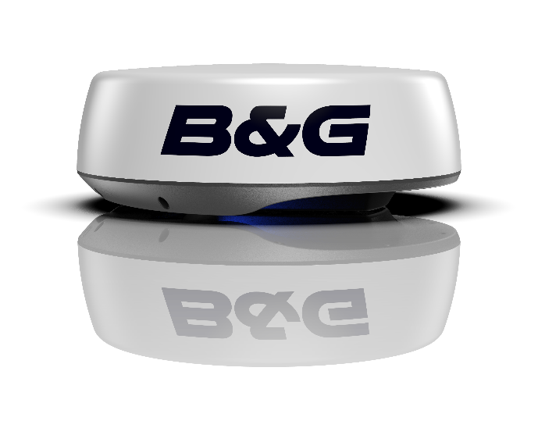
For imagery and other editorial requests, please contact:
Gemma Davies
gemma.davies@navico.com
About Navico: A privately held, international corporation, Navico is currently the world’s largest marine electronics company, and is the parent company to leading marine electronics brands: Lowrance, Simrad Yachting and B&G. Navico has approximately 1,500 employees globally and distribution in more than 100 countries worldwide. www.navico.com

