News Release

For immediate release
8 October 2018

Lord Iliffe presents Sail Training Awards

Mia Brackley and Elizabeth Bland are the proud recipients of MDL Marinas 2018 Sail Training Awards presented at TheYachtMarket.com Southampton Boat Show.

Presented in conjunction with Ocean Youth Trust South, MDL’s Sail Training Awards are designed to recognise, reward and challenge young people who have shown exceptional accomplishments and qualities which have inspired or supported others.
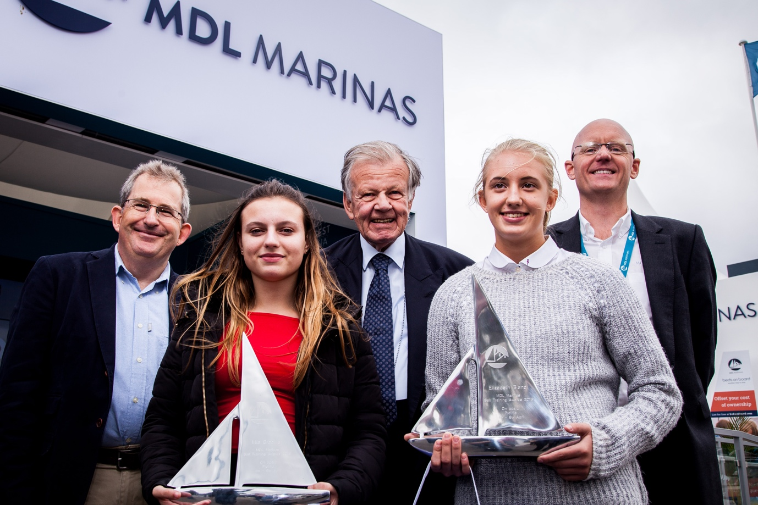
Pictured are (left to right): Mark Todd (Chief Executive Ocean Youth Trust South), Mia Brackley, Lord Iliffe (Board Chairman, Yattendon Group Plc), Elizabeth Bland and Michael Glanville (Operations Director MDL Marinas).

Mia Brackley and Elizabeth Bland were given the beautiful awards as recognition of their accomplishments while at sea. They spent five nights and six days living and sailing on board OYT South’s 30-metre vessel Prolific and were involved in all aspects of life on board, including hoisting sails, helping with maintenance, sailing the boat at night and cooking and cleaning with the rest of the crew. The voyage departed from and returned to MDL’s Ocean Village Marina in April 2018. Also onboard were Emily Godson, Carla Green, Hayden Knight and Shailyse Saunders.
continues . . .

The presentation was made on MDL Marinas waterside stand at TheYachtMarket.com Southampton Boat Show.
Keep an eye out for entry forms for the 2019 MDL’s Sail Training Awards on MDL’s website: www.mdlmarinas.co.uk. The awards offer admirable young people – carefully selected due to their exceptional accomplishments, or for overcoming adverse personal circumstances – the opportunity of a lifetime aboard the sail training ship.
MDL Marinas has run its Sail Training Awards for over 30 years. Ocean Youth Trust South is a charity which uses Adventure Under Sail as a personal development opportunity for young people aged 12-25.
More information from www.mdlmarinas.co.uk and www.oytsouth.org.

ends
Notes for editors:
A high res version of the image above is available to download from https://marineadagency.com/media-centre/

Ocean Youth Trust South
- Ocean Youth Trust South sails with around 450 young people each year.
- Sail training brings benefits to all sorts of young people. Voyages are designed to develop confidence, team-working, the ability to cope with unfamiliar situations, and tolerance and understanding of others.
- More information from: www.oytsouth.org/charity.asp

MDL Marinas
- MDL Marinas is Europe’s largest marina group, offering members over 120 destinations to cruise to in the UK, France, Italy and Spain through Freedom Berthing. Currently MDL Marinas manage 18 UK marinas, 1 in Italy and 1 in Spain.
- MDL Marinas is proud to be landlords to over 500 marine business companies, with nearly 260 staff delivering the unique MDL experience to all members, guests and commercial partners.
- The company also advises on worldwide marina developments including Europe, China and Crimea.
- For more information visit www.mdlmarinas.co.uk

The Marine Advertising Agency Ltd
- MAA provides simple, no-nonsense solutions to marine companies’ advertising, PR, media buying and communications needs.
- From brand development and marketing materials to website, eCommerce, email campaigns and social media, MAA offers a straightforward, knowledgeable and service-orientated approach.
- MAA is able to offer unrivalled value to help clients reach their target markets.
- For more information visit www.marineadagency.com

For media enquiries, more information, product tests:

Marine Advertising Agency
Zella Compton or Mike Shepherd
Email: zella@marineadagency.com Email: mike@marineadagency.com
Tel: +44 (0) 23 9252 2044 Tel: +44 (0) 23 9252 2044

Image gallery: marineadagency.com

