News Release
For immediate release
12 October 2018

Gosport Marine Scene gathers momentum with the appointment of its first Managing Director

The Directors of Gosport Marine Scene (GMS) are pleased to announce the appointment of Mark Bowden CMM as the first Managing Director of the Community Interest Company (CIC) formed in 2013 to advance the marine business sector, encourage marine related employment in Gosport and assist in the development of Gosport waterfront.

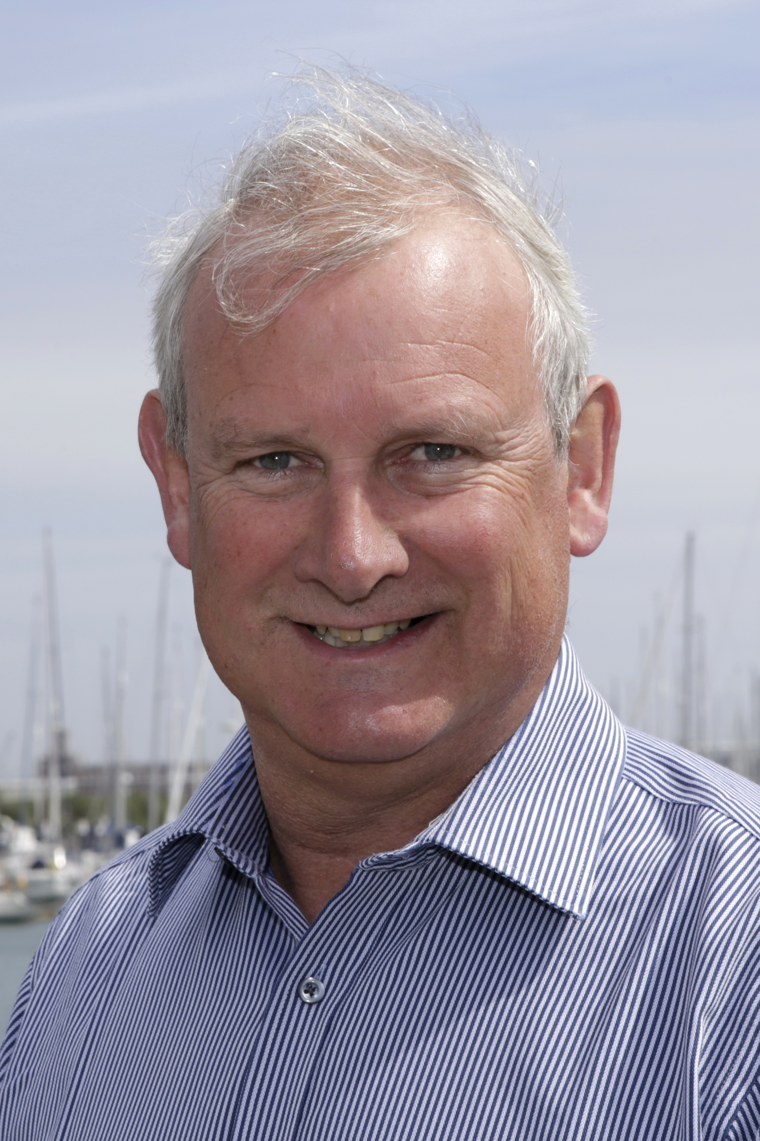
Mark Bowden's role will be to drive forward the GMS objectives, which include stimulating marine business, encouraging young people to get afloat for recreation and employment, and promoting Portsmouth Harbour as a destination for leisure sailors. This will involve building upon GMS's successful development work and maritime events to date, and expanding the network to embrace the marine sector across the whole of Portsmouth Harbour in collaboration with Gosport, Portsmouth and Hampshire councils and other partners.

Peter Melson CVO CBE, Chairman of GMS, said; “We are delighted to be moving ahead with the objectives of GMS, so the appointment of Mark is an important step for this Gosport-based CIC. With funding now secured from Trinity House, and with Portsmouth City Council and Gosport Borough Council now also committed to supporting GMS financially, Mark's appointment as Managing Director is a key strategic decision in delivering our objectives. Mark has run his own marine-based business in Gosport (Marina Projects) for over 16 years and so has much to offer in terms of knowledge of the harbour and the needs of the marine sector.”

Caroline Dinenage MP for Gosport, Stubbington, Lee-on-the-Solent and Hill Head quoted- "The Gosport Marine Scene was born in November 2012 out of my determination to promote our area as a world-class marine and sailing destination. Capitalising on our rich maritime heritage and skilled local workforce, I thought this had the potential drive jobs, youth opportunities and economic prosperity. Since then with the knowledge and enthusiasm of local employers and council members GMS has grown to be a shining example of what can be achieved. With Mark’s appointment and associated funding, GMS will continue to lead the south coast in connecting young people and marine businesses to deliver the skills we need for the 21st century."

Continues…..

Mark Bowden stated “I am delighted to be given the task of driving this most worthwhile organisation forward and I thank all the volunteers past and present for the work that they have done to bring GMS this far. This appointment and the recent funding commitments form the next chapter to enable GMS to have a positive influence across Portsmouth Harbour."

In due course, GMS will be renamed to reflect its wider role within Portsmouth Harbour.

For more information please contact:
Mark Bowden
mark@gosportmarinescene.com
07802 650623
www.gosportmarinescene.com

ENDS

Media enquiries:

For further information and requests for interviews, please contact:
Mike Shepherd
Tel.: 023 9252 2044; or mobile 07786 265 455
Email: mike@marineadagency.com

GMF MD contact details:
Mark Bowden
Tel: 07802 650623
Email: mark@gosportmarinescene.com
Notes for Editors

About Gosport Marine Scene and Gosport:
Organiser of Gosport's:
Marine Business Network, Gosport Marine Festival
Talent & Career Programme
Gosport Peninsula is a centre of excellence in ocean racing, sail training, marine tourism and trade.
Gosport is the home of: Alex Thomson Racing & Hugo Boss, Clipper Round the World Race, Global Ocean Race, Sail Training International, ASTO, Ocean Youth Trust South, Lee-on-Solent RYA Onboard, Toe in the Water . . . just for starters

