For immediate release: 24.09.2018
Crewsaver, champions of the #LifejacketSafe campaign, launch instructional lifejacket ‘HOW-TO’ videos
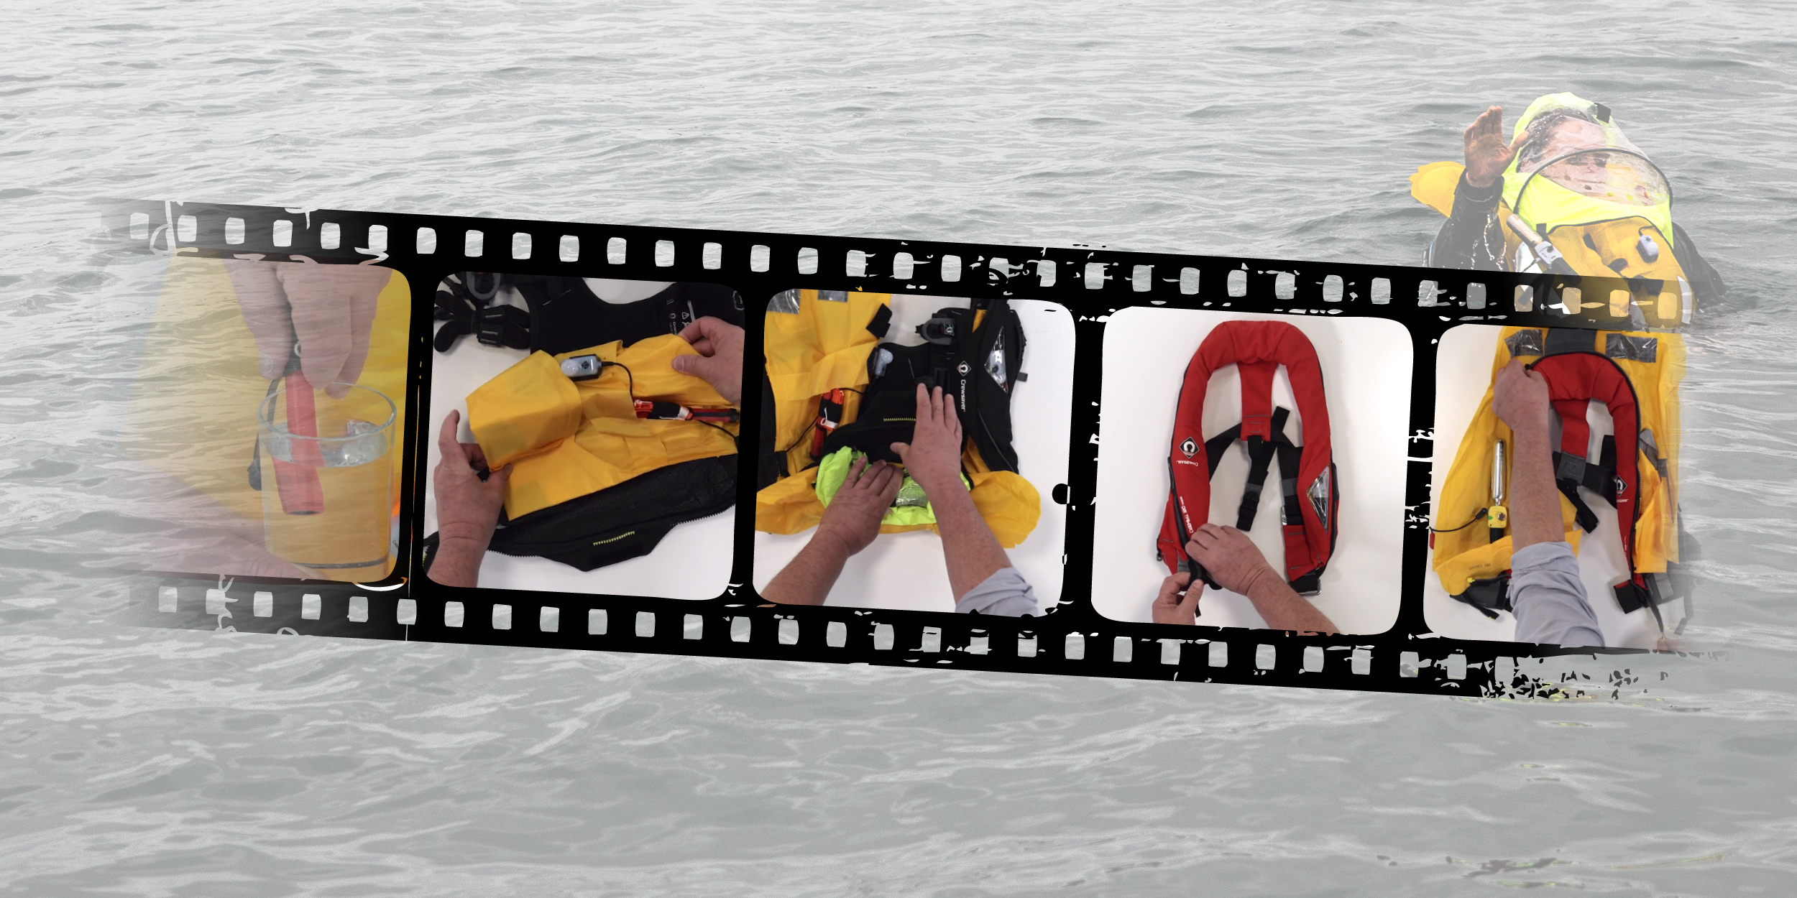
Users are encouraged to check, care and maintain their lifejacket, however for some, opening up a lifejacket can be a daunting experience. This is why Crewsaver, a leading designer and manufacturer of safety and performance equipment, has made a series of ‘HOW-TO’ videos.
Join Crewsaver’s very own Training Manager, Guy Page and #LifejacketSafe Ambassador, Hazel Proudlock, as they guide you through the step-by-step process of ‘HOW-TO’ rearm, repack and maintain your lifejacket. These videos are sure to give all lifejacket users the confidence to make the vital safety checks required before using out on the water. After all, a lifejacket is a lifesaving piece of equipment which your life could depend on.
Hazel Proudlock, #LifejacketSafe Ambassador says - “We don’t want you to be shy when it comes to getting to know your lifejacket. Open the lifejacket up, check the components and be confident to know that when you are on the water, your lifejacket is prepped and ready for action”
Guy Page, Crewsaver’s Training Manager commented - “Rearming and repacking your lifejacket is easy! However, we encourage you to watch our ‘HOW-TO’ videos to make sure you are doing it correctly so your lifejacket will perform at its optimum.”
Crewsaver is commited to raising awareness about lifejacket safety to all levels of user. This can be seen through its trailblazing lifejacket designs but also through the championing of the #LifejacketSafe campaign. As part of this campaign, these ‘HOW-TO’ videos, encourage people to not only wear a lifejacket but to give them the confidence and support to make sure it is well maintained and fit for purpose.
Crewsaver’s ‘HOW-TO’ videos include;
- Rearming your automatic or manual lifejacket
- Rearming your Hammar lifejacket
- Repacking your ErgoFit lifejacket
- Repacking your Crewfit 180N Pro lifejacket
- Repacking your Crewfit 165N Sport lifejacket
- Repacking your Crewfit 150N Junior lifejacket
- Care and maintenance for your lifejacket
Take the step to become #LifejacketSafe and view the ‘HOW-TO’ videos at http://crewsaver.com/uk/how-to-guides/. It may just save your life.
//ENDS//
For media information, hi-res images or product tests please contact:

Crewsaver
Hazel Proudlock, Marketing Dept
T +44 (0) 1329 820406
E hazel.proudlock@survitecgroup.com

Alison Willis – Marine Advertising Agency Ltd
T +44 (0) 23 9252 2044
E Alison@marineadagency.com

Notes to Editors

Crewsaver is a world-leading manufacturer of marine safety equipment and clothing for the commercial and leisure marine industries. Based in Gosport, Hampshire, the company designs and manufactures bespoke safety equipment for several countries’ Special Forces, and the aviation and oil industries. Crewsaver is the only company to hold an exclusive contract to supply lifejackets to the UK government’s Environment Agency and the Royal National Lifeboat Institution (RNLI). They are part of the Survitec Group. www.crewsaver.com

Survitec Group Survitec is a global leader in survival and safety solutions to the marine, defence, aviation and offshore markets. Survitec has over 3,000 employees worldwide covering 8 manufacturing facilities, 15 offshore support centres and over 70 owned service stations. It is further supported by a network of over 500 3rd party service stations and distributors. Across its 160-year history, Survitec Group has remained at the forefront of innovation, design and application engineering and is the trusted name when it comes to critical safety and survival solutions. www.survitecgroup.com

