Superyacht Tenders and Toys reveal wide product range
at Monaco Yacht Show (stand QA7).

After recently becoming a dealer for the lift eFoils, Superyacht Tenders and Toys (SYTT) is delighted to showcase these unique products at Monaco Yacht Show. The foiling electric surfboard is already proving very popular with clients as they’re the world’s premiere performance hydrofoils for surf and wake and the ultimate electric hydrofoil experience over any body of water – no wind, waves or towing required.

Also on the stand is a Veitis. Aiming to redefine motorcycling by completely reimaging, redesigning and re-engineering what a motorcycle should be for the 21st Century, this one’s electric in terms of looks and power. Perfect for coastal cruises.

In the SYTT favourites mix is Seabobs, providing unlimited riding pleasure for leisurely gliding or sporty driving, or safe diving, as well as Nautiques. The stand boasts two Nautique Watersports Tenders available for immediate purchase.

More information on all products being exhibited at Monaco Yacht Show is available via SuperyachtTendersandtoys.com or come and see them on stand QA7 where you can also meet the team.

Pictured: Veitis

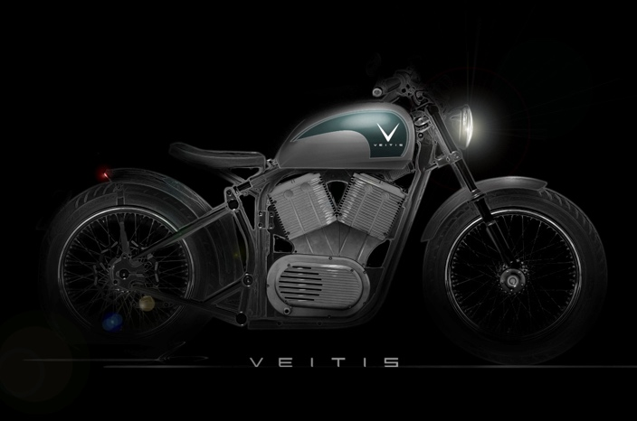

ENDS

Notes to Editors:
Superyacht Tenders and Toys is the leading independent consultancy and management company specialising in all superyacht tender and toy needs and provides practical solutions for the world’s finest yachts. Superyacht Tenders and Toys won the Queen’s Award for Enterprise: International Trade 2017, the most prestigious business award in the UK.

Media enquiries via Marine Advertising Agency:
Zella Compton, zella@marineadagency.com
Alison Willis, alison@marineadagency.com
Emma Stanbury, emma@marineadagency.com
T: 023 9252 2044

Or
Josh Richardson, Superyacht Tenders and Toys
T: UK +442380016363
T: France +33489733347
T: US +19643029066
E: info@sytt.co

