Superyacht Tenders and Toys recognised as ‘best marine company
to work for (under 20 employees)’ by British Marine

Superyacht Tenders and Toys (SYTT) is delighted to be recognised as the best marine company to work for (with under 20 employees) by British Marine. Announced during the 50th anniversary celebrations of TheYachtMarket.com Southampton Boat Show at a gala dinner SYTT was one of seven British Marine member companies to receive awards. SYTT was recognised for its commitment to its staff, training and skills development.
The judges were impressed by SYTT’s emphasis on creating a positive environment for its employees, where they are empowered to do the best that they can. One employee commented: “They [Superyacht Tenders and Toys] have truly created a fantastic place to work and it is a pleasure to come here every day.”
Claire Richardson, Director commented: “We are thrilled to have received this recognition from British Marine. We try to make work as flexible, enjoyable and rewarding as we can for our team but this, together with the success we have achieved and the awards we have won, would not have been possible without the outstanding dedication, commitment and hard work of the whole team.”

Pictured (L-R): Claire Richardson, Ally Ford, Tash Cooper and Natasha Sigal with the award.

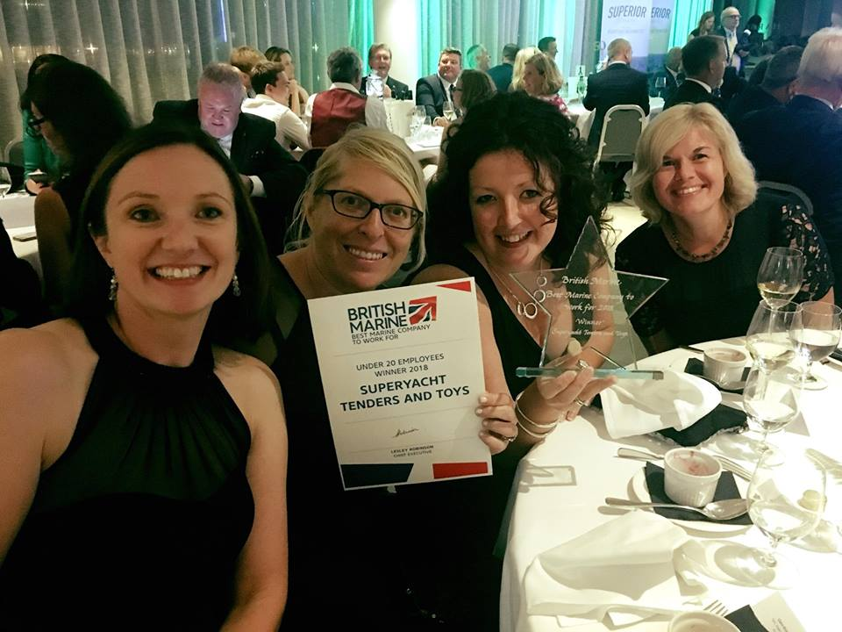

ENDS

Notes to Editors:
Superyacht Tenders and Toys is the leading independent consultancy and management company specialising in all superyacht tender and toy needs and provides practical solutions for the world’s finest yachts. Superyacht Tenders and Toys won the Queen’s Award for Enterprise: International Trade 2017, the most prestigious business award in the UK.

Media enquiries via Marine Advertising Agency:
Zella Compton, zella@marineadagency.com
Alison Willis, alison@marineadagency.com
Emma Stanbury, emma@marineadagency.com
T: 023 9252 2044

Or
Josh Richardson, Superyacht Tenders and Toys
T: UK +442380016363
T: France +33489733347
T: US +19643029066
E: info@sytt.co

