For immediate release: 19.09.2018
HOT OFF THE PRESS! #LifejacketSafe champions, Crewsaver, publish ISSUE 2 of the #LifejacketSafe newspaper
Due to popular demand, Crewsaver announces issue 2 of the #LifejacketSafe newspaper is now available - bringing lifejacket users up-to-speed with the latest thought-provoking developments. Packed full of lifejacket top tips, guest articles and games, the newspaper aims to highlight the importance of the trusted (and sometimes neglected) lifejacket. Readers of the #LifejacketSafe newspaper will get an insight into the importance of maintaining their lifejacket and discover ways they can keep their lifejacket action ready should the unexpected happen.
“We aim to keep people as informed as possible when it comes to both purchasing and maintaining their safety equipment. Issue 2 of the #LifejacketSafe newspaper includes some fresh new thoughts on safety and draws on many user experiences.” – Hannah Burywood, Crewsaver Marketing Manager
Since its debut in September 2017, the free #LifejacketSafe newspaper has been distributed in two languages around the globe and has appeared at a wide range of Crewsaver retailers, service stations and events. Head to the Crewsaver website to view online and keep your eyes open at events such as boat shows to get your hands on the latest issue.
New additions to the newspaper include:
- Inspiring interview with professional sailor Alan Roberts
- Insight into the PolarQuest Arctic mission
- New MCA safety practices for commercial fishing vessels
- Another type of inflatable safety product; use of mast head floats for sailing dinghies

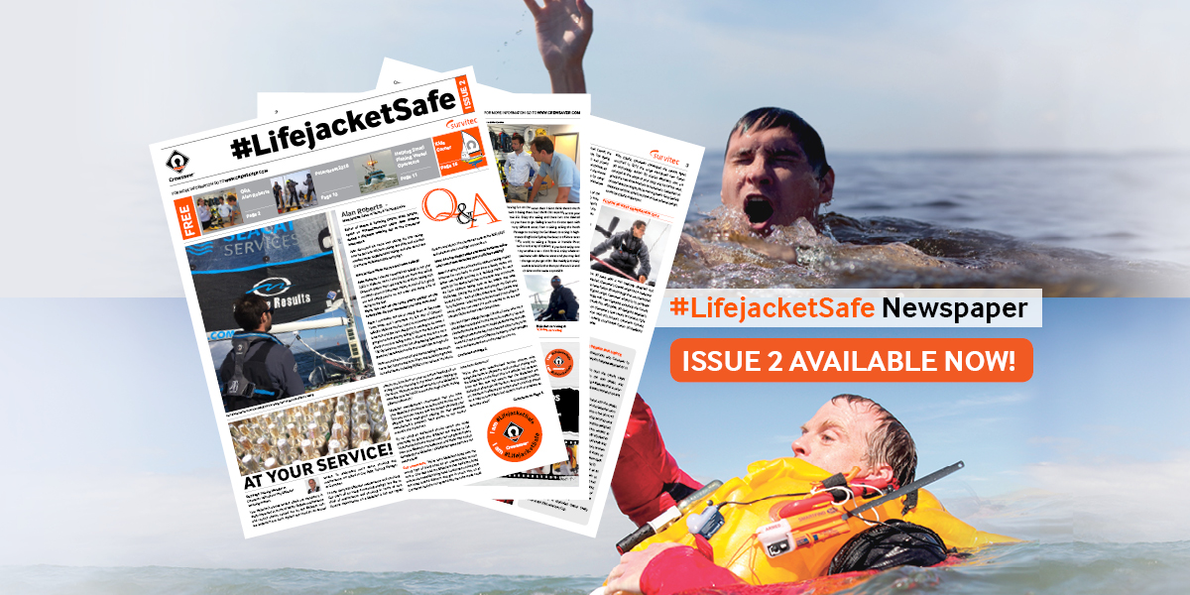
//ENDS//
For media information, hi-res images or product tests please contact:
Crewsaver
Hazel Proudlock, Marketing Dept
T +44 (0) 1329 820406
E hazel.proudlock@survitecgroup.com

Alison Willis – Marine Advertising Agency Ltd
T +44 (0) 23 9252 2044
E Alison@marineadagency.com
Notes to Editors

Crewsaver is a world-leading manufacturer of marine safety equipment and clothing for the commercial and leisure marine industries. Based in Gosport, Hampshire, the company designs and manufactures bespoke safety equipment for several countries’ Special Forces, and the aviation and oil industries. Crewsaver is the only company to hold an exclusive contract to supply lifejackets to the UK government’s Environment Agency and the Royal National Lifeboat Institution (RNLI). They are part of the Survitec Group. www.crewsaver.com

Survitec Group Survitec is a global leader in survival and safety solutions to the marine, defence, aviation and offshore markets. Survitec has over 3,000 employees worldwide covering 8 manufacturing facilities, 15 offshore support centres and over 70 owned service stations. It is further supported by a network of over 500 3rd party service stations and distributors. Across its 160-year history, Survitec Group has remained at the forefront of innovation, design and application engineering and is the trusted name when it comes to critical safety and survival solutions. www.survitecgroup.com

