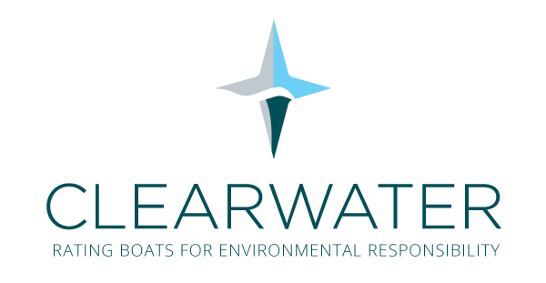

LAUNCH INVITATION
for immediate release

GOLD STANDARD AWARD FOR VITA 28 ELECTRIC CLASSIC TENDER
MARKS GLOBAL LAUNCH OF NEW ENVIRONMENTAL RATING SYSTEM
AT MONACO YACHT SHOW

Please join Clearwater Rating on British Marine’s stand QS28, located in the Darse Sud area, on Wednesday 26 September at 1500 hours for the award presentation. Plus, learn more about this important environmental initiative from its founding team

Boatyards and owners now have a completely unbiased rating system against which to assess the environmental impact of superyachts and leisure vessels. The launch of Clearwater Rating at the Monaco Yacht Show marks the first time that such an objective standard will be available globally, free of commercial bias.

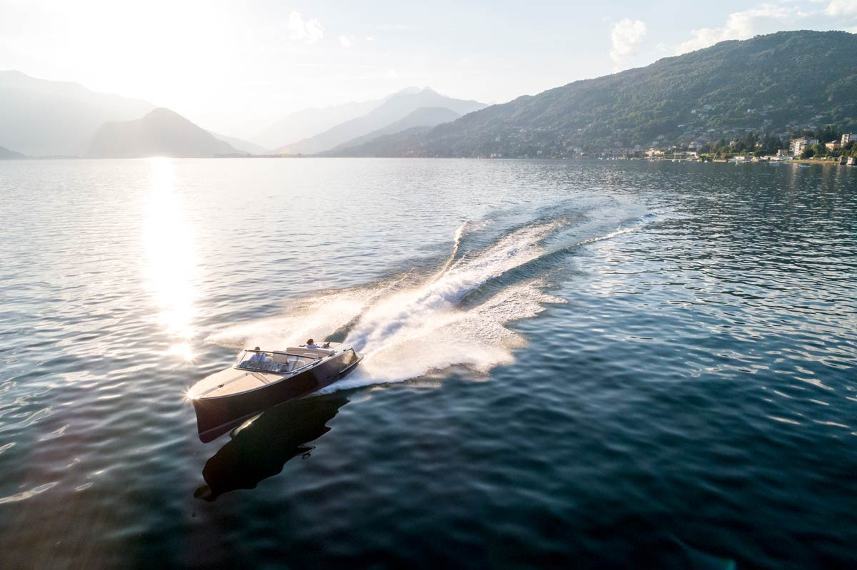

The Vita 28, first to be awarded the Gold Standard Clearwater Rating for its environmental credentials

To celebrate this milestone, Clearwater Rating will be awarding the new Vita electric-powered classic tender with its Gold Standard at the Monaco Yacht Show. Gold is the pinnacle of seven rating bands which will provide a clearly understood measure of the environmental footprint for vessels, from traditionally constructed and conventionally fuelled yachts, through to hybrids and zero emission vessels.

A Clearwater Rating provides:
- a manufacturer with an unbiased and standardised measure of the environmental credentials of its products
- an owner with benchmarks for the current and future impact of his or her leisure vessel, plus a basis to apply environmental best practice in day-to-day operations
- everyone with confirmation of the cleanliness of a superyacht, whether purchasing, buying, hiring or chartering

The Clearwater Rating system has been researched and created by three highly experienced experts in the field of technical compliance – Alasdair Reay and Maria Garcia-Donaire of HPi Verification Services and Craig Morris of CE Proof. It has been launched to fill a recognisable void in available global standards and the scheme will be run on a not-for-profit basis with any excess income donated to the Blue Marine Foundation. The Clearwater Rating team will commence building a board of independent governors for the scheme and will be actively soliciting interest from manufacturers, technical consultants, owners and others around the world to ensure its widest possible use.

Speaking prior to the launch, and just before he embarked on a London to Monaco cycle ride in aid of the Blue Marine Foundation, Alasdair Reay stated: “For some years, Maria, Craig and I have shared a frustration that no objective benchmarks existed for evaluating and grading the environmental footprint of superyachts and leisure vessels. We’ve now consulted, researched and invested in the Clearwater Rating system and I’ll be carrying our first certificate with me, by bicycle, for its zero-carbon footprint presentation to the Vita 28. Please join us on the British Marine stand QS28, located in the Darse Sud area of the Monaco Yacht Show, on Wednesday 26 September at 1500 hours, to see the award of the Gold Standard and to discuss the detail of the scheme with us.”

- ENDS –

For further information, please contact

Media enquiries and RSVP

E clearwater@hollambypartnership.co.uk
T +44 1344 266130 or +44 7590 693152

Clearwater Rating

E alasdair@clearwater-rating.org
T +44 7812 183328
W clearwater-rating.org

NOTE FOR EDITORS

CLEARWATER RATING
Clearwater Rating addresses a need in the leisure marine market for an objective, independent assessment of the environmental credentials of a superyacht or leisure vessel.

The Clearwater Rating system has been carefully researched to synchronise with environmental legislation and realistically incorporated best practice. It enables a manufacturer or owner to work though clearly defined steps that examine the impact of a leisure vessel upon air and water quality, energy consumption, noise pollution, seabed, foreshore, wildlife and global resources.

The heart of the system is the Clearwater Rating Calculator, on which you work through a series of logical questions with help screens. When completed, a rating is issued, representing a simply understood measure of the environmental cleanliness of a boat or superyacht. It’s a similar approach to commonly seen ratings viewed by consumers of electrical domestic equipment, house purchasers and car buyers when making informed decisions about their personal environmental footprint.

VITA
Vita Power was established in 2017 to bring the latest in automotive technology and engineering to the marine world. Its team comprises Chairman and Founder, Stewart Wilkinson, Managing Director and naval architect, David Gray, Head of Power and Performance, Peter McKinlay, and Head of Production, Adrian Gusman. They bring a wealth of experience from related fields including electric boats, the superyacht sector and F1.

The Vita is a full-production electric boat inspired by classic boat building traditions. At 30ft long, it is powered by a groundbreaking propulsion system, incorporating proprietary throttle and touchscreen technology from Vita Power. The boat was designed in the UK and will be built at Vita’s new hub on Lake Maggiore, Italy. The innovative power system integrates 130kWh of compact and lightweight liquid cooled Lithium battery storage with two 180hp electric water jet drives, controlled by an intuitive touchscreen interface. The Vita boasts a cruising speed of 25 knots and builds to a sprint speed of approximately 40 knots.

It will be the first ever vessel to be awarded the Clearwater Rating Gold Standard.

Vita Power

E jessica.toushek@vita.power.com
W vita-power.com

The Blue Marine Foundation
The Blue Marine Foundation (BLUE) is a charity that is working to solve the crisis in the oceans through providing innovative solutions to overfishing and enabling the creation of marine reserves. Although BLUE is a small NGO, it punches above its weight, having achieved a tremendous amount for the oceans in a short time. In 2014 BLUE won NGO of the Year in the PEA (People Environment Achievement) Awards in recognition that it was ‘getting results where they matter most’. In 2015 BLUE won four PEA Awards as part of the GB Oceans Coalition including ‘Overall Champion’.

The Blue Marine Foundation

W bluemarinefoundation.com

