Press Release

Superyacht Tenders and Toys appointed as the global superyacht partner for Avon Electric Jet Tenders

3 March 2020

Award winning Superyacht Tenders and Toys (SYTT) is celebrating being selected as the global dealer for the superyacht market of Avon Electric Jet Tenders.

The Avon eJET 450 is the world’s first electric jet tender that does not compromise on performance providing jaw-dropping acceleration combined with the comfort of silence. This is thanks to proprietary hydrojet technology developed specifically for the electric engine and BMW i3 battery.

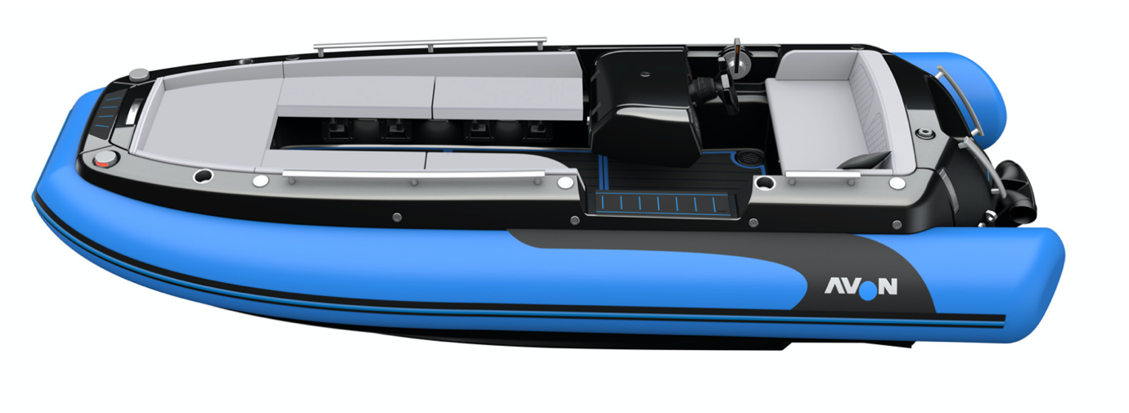
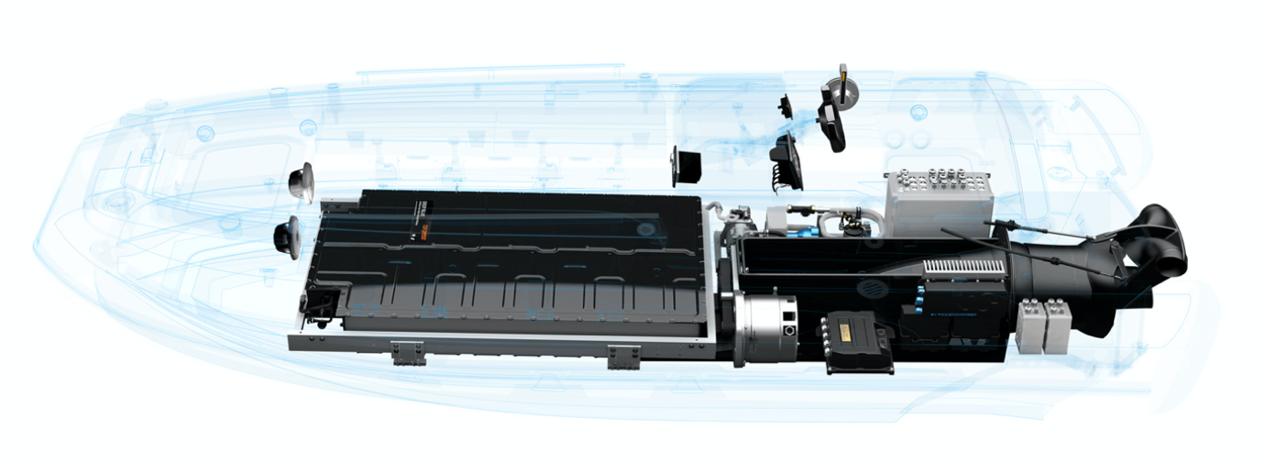

All boats are hand built in France, including the revolutionary jet drive using the century-old know-how of Zodiac Nautic. The eJET 450 is an ideal fit for yachts of 30m and larger replacing many of the well-known petrol and diesel alternatives. It can be configured in any colour combination and can come with a number of very attractive features such as a carbon bimini, carbon steering wheel, folding seating and more.

Richard Booth, Senior Project Manager and Sales Manager at SYTT comments: “Avon is a great fit for yachts as a small guest tender. The boats are well built, dry, fast and offer an enormous amount of guest seating all at a very attractive price point. We are looking forward to showing clients the boat in the flesh at LYBRA The Superyacht Show in May.”

Specifications:
- Length 4.5m
- Beam 2m
- Overall height 1.1m
- Torqueedo DB80/55KW motor with BMW i3 battery
- Dry weight 850kg
- Max speed 55 km/h
- Seating capacity 6 persons
- Usage 4 hours at normal use

About SYTT:
SYTT, with its headquarters in Ipswich, Suffolk designs, project manages and delivers yacht tenders and toys to superyachts globally. The company also has a yacht tender and toy rental business with a warehouse in the South of France. The company, founded in 2011, has grown extensively over the last nine years and is the market leader in its field. A large proportion of the company’s business comes from fitting out new build superyachts in Europe, as well as supplying to operational superyachts around the world.

ENDS

To learn more about Superyacht Tenders and Toys visit www.superyachttendersandtoys.com or contact info@sytt.co

High resolution images can be found here: https://www.dropbox.com/sh/xnqnetzr7k8l8zb/AADRHWYu6_qHN174R0W-SHhja?dl=0

