For immediate release
19 February 2020

Wessex Resins and Adhesives supports dinghy owners with ‘how to use epoxy’ demonstrations

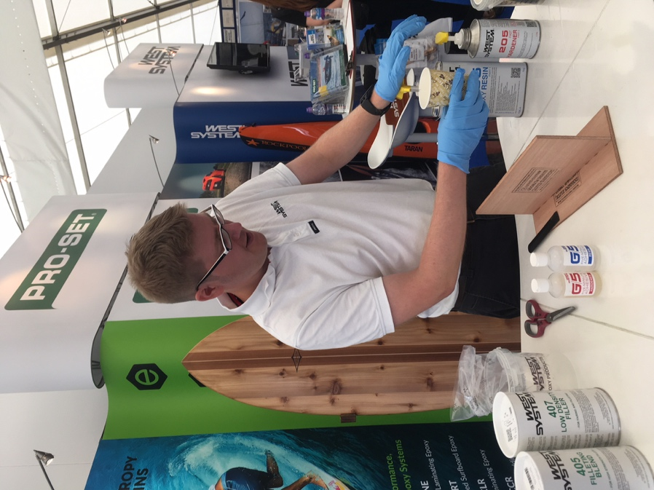
Wessex Resins and Adhesives is offering free repair demonstrations on its stand C2 (Hall Three) at the RYA Dinghy Show, Alexandra Palace, 29th Feb to 1st March.

For racers and enthusiasts, for those with wooden or composite boats, epoxy provides a straightforward and effective way to make DIY minor repairs.

As such the demonstrations offer expert advice about fixing all-too-common problems, from a season’s bumps and scrapes using WEST SYSTEM® epoxy products to fileting and bonding.

“At Wessex Resins we’re all about supporting the end user,” says David Johnson, sales director and technical advisor. “We share our knowledge readily and widely. Epoxy is fantastic to work with once you know a few key basics, it can transform boat repair for so many people, so coming to these demonstrations will give a great basis for people to start preparing for next season.”

Wessex Resins has been working in partnership with Gougeon Brothers, Inc. for more than 36 years, manufacturing WEST SYSTEM, PRO-SET and Entropy Resins epoxies here in the UK.

“WEST SYSTEM epoxy is a really versatile product,” says David. “It’s into its fiftieth year of development and is getting better and stronger all of the time. It’s being used by boat builders across the world – including Spirit Yachts, Sunseeker and Princess – and we’re looking forward to meeting more owners at the dinghy show, whatever the size of their boat.”

WEST SYSTEM Mini Pack Demonstration
(daily at 12.00)
The Mini Pack is a one-stop-pack for small repair jobs, and includes resin, hardener, two fillers, gloves and more. This demonstration explores how the contents can be used to effect repairs and explores techniques for fileting, bonding and the use of glass reinforcement.

Glass Fibre Repair Demonstration
(daily at 14.30)
It’s straightforward, time effective and economical to make small repairs to glass fibre hulls using WEST SYSTEM and G/flex epoxy. These demonstrations include techniques for hull / deck repairs.

WEST SYSTEM epoxy is a general-purpose epoxy system designed for coating, bonding and gap filling and is used by amateur DIYers in addition to professional boat builders such as Princess, Sunseeker and Spirit Yachts.

Find Wessex Resins and Adhesives on stand C2 (Hall Three) at the RYA Dinghy Show. Or check out wessexresins.co.uk for further information.

Pictured – Hamish Cook from Wessex Resins and Adhesives.
ENDS
Notes to Editors:
- Wessex Resins and Adhesives manufactures WEST SYSTEM, PRO-SET and ENTROPY epoxy products in the UK under license from Gougeon Brothers Inc., and distributes these leading brands across the whole of Europe, Africa and the Middle East via a well- respected distribution network.
- Wessex Resins and Adhesives provides international support for the world-renowned WEST SYSTEM, PRO-SET and ENTROPY epoxy brands.
- Since Michigan boatbuilding brothers Meade, Joel and Jan Gougeon first experimented with the bonding power of epoxy over 50 years ago, the WEST SYSTEM® and PRO-SET® product ranges have become the epoxies of choice for private boat owners, boat manufacturers, chandlers and naval engineers throughout the world.
- Wessex Resins has been working in partnership with Gougeon Brothers, Inc. for more than 36 years, manufacturing WEST SYSTEM, PRO-SET and ENTROPY epoxies here in the UK.
- Whether an epoxy is needed for laminating, bonding, coating, tooling or infusion, the combined breadth of WEST SYSTEM, PRO-SET and ENTROPY products will provide the solution. WEST SYSTEM and PRO-SET have passed extensive quality testing. They are certified by Lloyds Register and DNVL.

Media enquiries:
MAA – Zella Compton. zella@maa.agency 023 9252 2044
Wessex Resins and Adhesives – Sam Oliver, sam.oliver@wessex-resins.com 01794 521 111

Images are available online at https://maa.agency/media-centre/

