NEWS RELEASE

19 Nov 2019

MAA DINNER BRINGS INDUSTRY TOGETHER

Over 70 marine professionals joined MAA onboard Wapen van Amsterdam to celebrate another successful year of shared business interests, incredible product developments and continuing business success in uncertain times.

Forty-five international marine journalists from the Netherlands, Italy, Spain, Germany, Sweden, USA and the UK heard from MAA director Mike Shepherd, sailing raconteur Tom Cunliffe, President of Navico Knut Frostad, Navico’s senior global brand manager Julian Harvie and writer Matt Sheahan.
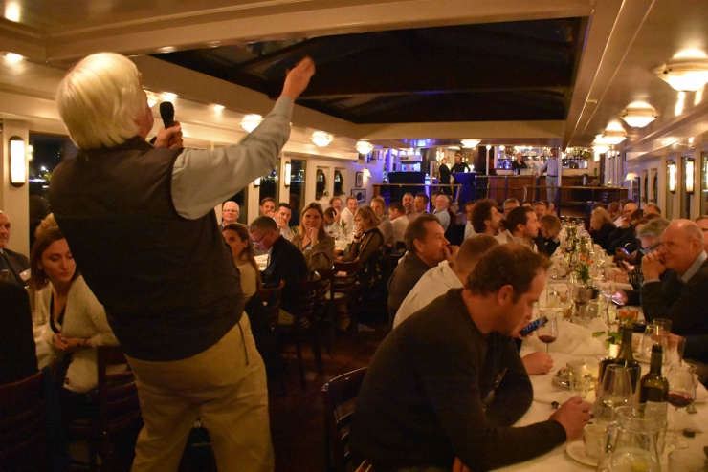
The annual MAA press dinner is now in its third year and continues to be a sought-after ticket, offering exclusive opportunities for select businesses to launch their products to the most renowned European marine writers. But more than this, it offers unequalled networking opportunities, lively debate and the chance to catch up with old friends while making new ones.

“It’s been a fantastic evening to network with all the media and industry,” says Knut Frostad, Navico. “It’s all about story telling and that’s what we all do. We tell stories through our products and through our industry.”

“What MAA does with its marine industry dinner at METS keeps the industry together,” says Mark Jardine, editor yachtsandyachting.com. “It’s hard to estimate just how important this event is to the marine industry and the fact MAA has done it off its own back and got the industry together is a massive achievement and a huge credit to Mike and the MAA team.”

“This was a fantastic evening,” says Mike Shepherd, MAA director. “We’re always blown away by the quality of guests here including representatives from the best marine titles across Europe, and many of the businesses with which we work so closely. Once again our speakers were exceptional.”

MAA was set up by Mike Shepherd in 2009, since then the company has experienced consistently strong growth. MAA was awarded Best Marine Company to Work For at the 2016 British Marine awards and is now firmly established as one of the foremost agencies in the marine industry.

MAA helps companies with everything from media planning and buying, PR and social media to brand development, eCommerce and website design and development.

ENDS

High res images of the evening are available via MAA’s media centre (https://maa.agency/media-centre/)

Image caption: Tom Cunliffe entertaining the guests.

MAA provides simple, no-nonsense solutions to marine companies’ advertising, PR, media buying and communications needs. From brand development and marketing materials to website, eCommerce, email campaigns and social media, MAA offers a straightforward, knowledgeable and service-orientated approach. MAA is able to offer unrivalled value to help clients reach their target markets.
For more information visit www.maa.agency
Media enquiries:
Emma Stanbury, emma@maa.agency Zella Compton, zella@maa.agency T: 023 9252 2044

